# The Dutch Agency for Rijkswaterstaat (Transport and Infrastructure)

# Description of the system

**Introduction**

Rijkswaterstaat is the Dutch government executive agency (separate from the policy ministry) in charge of the management and development of the main road network, the main waterway network and watersystems. In 2016 it had around 8800 employees and a budget of 4.2 billion EURO. The information concerning the RWS strategic management system described below is derived from van der Steen and Scherpenisse, 2015[1] and van der Steen, Scherpenisse, Van Twist, Ovaa, Van Den Boogaard, 2013[2], as well as information provided by the head of the Strategic Explorations Team.

Figure 1: the RWS process of continuous scanning, exploring and deciding on strategic issues

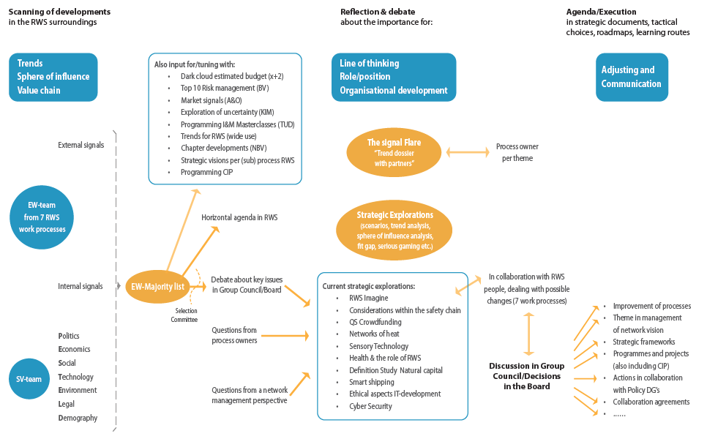

Source: RWS, 2017

Its “early warning system” (EWS) originated in 2008 in the Water Division’s Strategic Exploration Programme on request of deputy director-general. In 2009 it was decided by the DG to expand it to the whole organization where it started in 2010.

Originally the EWS was meant to be a process that intended to detect blind spots:

* from outside towards inside
* across all water related dossiers
* to enable looking forward as something may not necessarily be a problem today, but one may need to act now to avoid problems / miss opportunities in future
* in an exploratory, research oriented way.

From 2010 on, it also came to act as a “conscience”

* Get sensitive issues on the table
* Weak signal but uncomfortable: cannot be ignored, requires attention
* across all Rijkswaterstaat related dossiers (not only water)
* Answering the question: “Are we really doing fine, even if all projects and programmes are doing well?”
* hence a process for agenda setting, organizational and political.

**A process of permanent scanning**

Figure 2: overall process leading to decisions



Source:RWS, 2017

A starting point for understanding the process, summarised in the above box, is that RWS sees strategy as elaborating the role an organisation has in society. Hence, the EWS project leader invites a group of designated persons, representing each of the 7 core tasks of RWS (construction and maintenance, asset management and stakeholder management, traffic management, water management, crisis management, information technology and services, knowledge management) to look outwards by asking what, from their perspective, is going on in terms of new developments and trends, or shifts in the playing field, that might impact on the role and tasks of Rijkswaterstaat. Who would they like to talk to in this respect? If it turns out there is overlap in their interests, the invitees may team up with each other. In preparation of the conversation with the chosen external expert they do some digging of their own (with document/web analysis). They are asked to have three external conversations per half year, carefully chosen, and as such bring in five to ten ‘early warning signals’ on new developments and changes that relate to the core task they represent.

The 7 representatives spend no more than 0,1 FTE of time per person. They are supported in this by the Strategic Explorations team that is responsible for the whole process of scanning, organizing the selection process and organizing the subsequent discussions in the Group Council and Board of Rijkswaterstaat. The Strategic Explorations team also adds its own perspective by keeping their eye on new developments in society (within the various PESTELD[3] domains, with an open view, unrestricted by the core tasks of RWS). They also conduct in each of these PESTELD domains one or two early warning conversations each 6 months. The signals that are derived from these conversations are added to the signals that come from the 7 representatives of the core RWS tasks.

All of the above tasks together represent approximately 1,5 FTE in the Strategic Explorations team.

There are typically three kinds of signal concerning:

* trends: what is heading for us?
* forces: what are actors around us doing?
* value chain of RWS: are we working inside the organisation on a shared idea of added value for society?

The signals are not just about the future, but also about what RWS is not seeing, right now. They can concern:

* a trigger for future developments
* a symptom of current developments
* an early warning of a growing development

In 2016, ¼ were internally and ¾ externally oriented.

Signals can now be submitted at any time, however, they will be processed only twice a year. Signals are first checked in database with existing signals, as it is possible signals return more than once. This enable realizing that a weak signal is becoming stronger. It is then interesting to see its origin and development but also how decisions to select signals are being made. Signals are written down in a format (max half a page A4):

* Title: short, stimulating phrasing of the core of the signal
* Source: function and organisation of correspondent
* Signal: description of the upcoming development, patterns of change, directions other actors are choosing
* Consequences for RWS: possible impact for Rijkswaterstaat according to the respondent, in terms of: identity, role & position, strategic choices (heading), tasks, working routines, effectiveness, time, money and image
* [optional] Suggestions for action: what does the correspondent think RWS should do?

All signals are placed on a long list (approx. 60- 80 signals each half year). Those responsible for the Strategic Exploration team screen the signals, using a set of experience-based quality criteria:

* the signal is already known and being addressed
* in a recent EWS round, a comparable signal was already contributed and the new one does not add information
* the argumentation is not complete or the focus is not clear;
* there are many inaccuracies
* the signal is too small, not befitting the board of RWS (but it will be transferred elsewhere)
* the signal does not actually concern RWS
* the signal is too much a vehicle for personal goals of the person who brings the signal forward.

The signals that do not meet with the criteria, will be ‘horizontally put on the agenda’, i.e. sent to programmes, project groups, or experts in the organization to whom these signals can be worthwhile.

**Identifying the themes for further discussion**

The document containing the signals that passed the quality test (approx. 50-70) goes to a selection committee which consists of approximately 15 persons, who are a reflection of the organisation, and is renewed for approx. 1 /3 each time. As a preparation, they are asked to read the signals by themselves, and perceive which signals make them feel nervous because they do not fit with the existing perspectives, frames and practices within RWS. During the meeting of the selection committee, together they identify the themes that may affect the strategy and organization of Rijkswaterstaat, grouping various, also conflicting, signals. Generally they end up with 3-5 key themes that should (in their opinion) have the attention of the top of Rijkswaterstaat.

**Strategic discussion in the Group Council and follow-up**

After the meeting of the selection committee, a short summary is written of each theme, and signals are added that illustrate the urgency and different perspectives on the subject concerned. A last check is being made by internal experts on accuracy and quality of the added signals, effectiveness of suggested actions, whether the subject is already on the agenda somewhere in the organization, and if there is some common ground with former decisions. The responsible team can add comments without changing the signal.

An example of themes as well as of signals connected to a theme can be found below.

Box 1: themes and underpinning signals

Four converging trends (decentralisation, changing funding flows, environmental law and energetic society) call for a different type of collaboration. The state, including the Rijkswaterstaat, is insufficiently able to get some distance from its own structure and frameworks. These trends are:

* Pressure on RWS to strongly prioritise sustainability and to show ambition in this respect;
* Tensions between the perception of citizens and the actual (f)acts of the government;
* The need to adjust our approach to take account of the silver (ageing) economy;
* Blockchain technology, which should be seen as an opportunity as well as a risk as regards intermediary functions and security issues;
* Automated ships are coming: are we prepared for this?

The third theme, as an example, is further elaborated as follows.

Society is becoming less and less satisfied with a government that judges its success in caring for safety and the living environment by merely meeting formal standards. Whether it concerns noise levels within the dB standard or economic growth figures, the government can calculate that everything is going very well, but the citizen definitely does not experience it in such a way.

* For a growing group of people, Gross Domestic Product is no longer the main prosperity indicator. This indicator should deal much more with 'well-being' (we also see this development in several other European countries);
* Within the daily practice of RWS, we notice that citizens increasingly put their perception first. Achieving formal standards and technical foundations are no longer sufficient.

The question is: how can we keep up with this development?

Two underlying signals are added:

**14. Health, sustainability and happiness central to the economy of well-being**

*Source: Deltares*

**Signal:** Since the Second World War, people have become 12 times as rich, but not happier. This is one of the most important arguments from a growing group of people who wish to change the current economy and strive for a 'purpose economy' or 'economy of well-being'. In such an economy, not profit, but the social significance of enterprises will be central. Citizens will focus more and more on meaningful lives, healthier lives and a good work-life balance. The government gets rid of the main prosperity indicator (GDP) and replaces it with an indicator of welfare. The first signs of a transition to the 'economy of well-being' are the recent documentary 'Return on Happiness', critical statements about GDP, among other things, in the *Correspondent*, a strong increase in the number of social enterprise start-ups, and the parliamentary inquiry 'Towards a broad prosperity'.

**Consequences:** RWS will increasingly be affected by the welfare economy, as concerned citizens, their own employees, companies and regional government agencies will increasingly ask what impact large-scale projects have on their own well-being or the well-being of others. In the long run, the Ministry may also instruct RWS to make the welfare impact transparent. As a governmental organisation with responsibility for the ‘environment’ for living, well-being should be one of the major themes. In this context, the results of the parliamentary inquiry 'Towards a broad welfare concept' are also interesting. This indicates the way in which prosperity and well-being can be measured. If RWS does not contribute to the development of a welfare economy, a greater distance to the citizen may eventually occur, and as a result the RWS may execute its societal mandate less well. Also, the well-being of RWS own employees should not be forgotten.

**Suggestions for action:** RWS Works should ask all of its projects: To what extent does the project contribute to the well-being of people? For example use the “omgevingswijzer” to make an initial assessment of the impact of a project on well-being and health. If necessary, make an extensive welfare analysis. Investigate how RWS contributes to the welfare of its own employees.

**15. The end of the effect of standardisation is in sight**

*Source: RWS WVL, Division of Sound, Air and Nature*

**Signal:** The changes in the way society looks at the government and the way we want to function as a department, make it so that strictly technical way for meeting environmental standards is insufficient to maintain our ‘social licence to operate’. This process is reinforced for RWS, being the network administrator, through the decentralisation of environmental policy, as embodied in the Environmental Act. The environment demands more from us than complying with standards and an arithmetical-technical statement for the choices we make. For example, on the issue of air quality, the standards are now reached, but people are not satisfied, as the World Health Organisation now recommends a stricter standard or because they themselves make measurements with all kinds of apps. However these measurements are not just about numbers, but also about interests. They are used as an argument.

**Consequence:** The end of the effect of standardisation is in sight. A larger tension is growing between the system world of standards and calculations and people’s perception of the environment. Public opinion becomes more important for our freedom of movement than standardisation.

**Suggestions for action:** In the first place, within RWS, it is necessary to think through the dilemmas that this entails. After that, the discussion has to be broadened within the department and beyond.

Source:RWS, 2017

In the Group Council, which consists of the sixteen heads of all organizational units of Rijkswater­staat, the 3-5 key themes are being discussed on a strategic level. This is for example done by sharing the possible impact of the development on the organization (identity, tasks and procedure, organisation development), as well as sharing the estimate of the time horizon within which occur social dynamics that could lead to a turning point. This can be mapped visually (see below) where on one axis impact is set out, while on the other, the estimated time horizon. Next, the main strategic questions for each theme are determined and indications are given concerning the first follow-up steps that must be taken.

Figure 3: visual mapping



Source:RWS, 2017

The Group Council may ask for a more thorough “strategic exploration” to be done by the Strategic Explorations team, which focuses on:

* Nature and extent of the change / the trend;
* Opportunities and risks for RWS;
* Perspectives for action.

Usually, not more than two explorations will be asked for. If the Group Council concludes an immediate decision has to be made, with respect to new activities or changes in ongoing practices, this will be presented to the Executive Board of Rijkswaterstaat.

The setting up of strategic explorations, is not triggered only by the EWS but can also be asked for directly by process owners (the individual board members, each responsible for one of the 7 core tasks) or derived from the network vision (the long term vision of Rijkswaterstaat on the development and management of the main road network, main waterways network and watersystems, taking environmental sustainability as a starting point). The strategic explorations are usually conducted in close collaboration with RWS colleagues working on tasks that may be most affected.

The decisions about how to act are finally taken by the Executive Board. In a short briefing note pro and contra’s relating to decision options are described and their consequences are clarified. As the Board members are also part of the Group Council, this facilitates the discussions.

Two examples of a signal and what happened to it are provided in the boxes below.

Box 2: example of a signal concerning phosphate

*From waste product to valuable good*

*Phosphate is a waste product that leads to eutrophication problems for RWS and other water managers. It is, however, also an indispensable food substance. In an Early Warning it was flagged that the global phosphate supply is running out, while the finite supply is in the hands of politically unstable countries. The substance which until then would be a waste product of water would represent great value in the future. It emerged that companies showed increasingly more interest in developing methods for reclaiming phosphate.*

*Thanks to the signal, RWS had the opportunity to shift its position in this area from a passive role as a guard of the water quality to fulfilling an active, facilitating role in collaboration with the regional water managers. RWS could take on a facilitating role for the parties that are developing new technology for reclaiming phosphate and wish to gain practical experience with the main water system managed by RWS.*

*In the “Green Deals” of the state, agreements have been made with market players. RWS also put the topic on the agenda of the Ministry which prepares the second generation of watershed management plans.*

Source: van der Steen et al, 2013

Box 3: example of a signal concerning replacement

*From 1 to 1 replacements to a replacement strategy for installations.*

*RWS manages hundreds of installations (sluices, dams, bridges, pumping stations). As a rule these are replaced when they have reached the end of their technical lifespan, one-to-one, at the same location that was chosen some hundred years ago. The signal was that many installations were built in the 1920s and 1930s, and that RWS was to be faced with an extensive replacement task as of 2020. It was subsequently also established that the hundreds of millions of euro that would be involved in these replacements each year had not been reserved and would require strong justification when it came to the politics and that society sets different requirements for the future functioning of the water system (e.g. increase in cargo over water) and, therefore, for the installations. In addition, large replacements have to be done in concertation with regional development projects.*

*The RWS Board entered on its agenda that there was a need for a programme-wise approach to the replacements, which laid a connection between the current state of the installations, the required functionality in the longer term, and the political-administrative situation in the region. RWS is now working on a system that will put the replacement task well-justified on internal and external agendas.*

Source: van der Steen et al, 2013

Signals that were not selected can still be used by placing them on the agenda horizontally. This parallel use consists of:

* Targeted forwarding to organizational units
* Possible subjects for thematic “Lichtkogel trend book”:
  + conduct debate with partners regarding future developments
  + see for example an issue about lifecycle thinking in annex 1
* Also subjects for master classes given for a broader group of colleagues within and outside RWS
* Apply for budget risk management (“dark clouds”): this concerns tasks/projects/risks at the horizon of which the financial implications are not yet fully clear but that are important enough to take up in the budget proposals for the next year
* Input for other vision development (infrastructure, organisation culture, ...)

In addition, signals that are not so much of concern directly for RWS but more for the policy ministry will be directly communicated to the ministry.

The original sources of a signal are informed what happened to their signal.

The policy ministry is interested in developing an Early Warning System for the ministry as a whole, following the RWS example. It has been piloting the approach with first impressions being positive.

**Reflections**

The system was reviewed by academic researchers in collaboration with the Strategic Explorations Team (van der Steen and Scherpenisse, 2015 and van der Steen, Scherpenisse, Van Twist, Ovaa, Van Den Boogaard, 2013). They noted a tension between:

* Search for professionalization linked with the goal of detecting blind spots with
  + well-structured process;
  + quality assurance of signals;
  + well prepared dossiers;
* Search for new perspective, confrontation, linked with the goal of acting as a “conscience” (agenda setting / political).

Since 2014, this tension has been alleviated by not just sending themes and signals around on paper but also having the EWS team facilitate an active discussion in the group council.

1. Prospective Strategy: anticipation and agility in the Early Warning System of Rijkswaterstaat in the Netherlands, GDN Conference paper, Florence Scuola Normale Superiore.
2. Early signals, timely strategy. Essay by the Think Tank of the Netherlands School for Public Administration. NSOB.
3. The PESTELD domains of society: Politics, Economics, Social, Technological, Environment, Legal, Demography)