Making “strategic government” a reality in Finland.
The case concerns efforts to transform the way the Government at central level steers change in a country, notably Finland. The first part of the case details what was intended as described by key documents. The second part describes what actually happened. In this way, the case also shows to what extent setting out a new way of working can actually also turn into reality.
Planning for strategic government
In January 2015, OHRA – the project to reform the Government’s steering framework – put forward a number of proposals for the following parliamentary term aimed at improving the impact and effectiveness of Government actions. The OHRA Project comprehensively reviewed the Government’s steering framework and developed a model that coordinates content and resource management more effectively and promotes closer interaction between political leaders and senior civil servants. The new approach was designed to ensure that core policies pursued by the Government could be effectively implemented. The government strategy would in the future consist of the Government Programme, outlining broad policy objectives, and a Government Action Plan, providing a more detailed description of the means and tools to be employed to this end.
Indeed OHRA (2014) noted that the existing policy-making and planning processes had several deficiencies:
- Political and administrative systems had been seen as two separate elements, with, for example, a weak connection between financial and strategic steering as a consequence. The Finnish government was good at producing decisions but not necessarily at producing consequent change;
- There were too many objectives with the overall policy picture being unclear;
- Major reforms got started without a sufficient information base and reasoning about alternative ways to solve problems, with particular means chosen too early on.
Having understood that efficient vertical administrations had been appropriate in a world where problems were ”simple”, there was less knowledge around and it was easier to access it, but that the world had changed since then, the ambition for the Finnish government was (Kekkonen, 2017):
- Being strategic
  - Having the ability to prioritize: one cannot do everything at the same time;
  - Having foresight capacity: seeing what is behind the corner in a longer term perspective;
- Coordination and horizontal policymaking:
  - Dealing with complex and interconnected questions: wicked problems entail that solving one problem causes another problem elsewhere;
  - Overcoming gaps between the Centre of Government and sectoral ministries; the state and the people; politicians and civil servants, the past, present and future….;
- Evidence-based policymaking:
  - Knowledge is the connecting key between civil servants and politicians;
  - Civil servants have lost their monopoly in knowledge production: knowledge is everywhere.
It was the way the Government Programmes had been written until then that was seen as one of the major reasons for the above problems. Political discussions during the preparation of the Government Programme were focused on agreeing means, rather than goals. Little use was made of expert advice from civil servants nor was relevant evidence used systematically. The resulting Programme had become a detailed list of actions that did not give a clear signal to civil servants (who have to prepare reforms) what the key objectives of the Government (across all ministries, rather than for single ministries) really were. This was deemed problematic as many problems that need to be addressed the Government cannot be dealt with by one administrative branch, as solving one problem may create another. Hence, all branches require common goals.
Hence, OHRA (2014) recommended that the Government Programme, to be completed by Spring 2015, would not include detailed measures but state only 3-5 key policy objectives which would be taken into account when specifying ministerial responsibilities.
This would contrast sharply with the +/- 900 policy objectives that had been there before. The outlook had to extend to the next 10 years, hence beyond the government term. Of course, future governments can still change it but at least it is made clear the perspective is longer term (Kekkonen, 2017).
OHRA (2014) specified the Government Programme was then to be followed by an Action Plan which would reconcile political and financial objectives, the former being detailed in the Government Programme, the latter being outlined in the General Government Fiscal Plan which should be prepared at the same time as the Action Plan. Confirmation of the Action Plan was planned to happen by August 2015, at the same time as the 2016 Draft Budget. Every year, the Action Plan’s implementation would be reviewed in tandem with the budgetary framework.
Drafting the Action Plan was foreseen to be a joint endeavor between politicians and civil servants which should take place in the three months after the Government Programme is agreed. The Government would then give an assignment to prepare the Action Plan, consisting of elements pertaining to the General Government Fiscal Plan and guidelines for the policy packages that should address the strategic priorities. Themes would be confirmed as well as the required responsibilities and organisations. Participants at political level could be chairs of Government political parties, the Cabinet Committee on Economic Government or some informal meeting of the Cabinet. At civil servant level, the process would be steered by a general secretariat, composed of experts from the PMO and the Ministry of Finance, led by the Prime Minister’s State Secretary together with the Permanent Secretary of the Ministry of Finance, hence ensuring tighter cooperation between the PMO and the Ministry of Finance.
The Action Plan was intended to contain only 3-5 policy packages which should not be too broad (e.g. “welfare”) nor too narrow (e.g. a single project). Each of these packages would then be assigned to an inter-ministerial group and would be prepared by the Permanent Secretaries of the relevant ministries, experts from these ministries and representatives of the PMO and Ministry of Finance. Inside the relevant ministries, the Permanent Secretaries would need to ensure that the packages are integrated into the performance management and regulatory policy coordination systems of each ministry. The Permanent Secretaries should be supported by a group of strategy leaders (strategic managers) from within their ministry.
During the process, alternative models of implementation were to be produced by the experts, based on systematic information. Finally, the packages were to contain 1) a starting situation description 2) resources 3) actions and timeframes and responsibilities 4) Indicators of success 5) Information needs.
The packages would be continuously steered by their ministerial working groups. Next to this, the Government would regularly meet in a forum to maintain joint situation awareness (e.g. by developing the evening sessions for this purpose). At least at the beginning of every autumn session there should be a retreat, focusing on indicator information, info from the development of the economy and info on society as a whole. Every spring, the whole Government would have to review implementation of the Action Plan, at the same time as the review of the Fiscal Plan. This would then be presented to Parliament and would be the only time when decisions can be made that would lead to revisions to the budgetary framework.
For future Government Programme preparations, OHRA (2014) also stated that a systematic knowledge base concerning the future development of society and the current situation should be at hand for politicians. A concise summary of situation awareness information (summarizing insights of all available foresight material) should be drafted jointly by the Ministry of Finance and the PMO for use in negotiations. Sources would be:
- Future report to Parliament: Once during each electoral period, the Government involves Parliament in drafting a report on the future focusing key strategic issues relative to policy decisions to be taken in a 10-20 year period. The aim is also to encourage broad debate in society. The body in Parliament responsible for this is the standing Committee for the Future, which consists of 17 Members of the Finnish Parliament. It serves as a Think Tank for futures, science and technology policy in Finland. The current Future report concerns the transformation of work;
- Ministry of Finance reports on the state of the economy;
- Joint description of the changing operational environment as prepared by the ministries;
- Individual ministry future reviews, drawn up to support government negotiations since 2003;
- National foresight work.
In 2014, a report was also released by the PMO concerning the way national foresight work would be organised. Cooperative foresight was defined as a shared process for generating data and using this to shape perspectives. Indeed, the latter are what matters as the purpose of foresight is to spark of discussion of weak signals and their consequences (even unpleasant ones). It is action oriented (not only analysis and reflection on the future but also shaping it), open to alternative futures (not a single predetermined one), with as broad a participation as possible (instead of involving only experts or academics) and multidisciplinary (entailing diverse viewpoints rather than a single one). Foresight is long term in nature, stretching across a single government term. Ultimately, foresight should enable strategic decision-makers to address even unforeseen developments quickly. A key approach for achieving this is to use foresight data in trials (experimentation). While political decision-makers are the key customers of the perspectives generated by foresight work, those who are participating in the approach also benefit from sharing materials. Finally, society in general, whether they be the general public, organisations and businesses, can also become customers.
PMO (2014) intended to provide a response to the fact that while Finland was seen as a leading producer of foresight data, this was fragmented and scattered. This hampered seeing the big picture and could prevent timely recognition of major developments. Also, there was a risk of much overlapping work.
The approach proposed by PMO (2014) is based on interaction and networks (see figure below).
Figure 1: actors in the foresight network
Source: PMO (2014)
A coordinating body, embodied as a dedicated secretariat with a General Secretary, should be put in place that is a dynamic, agile and implementation oriented user of data on forthcoming change with expertise in leadership and process facilitation, networking, foresight, strategy and implementation. It should operate out of the PMO and its budget. This is a logical place as it would enable coordination with other services in the PMO such as the Government working group for the coordination of research, foresight and assessment activities (TEA Working Group, see below) and the secretariat for the meetings of Permanent Secretaries in relation to the coordination of the Government Programme. The General Secretary should be familiar with foresight and have a passion for development.
A Government Foresight Group should be set up, that meets under a high level chairperson and is supported by the General Secretary and his secretariat. The group consists of Finnish forerunners in foresight, such as various ministries, research institutions and individuals as well as opinion formers (from business, national and regional foresight actors, media, academics), the latter serving as non-permanent members. The Secretariat should prepare needs-based content themes and prioritise proposals from the Government Foresight Group, as well as prepare foresight reviews. Three different types of review would exists (see figure below).
Figure 2: types of foresight review
The primary objective of a review is to compile existing data. However, new information may also be generated. Interesting and contradicting views should be presented, in order to provide a challenge and to shed light on weak signals, opportunities and risks.
Next to this Government Foresight Group, the Secretariat is supposed to interact with the national foresight network. The Secretariat prepares tasks for delegation to the network (relaying special themes to contribute to, as put forward by the Government Foresight Group). The existing national network of foresight actors should be strengthened, by expanding it and giving it a clear mandate. In the network, ministries should be present in order to enable the smooth sharing of information, tasks and expertise across organizational boundaries. The network should enable encounters between foresight actors from various sectors and reaches of society, as laid out in the figure below.

Figure 3: foresight network process
Three meetings a year should be held to enable collaborative work, sharing of information and extensive networking. In between these meetings, clusters of actors (e.g. thematically) can convene independently and provide the network with data or receive data and assignments. Actors can choose to participate and contribute on a case specific basis. Opinions can be exchanged on electronic discussion forums and workspaces.
In addition, a “future atlas” should be developed to organize available foresight data and analysis. The atlas should shed light on the foresight activities of different players and eliminate duplicate work. An existing portal should be used as a foundation (e.g. www.2030.fi or www.foresight.fi ). Funding for the portal should come for the PMO but once developed, it should be administered separately. This portal should enable actors to share topical issues and address urgent matters. In addition, discussion on social media should be linked to it. Users should be able to upload information into shared wikis. There should be a voting function to enable hot discussions to be highlighted.
On a regular basis, a national foresight actor should take the lead, with support from the Secretariat, the Government Foresight Group and the national network, to organize a foresight forum. These forums should be scheduled annually and by parliamentary term to serve the information needs of ministries and the Government, taking into account events such as elections and the mid-term strategy review, the Government Report on the Future and future reviews by ministries. They should attract strong international participation to support the content, broader perspectives and development of the expertise of participants. The quality should be high enough to gain an international audience incl. from the media. They would provide material for foresight reviews and the foresight atlas.
Training opportunities should support foresight activity. A forum or network meeting could include a low cost training event e.g. of half a day, where actors can share best practices, hear about the latest trends or learn about practical methods. In addition, comprehensive schools, universities and other higher education institutes could integrate foresight elements in their curricula.
Continuous foresight should lighten the process underlying the Government Report on the Future, eliminating at least some foresight data collection and analysis. In addition, the future reviews of ministries would benefit from the data on the foresight portal (Atlas), while the portal can also be used to disseminate to the general public (for discussion and application) what is generated by the ministries.
What actually happened: realizing the plans?
The four largest parties were involved in the preparations of OHRA (2014), and the proposal had been reviewed in consultation with all the parties represented in Parliament. State Secretary Olli-Pekka Heinonen of the Prime Minister’s Office, who was in charge of the reform, noted that a broad consensus existed in terms of the objectives to be achieved. To translate the OHRA Project recommendations into concrete actions, an implementation project was established whose mandate extended beyond the change of Government, until the end of 2015. By and large, the planned reforms were implemented, although some of the terminology was changed.
The actual Government Programme (coalition agreement) was submitted to Parliament in the form of a Government statement on 29 May 2015. It was stated to be “…a strategic programme of reform. In contrast to what has been the custom, we have not included everything in the Programme, as the development projects of many administrative branches will continue unchanged”.
According to Kekkonen (2017), the chairpersons of the negotiating parties had a real lead position in the negotiations of the Government Programme. First, the chairs agreed on main policy objectives (priority areas, economy, security and EU-policies), fed by a report prepared by civil servants on the wicked problems that Finland was facing. This report was based on Foresight reports by all Ministries summarizing the horizontal policy challenges for the forthcoming Government term. At this stage, there was less influence by civil servants and lobbies than before. Only after this, shared work was embarked on to define key projects in each priority area, in working groups consisting of government negotiators put forward by the coalition parties. The Government Programme therefore became a programme of change, rather than a list of everything that needs to be done. This does not mean the latter is not important, but the machinery is already there to take care of it. Budget cuts for the existing machinery had been decided on already in the Government negotiations at detailed level, which meant less pressure in the first budget frame negotiations. On the other hand it was also decided in the Government negotiations that 1 billion EURO would be allocated to the five priority policy areas to boost the changes wanted.
Prime Minister Juha Sipilä’s strategic Government Programme envisaged Finland’s future in the following terms: “In 2025, Finland is an inventive, caring and safe country where we all can feel important. Our society is based on trust.” The Government’s objectives were to bring the Finnish economy onto a path of sustainable growth and higher employment and to safeguard sufficient financial resources for public services and social protection. With its five strategic priorities (corresponding to the “policy packages” in OHRA) in the Government Programme, the Government wanted to take steps to follow through with essential reforms in the areas of employment and competitiveness, knowledge and education, wellbeing and health, bioeconomy and clean technologies, as well as digitalisation, experimentation and deregulation( changes in the procedures and working methods of the Government).
The five strategic objectives are materialised in the form of 26 key projects (to which the 1 billion EUR was dedicated and allocated later in the action plan, see the box below. Next to these five strategic priorities, the Government also committed to structural reforms in terms of overhauling the pension system, a social welfare and healthcare reform, reducing the amount of obligations and functions in local government and reforming central and regional administration.
Box 1: key projects
- Employment and competitiveness
  - Strengthening competitiveness by improving conditions for business and entrepreneurship
  - Incentive traps preventing acceptance of work will be removed and structural unemployment reduced
  - Local agreement will be promoted and barriers to employment removed
  - Reform of employment service activities to support employment
  - Housing construction will be increased
- Knowledge and education
  - New learning environments and digital materials to comprehensive schools
  - Reform of vocational upper secondary education
  - Acceleration of transition to working life
  - Access to art and culture will be facilitated
  - Cooperation between higher education institutions and business life will be strengthened to bring innovations to the market
  - Youth guarantee towards community guarantee
- Wellbeing and health
  - Services to be based on customer needs
  - Health and wellbeing will be fostered and inequalities reduced
  - Programme to address child and family services will be implemented
  - Home care for older people will be developed and informal care enhanced in all age groups
  - Career opportunities for people with partial work ability
- Bioeconomy and clean solutions
  - Towards carbon-free, clean and renewable energy cost-efficiently
  - Wood on the move and new products from forests
  - Breakthrough of a circular economy, getting waters into good condition
  - Finnish food production will be profitable, trade balance on the rise
  - Nature policy based on trust and fair means
- Digitalisation, experimentation and deregulation
  - Public services will be digitalised
  - A growth environment will be created for digital business operations
  - Legal provisions will be improved
  - A culture of experimentation will be introduced
  - Management and implementation will be improved
Two examples of the elaboration of the five strategic priorities are depicted below.

Box 2: Finlands’s strategic priority 5: DIGITALISATION, EXPERIMENTATION AND DEREGULATION
The description of a key project is very concise e.g. see the box below for “culture of experimentation”
Box 3: key project culture of experimentation
“Experimentation will aim at innovative solutions, improvements in services, the promotion of individual initiative and entrepreneurship, and the strengthening of regional and local decision-making and cooperation. Experiments will make use of citizen-driven operating practices.
- An experimentation programme, including extensive trials and several smaller experiments, will be implemented.
- Systematic experimentation will be introduced and a legal basis will be created to make the arrangement of experiments easier.
- Experimentation will reduce response times and improve anticipation during the process of solving social problems, and the Government’s strategic aims will be promoted.”

Box 4: Finlands’s strategic priority 3: WELLBEING AND HEALTH
Also for the key project “services to be based on customer needs”, the description is concise e.g. see the box below.
Box 5: key project: services to be based on customer needs
“ An emphasis will be placed on early support, preventive methods and effective customer-oriented service chains across administrative boundaries. Use of practical expertise and people’s involvement will be strengthened. Change will be based on partnerships between the state, municipalities, organisations, the private sector, parishes and actors in working life. The fulfilment of human rights will be strengthened. People will have opportunities to make their own choices:
- The public service promise will be defined and the cost and quality of services made transparent.
- National steering mechanisms will be stepped up for the more effective implementation of legislation.
- The use of electronic services will be enhanced in self care and counselling. The potential of health technology will be exploited more effectively.
- The Act on Public Contracts will be reformed to support national interests and citizens’ wellbeing.
- A pilot study to extend the service voucher system will be initiated in cooperation with
- municipalities/joint municipal authorities. The municipalities/joint municipal authorities participating in the study will provide their residents with extensive opportunities to use service vouchers. The act on social welfare and health care service vouchers will be amended based on the necessary criteria relating to the pilot study.
- A basic income pilot study will be performed.
- The appropriate targeting of non-income-based transfers and social security transfers payable abroad will be examined as part of the reform of the social security system.”
On 28 September 2015, an implementation plan was launched to put the key projects and reforms into action, specifying the schedule, measures and financial resources, amounting to EUR 1.6 billion, of which EUR 1 billion is earmarked for the key projects:
- Employment and competitiveness, EUR 170 million
- Knowledge and education, EUR 300 million
- Wellbeing and healthcare, EUR 130 million
- Bioeconomy and clean technologies, EUR 300 million
- Digitalisation, experimentation and deregulation (procedures), EUR 100 million
The decision on the resources between 2016 and 2018 for the key projects was integrated in the general government fiscal plan at the same time as the implementation plan was launched. The implementation plan was to be executed within these financial parameters and within existing central government spending limits and other general government financial plans. By notification of the Prime Minister, the Government presented its key projects and reforms together with plans for their implementation to Parliament early October 2015.
The Government Programme has a 10 year perspective in addition to the four year Government term perspective. The implementation plan operationalizes (incl. budgets) the Government plan for the next 4 years. The implementation plan is updated every year in tandem with the four-year fiscal plan (which is a rolling system, with a 4 year plan in place at any time) (Kekkonen, 2017).
Two examples of a key project in the Plan are provided below.
Box 6: Key project descriptions in the plan
3 WELLBEING AND HEALTH
KEY PROJECT 1: SERVICES RESPONSIVE TO CUSTOMER NEEDS
Minister of Social Affairs and Health Hanna Mäntylä, Minister of Family Affairs and Social Services
Juha Rehula.
The objective is to provide customer-responsive operating processes conducive to independent
living in the context of social and healthcare services, and to ensure an appropriate level of social
security.

Measure 1: Reform the operating process of social welfare and healthcare services by placing the customer centre stage.

Measure 2: Assess the allocation of social assistance under the residence-based social security system

Measure 3: Carry out a basic income experiment.
An experiment will be carried to determine whether income poverty, non-access to services and red tape related to welfare benefits and taxation can be reduced and incentives for employment increased within the framework of sustainable public finances.
5 Digitalisation, experimentation and deregulation

KEY PROJECT 4: A CULTURE OF EXPERIMENTATION WILL BE INTRODUCED
Minister of Local Government and Public Reforms Anu Vehviläinen

Experimentation will aim at innovative solutions, improvements in services, the promotion of
individual initiative and entrepreneurship, and the strengthening of regional and local decisionmaking
and cooperation.

Measure 1: A culture of experimentation will be introduced.
Willingness and competence to experiment will be enhanced in order to foster a culture of
experimentation. Experiments include an experimental programme and legislative amendments facilitating such experiments.

The experimental programme will function on three levels: 1) the strategic level (e.g. experiments entered in the Government Programme: basic income, language studies, service voucher system, service initiatives and a free municipality trial); 2) the experiment cluster / partner level (experiments which promote the Government’s goals and require Government support but which are conducted by local authorities, regions, NGOs or businesses); and 3) the grass-roots level (the civil society).
1. The three-level programme will be implemented on the umbrella principle: all actors are
independent but provided with certain shared support measures, such as the services of an
‘experiment bureau’, a peer community, competence improvement and communications.
2. A website promoting experimental activities will be set up as a forum for actors in
experimentation, for sharing information and for publishing problems and solutions
encountered. Public challenges and ideas competitions will be organised to encourage
experimentation.
3. Legislation will be amended to facilitate experimentation, including the Local Government
Act; obstacles to experimentation will be eliminated. A parliamentary advisory board will
be appointed to promote experimentation.
4. Public procurement will also be used as an active tool for promoting experiments and
reforms. Setting up an experiment fund will be explored. The experiment fund would be a
facility with funding for instance of EUR 15 million from a variety of funding providers.
These funding providers might be local authorities (Association of Finnish Local and
Regional Authorities), regions, businesses, foundations and NGOs. Drawing on European
structural funds will also be explored. The experimentation function would be responsible for the fund.
There is a designated minister for each key project, and each strategic priority is managed by a group of Ministers. The Government secures the implementation and, where necessary, the readjustment, of the key projects by means of active steering and monitoring in its strategy sessions. Moreover, the effectiveness of the key projects is regularly monitored using specific indicators. The Government gauges and fine-tunes the implementation of the key projects every spring in tandem with the annual schedule for updating the general government fiscal plan. Revision of the implementation plan of the Government Programme is handled preliminarily in the groups of ministers and approved in the Government’s strategy session. The Government Strategy Secretariat (strategy unit) assists the Government and ministries in implementing and monitoring the key projects and the Government Programme as a whole.. In its mid-term review on 25 April 2017, the Government reached agreement on new initiatives in the areas of knowledge, growth and, employment, caring, renewal and security.
This mid-term review was prepared in the governments bi-monthly strategy sessions where the Government Programme and progress in the Government objectives are discussed. Over time, every element will have been up for review more than once. The strategy sessions are for ministers only (they cannot be replaced). A minister can be supported by expert civil servants on request. Besides this support for individual ministers, the representatives of the Government Strategy Secretariat are the only civil servants that are there to support the Prime Minister and the whole Government.
As key principle of the Government Programme is to define policies cross-sectorally, there are several ways to coordinate horizontal policy implementation at the level of civil servants. The meeting of the Permanent Secretaries of the Ministries chaired by the Prime Minister’s state secretary has an important role. Also, there is a network of strategic managers from all ministries that coordinate the key projects, under coordination of the Government Strategy Secretariat. (Kekkonen, 2017).
Kekkonen (2017) also states that progress was made in “cutting the strategy jungle”: there are now half the number of steering documents (originally more than 300 of which over 100 at the level of Government). This was achieved by having the main strategy in the Government Programme and then asking all Permanent Secretaries of each ministry: why do we need this particular steering document? Often, the documents were of a technical / managerial nature, not a political one. Hence, these should not be dealt with at the political level. Furthermore, it is considered necessary to avoid new separate strategies to arise and to strengthen horizontality in main strategies. This “cutting the strategy jungle” exercise is however still work in progress.
As stated above, OHRA (2014) also called for a more systematic knowledge base that would inform the preparation of Government Programmes. PMO (2014) described an approach that would at least in part address this issue. The Prime Minister's Office and Sitra (the Finnish Innovation Fund) now coordinate the national foresight network and support foresight activities. The national foresight network includes a number of actors both in private and public sectors which are involved in foresight activities. These include ministries, agencies universities, and regional councils. In addition, members include a host of other societal actors, such as researchers, companies and NGOs. There is an online community via Yammer. “Foresight Fridays” are monthly half day meetings of the network which entail presentations, courses and networking, open to all. Annually, a national forum “Finnsight” is organized jointly by key actors (the first was held in autumn 2015).
The Government Foresight Group appointed by the Prime Minister's Office on 21 January 2015 started on 1 February 2015. It supports the work of the national foresight network by facilitating the use of its views in decision-making and in other key processes. A Secretariat assigned to the Prime Minister’s Office performs preparatory work and aids the Government Foresight Group’s work. The group consists of:
- State Secretary (chair), Prime Minister's Office;
- Professor, University of Oulu;
- Director, Strategy, The Finnish Innovation Fund Sitra;
- Researcher, Demos;
- Director of Development, Ministry of Social Affairs and Health;
- Director, Council of Tampere Region;
- General Secretary, Senior Specialist, Prime Minister’s Office;
- Professor, Aalto University;
- Vice President, VTT Oy;
- Advisor, Prime Minister’s Office, The Future Department, United Arab Emirates;
- Professor, Finland Futures Research Centre.
The foresight network and Government Foresight Group explicitly take guidance from the PMO (2014) report.
Next to the above, OHRA (2014) also recommended that the objectives of the Government Action Plan should be taken into account by ministries and research institutes in relation to their research plans and performance management systems.
Hence, the Government adopts a plan for analysis, assessment and research annually. The Government Action Plan has been used as a basis with the numbering of the items in the Government plan for analysis, assessment and research follows the itemisation used in the action plan, as depicted below.
Table 1: excerpt from plan for analysis, assessment and research
Under the leadership of the Prime Minister's Office, the TEA Working Group is in charge of formulating the plan. The working group comprises experts from all administrative branches. The resources available for implementing the plan amount approximately EUR 10 million annually. The appropriations are used for analyses, assessments, foresight reports, impact comparisons of various policy instruments and evaluations of situation awareness scenarios. The analysis, research and assessment projects can span from a few months to three years.
The Government working group for the coordination of research, foresight and assessment activities (TEA Working Group) serves to strengthen horizontal monitoring of research, foresight and assessment activities, improve the information base for decision making and develop new ways of distributing information on research, foresight and assessment activities to decision makers and society at large.
The TEA Working Group was appointed by the Prime Minister's Office for an indefinite term and it involves all ministries. It serves as the collective contracting authority for the coordination of research, foresight and assessment activities of the Government and its ministries. It coordinates the drafting of a description of the context of operations and other foresight work as the basis for the futures reports of the ministries.
In addition, each year, the TEA working group prepares the proposal from the Strategic Research Council for a decision on the thematic areas and priorities for strategic research to the Government, after consultation with the Research and Innovation Council. On 25 September 2014, the Government appointed the SRC to serve a term running from 26 September 2014 to 31 December 2018. After the Government determines the research needs and decides the final themes, the SRC formulates these into research programmes and funding calls. SRC programmes run for 3–6 years. The SRC’s annual funding budget is some 55 million euros.
In the Government’s Programme and Action Plan, priority 5, key project 4 “A CULTURE OF EXPERIMENTATION WILL BE INTRODUCED” (see Box 3) deserves specific attention. A major influence in bringing this about was Juha Sipilä, who became Prime Minister after the 2015 election. He had been heavily involved as a parliamentarian in the Committee of the Future (mentioned above in connection to the Government’s Future report) which held hearings regarding new methods of steering and strategy for the country. The Committee had commissioned a report named “Time to experiment! Finland on its way to the Experimental Society” in response to the feeling in parliament that it was too far removed from what was going on. This also tapped into the (above mentioned) issue in OHRA (2014) that there was a lack of an evidence base in policy-making. In addition, Finland was seen as a “legalistic” society where regulation was the preferred vehicle for change and lawyers and socials scientists do not meet (OECD, 2017, p. 80) .
Indeed, Kekkonen (2017) states the ambition of the new government as moving from a system driven heavily regulated society towards a flexible people-centered way of serving, co-designing and co-creating of services.
After the election, a project to explore tools and approaches from the field of behavioral insights, experimentation and evidence-based policy making was therefore commissioned from Demos Helsinki, a Nordic think tank. They started to work in early 2015, studying the literature and what top public innovation centres were doing (such as MINDLAB, BIT, Kennisland, What works Centre for Aging Better, Policy Lab UK…). On the basis of this they developed a “human-centred model of experimentation” that influenced the shaping of priority 5 of the Government Action Programme. The model had two different ideas built into it: top-down thinking (randomized controlled trials as espoused by evidence based policy-making) and bottom-up thinking (linked to rapid iteration as in design thinking). This led to a separation of large policy trials (formal RCTs) from smaller more intuitive ways of experimenting at grass-roots level (OECD, 2017, p.81-85).
Annala et al (2015) describes the outlines of a new approach as depicted in Figure 1.

Figure 4: operating model for experimentation
Source: Annala et al (2015)
It was estimated that experiments would take a minimum of six to nine months to go through all the phases, although less complex versions could be done more rapidly. In line with the OHRA (2014) recommendations, an evaluation should take place annually. However, as some societal objectives can be challenging it was recognized that it would not always be possible to collect sufficient data for evaluation within a year and hence intermediate impacts would have to be defined and further impact assessment continued over a longer time period (Annala et al, 2015, p. 7 and 8).
A key principle in Annala et al (2015) was that behaviour based methods would be used to develop various mechanisms (e.g. legislation, taxes, better targeting of information, nudges...) for influencing citizens in order to achieve desirable outcomes regarding societal objectives. It is essentially a people driven approach which requires to understand problems and their broader systemic dimensions first, rather than trying to devise mechanism to tackle societal objectives directly. Hence, first, the Government Programme would be analysed to identify objectives that require an understanding of human behaviour. Relevant objectives need to be thoroughly assessed to identify the components that may be suitable for the experimentation programme. Of course, public servants must also be interested in testing and exploiting new approaches. The Finnish “changemaker” network could be used for identifying such people (as well as for sharing best practices and results).
Once a problem is selected, a first step should consist in defining it in greater detail. This should be done via a systematic, facilitated review of scientific data and practical solutions (known best practice in Finland and abroad) for which first an open call is launched. This means anyone could propose experts (academic, professionals, expertise based on experience, outside of the administration e.g. from citizens, enterprises, NGOs, …) in possession of information or insights relating to the problem. The aim would be to sharpen the understanding of what is already known concerning challenges and opportunities and “what works” relating to the political objective and what still needs to be clarified. Next to using design thinking tools, a literature review should also be conducted. The expert review itself of all the contributions would be done via a series of workshops with 6-8 participants, which could take 3-5 days. A final workshop would facilitate researchers, public servants, implementers and other key parties to familiarize themselves with each other’s perspectives and form a common overall view. The outcome of this could be that there is sufficient information to be used in a policy process immediately, or that there is a need to generate more specific information via an experiment.
In the latter case, the next phase of the model would consist in setting up a “qualitative” experiment which refers to small scale testing of assumptions regarding the factors that best affect behavior in specific contexts, as formulated in the review phase, using ethnography, interviews, hackatons, analysis of service provider reports, vignette experiments, scenario modelling and other qualitative methods. The focus would be on understanding the views of the intended target groups, with several rounds of experimenting happening.
After that, a “verificatory” experiment of the most relevant solutions in realistic environments could be conducted. Hence, a partner would be required that could facilitate the experiment in such a environment. The experiment would aim to attain precise quantitative assessment and wider applicability of results (either directly linked to the objective or indirectly if a direct link is not possible within the timeframe). The verificatory experiment must be feasible on the basis of moderate resources and acceptable to those involved. The method would consist of randomised controlled trials, quasi-experiments or before/after designs.
The mechanism for conducting the qualitative and verificatory experimentation would be a two phase call for tenders (with a decision on doing the verificatory phase depending on the result of the qualitative phase) and the budget could come from the Government’s analysis, assessment and research plan appropriations (with 1/5th of the budget earmarked for such work). The call would need to contain a detailed description of the understanding developed in the previous expert review of a) the problem to which the policy objective is responding b) the people and operators on whom the measures would have an impact and whose expertise would be useful in developing the relevant mechanisms c) the first impressions of the methods which might be useful to solve the problem. Applicants would ideally be a partnership of researchers and a ministry and/or municipal unit and/or other external actors.
Once the experiment has generated the intended data, an evaluation of the solutions would be performed on the basis of this data. A workshop would be conducted with service providers, representatives of the target group, researchers, public servants and other parties (preferably involved in the first phase) to determine the usability of the results. As a result, the responsible ministry would prepare a proposal for measures that integrate the learning. Finally, the experiment itself is to be evaluated based on whether behavioural based information was indeed used in the preparation of measures and whether the operating model was useful in achieving this. The TEA working group may be involved in the evaluation phase. All of the information is also to be made available for public assessment.
In terms of actors to be involved in the operating model, Annala et al (2015) specify:
- Facilitator: coordinates the experiment (e.g. prepares invitations to tender) and ensures the accumulation expertise regarding the experiment in the public administration;
- Research institution, internal (with a ministry) consortium or external consortium conducts the experiment (requiring a platform e.g. a municipality, regional administration or other organisation), contributes expertise (in design and behavioral science as well as experimentation) and ensures adequate documentation;
- Ministry(ies) official(s): ensures that use can be made of issues forming the subject of the experiments and shares expertise inside the ministry.
Based on the Government Action Programme and Plan, the “Experimental Finland” team started effectively to work in 2016 out of the Government’s Analysis, Assessment and Research Team’s (situated in the PMO) budget (OECD, 2017, p. 80 and 85), as the “facilitator”, to implement what Annala et al. (2015) had laid the foundations for.
This team developed the following typology of experiments (OECD, 2017, p. 86):
- Strategic level: pilot studies selected by the Government, such as pilots for basic income, service initiatives and local government trials;
- Pooled pilots and partnerships level: pilot studies that promote the objectives of the Government programme (regional or sector orientation);
- Grass-roots level: municipalities, regions, academics, charities,…
The 6 person team is most heavily involved with strategic experiments but also assists pilots and encourages grassroots level experimentation by networking, facilitating and brokering. The team is supposed to dissolve by the end of 2017, with the hope that the dynamic it started, (e.g. by The Experimental Finland tour) will be sustained by the networks of experimentation enthusiasts inside government as well as other parties, such as polytechnics, that the team drew in (OECD, 2017, p. 86-7). Of course, ultimately, ministries are autonomous and the PMO cannot force them to experiment (OECD, 2017, p. 91). In any case, what is unique about the Finnish model is that a change of culture was made a political goal in its own right and that grass-root experiments are promoted together with policy measure experiments. Finland is aiming to be a forerunner of a new kind of administrative culture.
Indeed, 6 major strategic policy initiatives are well underway:
- Basic income: Minister of Social Affairs and Health (2017-2018) intending to test whether a basic income can help reduce income poverty, marginalisation, red tape in social benefits and taxation, and find incentives for work in a way that is sustainable for public finances.
- Digital municipality trial Minister of Local Government and Public Reforms (by December 2018) intending to promote open-minded, forward-looking development of procedures and service procedures in local government to improve the wellbeing of citizens. The trials serve to generate evidence-based savings and/or curb expenditure growth in local government by exploiting digitalisation.
- Local government trials Minister of Local Government and Public Reforms (already completed) aiming to reduce local government duties and obligations. This range of trials and pilots includes trials about an integrated model for wellbeing, about educational services, about the supervision of local government activities, about housing services, about cooperation between local authorities and the Social Insurance Institution and about the youth guarantee.
- Language trials: Minister of Education and Culture intending to increase and diversify language studies. Launch a regional experiment whereby language studies start in the first year of school, and enable regional testing to broaden the range of language studies.
- Service voucher system: Minister of Social Affairs and Health and Minister of Family Affairs and Social Services (2017-2018) intending to trial a service voucher system trial so that it can produce information in support of the forthcoming freedom of choice model and for law drafting purposes.
- Regional trials in employment and business services by Minister of Justice and Employment ( 2017-2018) to put in place comprehensive inter-administrative and customer-oriented procedures for employment and business services. The trials pave the way for 2019, when the counties take responsibility for organising employment and business services.
Next to this, there are also experiments at municipal and grassroots level. The nature and scale of experiments varies from EUR 500 to 20000 for grassroots, and EUR 50000 and upwards for pilots and fully developed RCTs (OECD, 2017, p. 89). Minister of Local Government and Public Reforms Anu Vehviläinen after the first year and a half of Experimental Finland, in March 2017, emphasised that municipalities can decide themselves to experiment with new practices in a wide variety of ways without any changes to the legislation. The municipality of Liperi was used as an example. It was preparing an experiment where children under the age of five would be entitled to 80 hours of early childhood education free-of-charge per month. Liperi had earlier introduced a fee per hour in early childhood education, and the new experiment would be continuing this development work. Ira Alanko, Project Manager of Experimental Finland, stated that the grass-roots development work going on across Finland was quite impressive but that some issues had been detected: difficulties in disseminating best practices and trouble finding funding for small experiments. Some of this will be addressed by a new online platform, “the Place for Experiment” (at www.kokeilunpaikka.fi).
Box 7: Place for Experiment
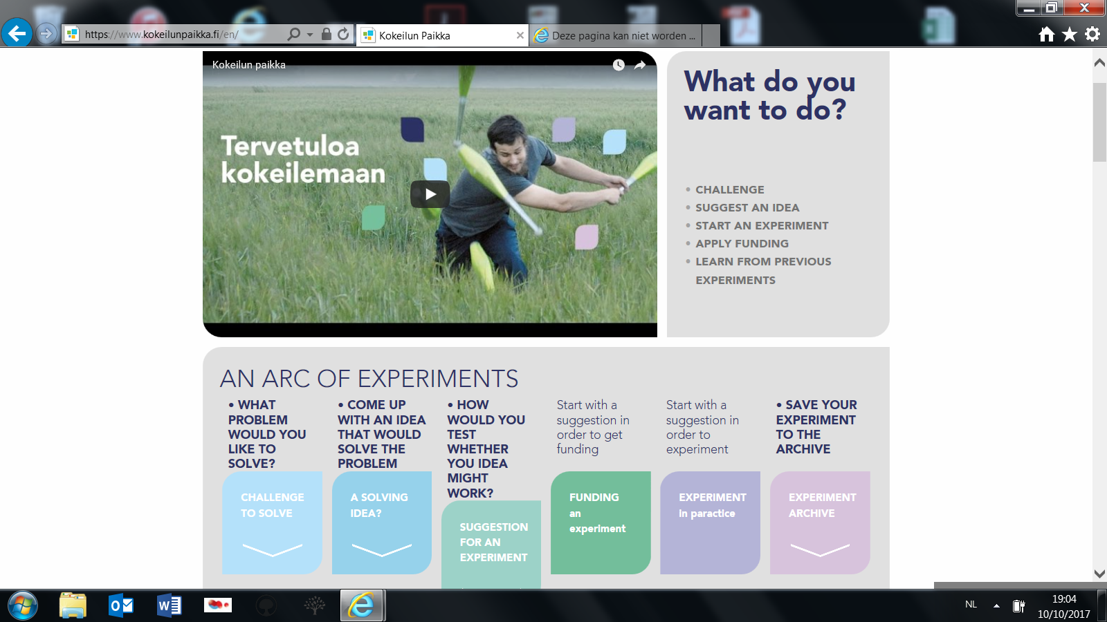

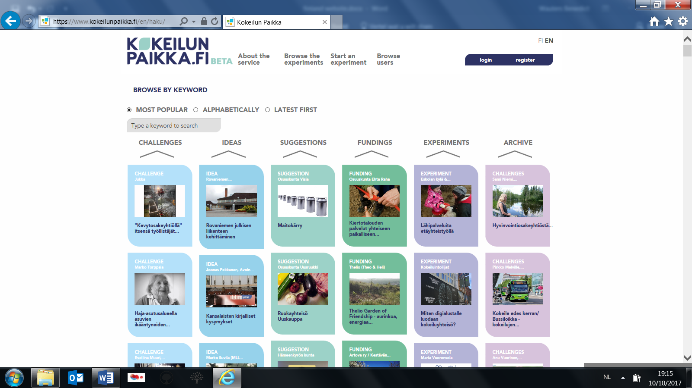
Place to Experiment, created with funding from the Government’s key project ‘Public services will be digitalised”, is a digital platform that is intended to help take ideas into concrete experiments. It should bring together people who have ideas, people who want to try out new things or spar others or provide funding and people who are end-users. Users of the platform can therefore share a challenge, idea, make a proposal for an experiment, collect feedback and move on to actual testing with the support suitable companions. Also, it is possible to reach out to crowdfunding or apply for thematic funding via the platform. For example, a first crowdfunding campaign focusses on circular economy, new work and artificial intelligence and there will be future campaigns for new kinds of local services and new ways of using public facilities. Findings and lessons learnt can be shared on the platform. It is also possible to comment on others’ ideas, reply to a challenge,… The platform should in this way facilitate co-creation across municipal and sector boundaries and makes experiments and funding more communal and transparent. It also brings together scattered information and finds a wider audience for good solutions. In May 2017, shortly after being launched formally (after a BETA testing phase), over 250 users had registered and some 60 experiments were already blooming in their different stages..
Kekkonen (2017) sums up the approach in the figure below.

Figure 5: experimental culture
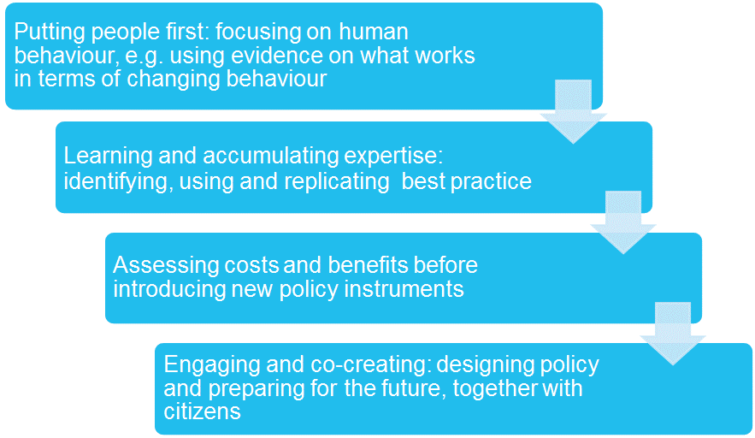
In conclusion, what is next for Finland? Kekkonen (2017) states that the challenge is now to preserve the Government Strategy Process as a whole:
- There is a risk of separation of political (strategic) and budget processes and new policy processes being established that live a life of their own;
- There is a risk of key projects becoming siloed due partly to deviations from OHRA (2014) e.g.:
  - some of the key projects contain elements that look new but that still were just a continuation of business as usual;
  - some of the elements of key projects are financed by the regular budget, rather than the 1 billion strategic budget.
In addition, the question is how to extend the political interest to the implementation of policies and their results which requires:
- ”Prioritizing the priorities” – must win policies
- Safeguarding / clarifying the role and resources of the Government Strategy secretariat
- Innovating new ways for the horizontal policy making and coordination
- Ensuring foresight work finds its way into Government strategy sessions.

Source: http://valtioneuvosto.fi/en/ohra-project
OHRA project group, 2014, From decisions to changes : reforming the Government’s Steering framework -report and recommendations of the OHRA projects
Kekkonen, 2017, Presentation on Strategic Policymaking – new working methods of the Finnish Government, Public Administration and Governance network, Prague, 24.3.2017
Permanent Secretaries are in Finland the highest ranking civil servants.
http://vnk.fi/en/government-report-on-the-future
https://www.eduskunta.fi/EN/lakiensaataminen/valiokunnat/tulevaisuusvaliokunta/Pages/default.aspx
http://vnk.fi/en/government-report-on-the-future
PMO (2014), Cooperative and continuous foresight : a proposal for a national foresight approach. PMO Finland.
Source: http://valtioneuvosto.fi/en/ohra-project
Source : correspondence with Kekkonen in November, 2011, head of the strategy unit in the Finnish Prime Minister’s Office.
Source: http://valtioneuvosto.fi/en/sipila/government-programme
Source: http://valtioneuvosto.fi/en/implementation-of-the-government-programme/information
Source: http://valtioneuvosto.fi/en/implementation-of-the-government-programme
Source: http://valtioneuvosto.fi/en/implementation-of-the-government-programme/information
Source: http://valtioneuvosto.fi/en/implementation-of-the-government-programme/information
Source: http://valtioneuvosto.fi/en/sipila/ministerial-working-groups
http://vnk.fi/en/foresight and www.foresight.fi
http://tietokayttoon.fi/en/putting-knowledge-to-use
http://tietokayttoon.fi/government-working-group-for-the-coordination-of-research-foresight-and-assessment-activities
http://tietokayttoon.fi/en/government-working-group-for-the-coordination-of-research-foresight-and-assessment-activities
http://www.aka.fi/en/strategic-research-funding/src-in-brief/
Systems approaches to public sector challenges: working with change. OECD.
A draft version of the report was already presented for discussions by Permanent Secretaries in mid march 2015, with the PMO strategy unit already tasked to develop relevant materials for the new Government Programme, while Demos was finalizing the report up until July 2015.
Annala et al , 2015, Design for Government: human-centric governance through experiments. DEMOS Helsinki.
http://kokeilevasuomi.fi/en/contact-us
http://kokeilevasuomi.fi/en/article/-/asset_publisher/10616/suomesta-kokeilukulttuurin-kansainvalinen-edellakavija-kokeileva-kehittaminen-avuksi-kuntakentan-suureen-muutokseen
http://kokeilevasuomi.fi/en/strategic-policy-trials
http://kokeilevasuomi.fi/en/article/-/asset_publisher/10616/suomesta-kokeilukulttuurin-kansainvalinen-edellakavija-kokeileva-kehittaminen-avuksi-kuntakentan-suureen-muutokseen
https://www.kokeilunpaikka.fi/en/post/175/this-is-place-to-experiment/ and http://kokeilevasuomi.fi/en/article/-/asset_publisher/10616/kokeilunpaikka-fi-on-alusta-yhdessa-tekemiselle-ja-kokeilujen-rahoitukselle

