# Transitions in Flanders

# Description of the system

The case description is taken from Wauters (2015)[1], updated with information after the date of publication.

# Moving towards a transition process (pre- 2002- June 2006)

Inspired by the Dutch transition management policy (Ministerie van Volkshuisvesting, Ruimtelijke Ordening en Milieu, 2001, Nationaal milieubeleidsplan 4), the Flemish Government decided in 2004 to start experimenting in its environmental policy with transition management (see chapter above on “shaping ecosystems of actors”). It was decided that the expertise of Prof Jan Rotmans and his team would be hired to give transition management a start in Flanders. This means that the approach to transition management that is tried out in Flanders employs a so-called transition arena with niche-players and forward thinking regime players to develop a common problem structuring of the system under discussion, and then moves on to develop a transition agenda. The transition agenda contains a future vision for the system, transition paths towards that vision, and a series of experiments to test and initiate the paths in reality.

In Flanders, the first transition process to adopt this approach was initiated in October 2004 in the area of sustainable housing and building (DuWoBo), and Dutch researchers were directly involved in this process. This process was initiated by the environmental administration LNE (at the time called Aminal). The second process, that we will elaborate further in this case study, regarding sustainable materials management (called Plan C), followed the same transition management approach, and started in June 2006, but without Dutch involvement. The process was initiated by the Flemish waste agency OVAM. Plan “C” refers to the idea that a Plan “B” would not be sufficiently radical in terms of innovation.

In the case of Plan C, there were two problems that demanded attention. First, since the turn of the century there was an ongoing discussion within OVAM about the long term orientation for waste policy, in particular the further development of the waste hierarchy and prevention policies. At the beginning of the 21st century, Flanders had succeeded in creating a well-performing waste system and it was (and still is) considered top of the European class in selective collection and recycling. However, the fact that the total amount of household waste remained high and that industrial waste was not under control, had led to a realisation at the political level and with several OVAM officials that, in order to further reduce waste amounts, a new step in waste policy was needed.

Second, during the administrative BBB (Beter Bestuurlijk Beheer) reform (inspired by New Public Management) at Flemish level, OVAM had been assigned the task of ‘resource flow management’ This was in fact a manoeuvre from OVAM supported by the Minister of the Environment to keep waste prevention policies in the task description of OVAM (under the disguise of ‘resource flow management’), instead of losing it to the general environmental department LNE (Leefmilieu, Natuur, Energie). Of course, the new description initiated new expectations and it was unclear what the contents of the new field were to be, how it should be organised and what its relation was with existing waste policies. In the follow-up discussions, OVAM started interpreting the new task as ‘materials policy’ and as a possible translation for its long-term policy. But still, the contents of the new field remained unclear.

During the preparation of MINA 3, the Environmental and Nature Policy plan for 2003 to 2007, transition management had surfaced in several studies (and in the advice of the advisory councils SERV (advice 10 June 2002) and MINA-raad (advice 4 July 2002) as a potential solution for the problems of long-term sustainable development policy and the integration of environmental and innovation policy.

Both SERV and MINA-councils pleaded for radical innovations under the form of long-term system innovations and asked the government to study the possibilities of framing these as transitions and transition management. Between 2002 and 2004, several researchers, civil servants (such as Walter Tempst at OVAM, others at LNE) and policy advisors (such as at SERV) had come in contact with the concepts of transitions and transition management through research reports or in the preparation of policy advice and had started regarding them as promising concepts for policy renewal. In this period, several of them also went to visit Jan Rotmans and his team at ICIS Maastricht to discuss the new concepts. These civil servants and policy advisors actively promoted transition thinking as a policy option by bringing it up during the preparation of policy advice or the preparation of new policy plans (MINA 3 Environmental Year Programme, 2004 & 2005, OVAM Strategic Plan, 2005-2009). Specifically for the case of Plan C, under the impulse of Walter Tempst, OVAM ordered a study from ICIS Maastricht about the potential of transition management for the reorientation of waste policy. The study concluded that a sustainable materials perspective had potential to tackle the existing problems in the waste system and that transition management was a promising concept to initiate renewal of policy. In June 2004, OVAM’s Board of Directors adopted the conclusions of the report and decided to defend them with the new Minister of the Environment.

In fact, the overall mood in environmental policy-making had become more supportive of long-term policy-making and sustainable development after green Ministers entered the Flemish Government in 1999. Even after the Greens lost the election in June 2004 and the Christian Democrats took over the policy domain, the support for transition management remained, as the new minister Peeters introduced it in his Policy Note 2004-2009 (published in December 2004) as an experiment in policy. Its very last operational goal stipulates that sustainable building and housing will be used as a testing ground for TM in Flanders. The specific wording of these parts of the note is influenced by proposals from the environmental administration and advisory councils SERV and MINA-council. The next year, the minister also approved the start of a transition management process in sustainable materials management via the environmental year programme.

After the OVAM Board of Directors permitted to set up a transition management process, OVAM officials began the preparation in mid 2005 with the selection of two consultancy agencies to coach the process. They first screen potential Flemish participants from government, business, knowledge institutions and NGO’s. Early 2006, two group discussions are organised with potential candidates around the theme “broadening waste policy to materials policy”. The participants that seem most interesting and forward-looking are asked to participate in the first transition arena. There is some contingency in this selection: some people do not find themselves capable enough or they refuse because of lack of time, others are stumbled upon more or less by accident, but in the end a diverse group of fifteen people is composed from government (OVAM, LNE, IWT), business (Agoria, Indaver, Colruyt, Federplast), academia (KU Leuven, UGent), consultants (Sustenuto, Advizors), NGO’s (NBV40, Oxfam), and a representative from the Minister for the Environment. These people have backgrounds in amongst other things materials, waste, chemicals, environment, consumer affairs, distribution and innovation. The group can be said to consist almost entirely of forward looking regime players.

They are asked to participate as individuals and not as representatives of their organisations, but it is obvious from the group’s composition that it also respects certain equilibriums between stakeholder groups. In addition, a preliminary system analysis is prepared by the consultants, drawing on a previous study delivered by Dutch transition researchers.

In June 2006, the arena is officially installed. The representative of the Minister of the Environment and the Administrator-General of OVAM address the participants and urge them to develop a long term transition vision for sustainable materials management that can also be translated in short-term actions. In explicit references to the rules of the game of transition management, the representative of the Minister tells participants that they are not chosen for their representativeness but for their ideas, and that they are provided space and time to deliver good work, away from the pressure of short time tangible results.

In terms of resources, the yearly budget of Plan C was then estimated at 250 000 EUR, to pay for consultants, staff of OVAM (+/- 60 000 EUR) and other administrations (+/ 25 000 EUR).

The figure below provides the overview of what happened since 2002.

Figure 39: three streams and policy windows in the Flemish transition track



It uses the framework provided by Kingdon (2011) earlier. As made clear earlier, it distinguishes between three “streams” of influence in shaping policy:

* the problem stream (in red);
* the policy stream (in green);
* the political stream (orange).

The blue boxes depict “policy windows”.

# Transition arena: defining urgent and persistent issues and formulating a vision (September 2006- January 2007)

In September 2006, the transition arena meets for the first working meeting. Karel Van Acker (materials scientist from KU Leuven) and Paul De Bruycker (industrial waste group Indaver) are chosen as presidents. OVAM has also reserved a limited budget for two experts in groups dynamics and multi-party collaboration (prof. Tharsi Taillieu, Marc Craps) to follow the process, draw lessons and when needed give advice on how to conduct the process.

The management and coaching of the process is done by a transition secretariat made up of the consultants, the OVAM project leader, the process experts and one of the presidents (Van Acker). Except for the president, these people try to stay clear from substantive discussions during the arena meetings, so as not to mix different roles.

The systems analysis is thoroughly discussed during this first two meetings. Problems identified include the environmental consequences of current production and consumption patterns, growing scarcity of resources and materials, social effects of these patterns, unequal North-South distribution, and the current culture of consumer spending. These trends undermine welfare worldwide and necessitate the search for radical changes in the system of material use and management.

Then in the subsequent 3 meetings the group moves on to the formulation of a future vision of sustainable material use, selecting key themes on which to focus in Flanders, defining solutions and identifying levers for change. The full 6 page vision in Dutch that was finished in January 2007 can be found in annex 1 of this publication.

The vision sketches an image of how the Flemish society should ideally deal with resources and materials. Society will handle resources, materials and energy responsibly and with care, and resources and materials will be regarded as common goods. Materials are managed and controlled over the whole of the life cycle in cooperating networks or clusters of producers, processing companies and consumers. The materials system will function as a subsystem of a service economy: people do no longer measure their happiness on the basis of the property of material products, but on access to services that are embedded in the social and natural environment. Flanders is a trend setter in material management, with a high level of knowledge about wise material use and the development of new materials and services. These developments also offer new opportunities for the Flemish economy as the cradle of sustainable material management.

The central storyline around which the participants unite in this picture of the future is therefore one of a high-grade closing of the material loops: we will not use less material products, but the new resources needed have to decrease drastically.

The vision is made more concrete by defining five themes for change:

* Smart Closing of Cycles: materials are managed as common property. Closing of circles becomes possible thanks to intelligent infrastructures which facilitate material flows;
* Tailor-made Materials: access to materials is guaranteed, but this is only possible when materials and products are drastically renewed (made from renewables, multifunctional and flexible in usage, easy to disassemble and to reuse or recycle, intelligent materials);
* At Your Service: people do not measure quality of life on the basis of property, but on the basis of access to services. A service economy develops with completely new type of companies. New functions and services are integrated in products.
* Alert Public: consumers take on responsibility for their consumption choices and take conscious and informed decisions. They evolve from unconcerned choosing towards conscious caring;
* Green Synthetics: an important Flemish industrial sector which makes use of new opportunities to become market leader in sustainable synthetics.

The group then works at bringing in more people for the next phase, by drawing on their networks.

# Transition arena: working out transition pathways with a broader group (May 2007-May 2008)

In May 2007, about 60 persons meet in Leuven, where the new members are introduced to the work already done and invited to participate in one of the five themes. The working groups are mostly headed by people from the original group. Their task is to flesh out transition pathways for their themes. This requires describing a desired future and detailing the necessary steps to reach it.

Coordination and management is now done by a task force, which merges most of the members of the original arena with the presidents of the working groups in order to make it easier to watch over the process and guard the coherence between the original vision and the work of the working groups.

It produces a mission statement in the spring of 2008: within 5 years, by 2013, the network should be the reference in Flanders for sustainable material management, with a portfolio of 20 talked-about transition experiments, of which at least half have been initiated by private actors. By then, Plan C will have created societal awareness for a materials transition, realised some institutional changes that support self-organisation of the process and become an esteemed partner in European and international networks.

The working groups meet on a regular basis. During a meeting in October 2007, they present their work to each other for the first time. By May 2008, they have completed their task in formulating pathways for each theme and in identifying in total 33 possible experiments linked to these pathways.

During a new collective meeting, they present their work again to each other. Everyone receives a “reference document” containing the systems analysis, the vision, the mission, the pathways and the experiments. The administrator-general of OVAM declares that Plan C will receive further support until half 2009, but that other parties should also start chipping in to help sustain Plan C as an independent network of excellence.

An example of pathways is provided below for the theme Alert community (excerpts).

Box 1: “alert community”

*“In current Western thinking economic growth is often the most important criterion. But this cycle of ‘production for production’s sake’ and ‘consumption for consumption’s sake’ is unsustainable. Support for this way of thinking in our society is coming to an end. An important challenge is to break through habitual behaviour. Sustainable, co-determining consumers play an increasing part within the whole production and consumption chain – also in material management. They feel jointly responsible for caring for the community.*

*An Alert Community is an alert, informed, caring and respectful community that shows great readiness to act. Things may and can be called into question and there is readiness to make changes. It is a community that looks out for the collective needs, interests and problems and develops towards a positive attitude and really positive behaviour with respect to the big ecological challenges.*

*An Alert Community considers, chooses and acts from conviction – not from guilt or a narcissistic concern for itself – and is always aware of the limitations of people, society and the earth. It is a community that cares for each of its members.*

*An Alert Community succeeds in bringing about a renewed stewardship for the earth, a circular economy with real opportunities of minimising our impact on the environment. In addition to thinking in terms of efficiency, sufficiency – “enough” – has an important place in this society with alert citizens.*

*Who must be made alert and how?*

* *Politicians: they must create the framework for sustainable materials management; change takes place via regulations and policy.*
* *Business people: they must make sustainable materials management possible from the supply side; change takes place via businesses with corporate social responsibility*
* *Citizens / consumers: they must make sustainable materials management possible from the demand side as a consumer (with the purse) or as a citizen (with the vote); change takes place by sustainably consuming citizens.*

*This leads us to two transition paths that are not fully independent of one another: corporate social responsibility and sustainable consumption. In the first transition path a sustainable materials management is achieved because the citizen as consumer has taken a step towards sustainability. In the first phase a critical percentage of the population (10-15%) takes the step towards sustainability. As a result sufficient energy is created to mainstream this behaviour. The target public are the pioneers, the cultural creatives. There is a commitment to new or existing experiments and innovations that already partly reach this public. This mainly comes down to linking the experiments together so that the consumer is approached in a more integrated way. Successive series of experiments gradually become increasingly ambitious (from low hanging fruit to radical changes). At the same time via education the corporate consciousness of sustainability is increased. When the majority of this section of the public have taken the step towards sustainability, this behaviour can be mainstreamed by imitation or policy.*

*In the second phase a sustainable materials management is achieved because the general public takes steps towards sustainability. The target public is the general public. The experiments from the first phase are built on further. The wider culture is already focused on sustainable materials management.*

*The challenge now consists of encouraging individuals to sustainable behaviour. New experiments now reach a wider public that is made alert by education and via exemplary roles. They appeal to the consumer as an individual.*

*To sum up this leads to the following milestones:*

* *2010 First generation of integrated experiments carried out*
* *2010 Both internal and external dimensions of sustainability are embedded in the education plans*
* *2015 Critical mass of cultural creatives closes the attitude-behaviour gap*
* *2020 Second generation of experiments carried out*
* *2025 General public consumes sustainably*

*In the second transition path a sustainable materials management is achieved because the business community has taken the step towards sustainability. Here too we distinguish two phases. First we work with these pioneering businesses on experiments and innovations. Because they gain a competitive advantage (more profit and/or better image), other businesses will in the meantime imitate this or the policy can mainstream the new behaviour via regulations. At the same time via different channels the corporate consciousness regarding sustainability is increased.*

*In the second phase a sustainable materials management is achieved because all the companies take steps towards sustainability. This builds further on the experiments from the first phase. New experiments now reach the whole business community that is made alert by communication and via exemplary roles.*

*To sum up this leads to the following milestones:*

* *2010 First generation of integrated experiments carried out*
* *2010 Both internal and external dimensions of sustainability are communicated to the business community*
* *2015 Critical mass of businesses is sustainable*
* *2020 Second generation of experiments carried out*
* *2025 All companies produce sustainably”*

The texts in Dutch for the four other themes of the overall vision are presented in annex 2.

# Agenda setting and experimentation (May 2008- 2014)

In October 2008, Plan C goes public and presents its work to an audience of 120 participants from different sectors. People and organisations are connected and new ideas for experiments collected.

However, “entrepreneurs” who can actually get some of the experiments started are hard to find. Participation of companies is rather low.

The task force also works on a business plan for sustaining the network. In this plan, Plan C is put forward as a platform for radical renewal, that also will work towards cooperation and consultation with existing funding channels. Plan C is not itself a financing mechanism for experiments. However, the label “Plan C experiment” should become recognized as a value added in appraisals for funding by others. In January 2009, the administrator-general of OVAM announces that Plan C will start work on becoming autonomous, that there will be a new consultant appointed and that there will be a provisional structure in the mean time. The provisional structure replaces the task force with two complementary bodies: the Strategic committee for organisational development, in charge of making Plan C autonomous, and the Strategic committee for substantive coordination, in charge of realizing the vision via experiments. The new consultant will support both of these bodies.

The start of this new structure leads to some of the original actors dropping out, while also a few new ones come in. However, no business representatives remain. The consultants now take on most of the work, a marked difference with the earlier phases of Plan C. For example, they develop a method to bring ideas to the level of feasible experiments. The hardest part is however to assemble all the resources and make sure pre-conditions are fulfilled for an experiment to get started. From 2009 to 2011, four experiments are coached, out of which two are finally proposed for funding to the MIP3-programme by consortia. Only one is approved.

Plan C, using European Regional Fund financing, also sets up various multi-stakeholder platforms around specific themes (e.g. re-use of wood-waste, tailor-made local production and consumption, internet of things, sustainable materials management) to create new ideas for experiments. Plan C is recognized as being good at bringing people around the table and developing ideas. However, the basic problem remains that funding sources for taking these further are not under Plan C’s control, which discourages entrepreneurs to engage.

By the spring of 2011, the Minister of Environment proposes the theme of “sustainable materials management” as the flagship initiative for the policy domain in the “Vlaanderen In Actie” (Flanders in Action) programme, which was launched by the prime minister to put Flanders in the top 5 of regions within Europe by 2020.

This then resulted in a round table conference where government, industry, knowledge centres and other stakeholders discuss the matter. There, Plan C presents “I-made”, a project intending to turn Flanders into the first experimental garden worldwide of local custom-made production, using 3D-printing and rapid manufacturing. Hence it is clearly part of the transition pathway “tailor-made materials” defined in the previous phase of Plan C where “route c” consisted of “more attention for local (and smaller scale) production.

Plan C then managed to secure funding for I-made as a two year project and hence it became active as of the Spring of 2012. This project was also the first to be operated by the newly (March 2012) established autonomous non-profit organization Plan C vzw (see annex 3 for its statutes). The road towards becoming such a “vzw” (non-profit) was not an easy one, with ongoing disagreements concerning the legal form and sources of funding, attested by the fact that it took more than 3 years to make it happen (since the request mentioned above by the administrator-general of OVAM in 2009 that Plan C become autonomous).

The Materials Decree of 24 June 2011 established in its chapter 6 an informal cooperation, between OVAM, the departments EWI (economy, science and innovation) and DAR, and VITO (Flemish institute for technological research), with OVAM taking the presidency of the new cooperation; other government agencies can later be included. The cooperation has three tasks: operational support for Plan C (but in principle also other organisations with a similar goal can be supported), stimulating information exchange and cooperation between government agencies with similar goals, and participating in projects where the expertise of OVAM and the other agencies can be useful). However, only when OVAM finally decided in December 2011 to found the “vzw” and to guarantee funding for it, regardless of who joins in, was the momentum created to get a diversity of other partners to join in setting up the “vzw” in March 2012. Since 2011, additional means of 80 000 EUR are provided via the Flemish Administration of general government services (Diensten Algemeen Regeringsbeleid, DAR).

In 2014, Plan C published the lessons learnt from I-made (see annex 4). The publication describes the experiments that were conducted with two lead partners: TP Vision and Helbig. For example, the experiment conducted with TP Vision consisted trying out how television (components) could be produced quicker, more flexibly and with great design freedom as well as made more sustainable in terms of materials use. The experiment consisted of an exploration of technology, a life cycle analysis of old versus new production methods, technical and cost impact analysis, business model development and innovation and finally design and proof of concept using rapid manufacturing technology. Valuable lessons were learned which are cited in the report. The same applies to the other experiment with Helbig, concerning the fashion retail environment of the future. This project first developed four strategic scenarios of the future to get a better sense of different possible futures. Next a service design project (with design agency Pars Pro Toto) to develop the “shop of the future” was undertaken. Next, possibly useful technologies were explored. Finally, an environmental impact analysis of the fashion retail sector was made. Interestingly, also other related initiatives, not under the control of Plan C are discussed in the report. This shows the Plan C may have recognized that other initiatives can also support the vision, even if they did not originate in the Plan C process.

In 2014, Plan C was offering various services ranging from coaching businesses in their challenges of becoming more circular in terms of material use, delivering workshops and lectures on the topic as well as being partners in projects. In 2014 it employed 5 full time staff members and has an annual budget of +/- 410 000 EUR, financed for 5% by own revenues from events, lectures, sponsors), 65% structural funding (+/- 250 000 EUR) and 25% from projects (see annex 5 for the 2014 annual report).

The idea is that OVAM takes the overall lead in developing the materials system, with a focus on the short and medium term, while Plan C gets the task of long term development and engaging in experiments that are a translation of its vision. A new policy research centre on sustainable materials, called SuMMa, which is headed by the president of Plan C, should support both.

# Evaluation of the case

While the case study shows how Plan C over a period of about 8 eight years evolved, the question is how to evaluate this? Clearly, such “projects” that aim at very long term visions cannot be evaluated simply by assessing if they made that vision happen. However, it is possible to ascertain the “contributions” made by Plan C. The figure below shows what happened after it was decided in 2006 to set up Plan C as a transition platform in its wider context.

Figure 40: events after setting up Plan C until 2011



From the point of view of Plan C, this can be interpreted as a form of anchoring the ideas developed at the level of a policy niche to the regime level, making smart use of passing streams. From the point of view of the regime level, it looks more like a typical example of agenda-setting.

Probably the most important result of Plan C was the discursive renewal it realised in Flanders between 2006 and 2008: it formulated a discourse on sustainable materials management in which waste is part of a broader materials system. Certainly until 2008, Plan C was the main voice in Flanders on sustainable materials management.

Several OVAM policy officers were not only participants in the Plan C process, but were also involved in internal OVAM discussions on the translation of the results and their implications for OVAM’s own policy orientation and organisation. Parallel to the Plan C process, OVAM installed an internal learning forum during 2007-2008, called The fifth floor, where the new developments and the results of Plan C were discussed and where the insight grew that materials management should not be regarded as a third policy line (along with waste and soil management as stated in the strategic plan of OVAM for 2005- 2009) but that the waste system should be regarded as part of a ‘higher’ system, the materials system.

A crucial breakthrough was the realisation within OVAM that this line of thinking implied that the obligation, coming from the EU-level, to translate the Waste Framework Directive (2008/98/EC) into new Flemish legislation, should not simply lead to a new Waste Decree, but that the new Decree should somehow reflect the materials storyline. In fact, the EU Directive’s main aim is to strengthen the waste

hierarchy in the waste policies of the EU member states and to reduce the discrepancies in waste policies between member states. But inspired by the experiences with Plan C and by similar discourses at EU and OECD level, OVAM proposed to the Flemish Minister of the Environment to translate the Directive into a Materials Decree instead of into a new Waste Decree, in that way going several steps further than the EU required (and then the ambitions of most EU member states). The minister, guided by advisors that had an OVAM history and who had closely followed the Plan C process during the first years, was positive and during the negotiations for the new Flemish Government in 2009, succeeded in inserting the idea into the Governmental Declaration.

The shift from waste to materials policy had now reached the governmental agenda, but it took two more years to rise on the decision agenda. Different opportunities arose and different streams could be coupled that strengthened the adoption of the materials discourse and anchored it further at political and administrative level.

One evolution is situated in the problem stream, where in the course of 2009 and 2010 we see a fast rising awareness of the urgency of addressing the resources and materials problem. This can be labelled as landscape pressures, such as the rising demand for resources worldwide (e.g. from China), the import dependency of EU-countries, and the rising prices of resources as well as growing interference between systems of materials, energy, food and water (e.g. renewable biomass energy policies may hinder development of a bio-based materials economy or impact on food security). Apart from OVAM itself and Plan C, important new players in the Flemish materials system such as the sector federations Agoria (technology industry) and Essenscia (chemical industry) actively drew attention to these problems and demanded government action. Also EU initiatives such as the Raw Materials Initiative (EC, 2008), which grew out of anxiety over the availability of resources for the European economy, increased the awareness for the problem.

Another element, part of the political stream, was the preparation and development of the new Strategic Plan 2010-2014 for OVAM. Under coordination of OVAM’s strategic team, a broad consultation process with stakeholders was set up. This process deepened the understanding of a sustainable materials orientation within OVAM. In the strategic plan, waste and materials are no longer regarded as separate policy lines – as was the case in the previous Strategic Plan 2005-2009 – but waste policy has become part of sustainable materials policy. The new plan was accompanied by an internal reorganisation of OVAM, meant to prepare the organisation for its role in the future materials economy.

Since 2010, the former department waste management has been reformed into the department waste and materials management. While the old department was organised around seven specific waste flows (such as organic waste, household waste etc.), the new department is organised around two chain services (“chain management and companies” and “chain management and local government”) and a policy innovation service. Within each chain service, specific teams are created that have the ambition to do the follow-up of a whole production and consumption chain, such as a team chemistry and a team biomass that try to cover the chemical and biomass cycle respectively. The objective of the policy innovation service is to evaluate the policy instruments OVAM currently employs and to formulate ideas for innovating instruments in such a way that they contribute to the waste-materials shift.

It is interesting to note that the head of the new policy innovation service has played an important role in Plan C (he was amongst others the OVAM member of the first arena in 2006). OVAM officials also recognise the influence of Plan C in the reorganization of OVAM.

A further opportunity was the Belgian presidency of the EU during the second half of 2010. Because Belgium is a federal state, the preparation of a task such as a European presidency requires a lot of coordination between the federal and the regional level. During the preparation process, the presidency of each EU policy domain is divided between ministers of the different Belgian policy levels. In this way, the Flemish Minister for the Environment became responsible for the presidency of the EU Environment Council. It is a tradition at European level that each presidency formulates several own priorities, so during the preparations for the environmental presidency at Flemish level, OVAM proposed materials policy as one of the priorities. Because materials policy was already politically relevant with its introduction in the governmental agreement and because of OVAM’s good reputation for its European policy work – with a first-hour member of Plan C’s transition arena as head of OVAM’s EU division – the ministerial cabinet was in favour of the idea and formulated ‘sustainable materials management’ as one of the environmental spearheads for its Belgian presidency. In July 2010 an informal Environmental Council in Ghent was devoted to sustainable materials management, which gave the minister an opportunity to present herself nationally and internationally with the theme. During the formal EU Environment Council in December 2010, she succeeded in introducing language that links the EU 2020 Strategy and its flagship initiative on resource efficiency to ‘system innovation’ and ‘the creation of a multi-actor transition platform on resource efficiency’. Furthermore, exactly during the presidency, OVAM organised and hosted a high-profile OECD workshop on sustainable materials management. The result and visibility during the EU presidency together with the OECD workshop, contributed to a political confidence in the potential of the materials storyline.

Early 2011, the minister proposed sustainable materials management as her flagship for the socioeconomic programme Flanders in Action (ViA), in that way positioning materials as an essential part of the transformation and innovation of the Flemish economy. This resulted at 6 June 2011 in a Round Table on Sustainable Materials Management where industry, knowledge centres and other societal partners signed a Declaration in which they engaged themselves to work towards a Materials Pact and an operational plan on sustainable materials. By the time the Materials Decree was approved by the government on 24 June 2011, the combination of all these streams had laid a solid political and administrative foundation for the new orientation.

Furthermore, the whole process and the different evolutions had also led to active involvement of all important stakeholders. There do not seem to be any major voices that oppose the shift from a waste to a materials orientation. What is moreover noticeable, is that most of these actors cannot be categorized as small players or niche actors. The regime actors themselves, often larger companies active in private waste management, are trying to reposition themselves from “handlers of waste” to “suppliers of materials and fuels from secondary processes”; the traditional technology and chemical industry (as represented by Agoria and Essencia) want to reposition themselves as partners in more sustainable, closed-loop economy (with Agoria’s director having been part of the original Plan C arena and Essencia involved in Plan C’s Green Synthetics pathway, which sparked the FISCH initiate – Flanders Strategic Initiative for Sustainable Chemistry); universities and knowledge centres are presenting themselves as pioneers and partners in knowledge development for materials. An example is VITO (which has a unit for “Transition, energy and the environment”) which also launched in 2010 Cleantech Vlaanderen vzw to coordinate all initiatives in the Flemish clean technology industry.

This dynamic is confirmed by the support provided since 2012 of Agenda 2020 (within the Vlaams Materialenprogramma - Flemish Materials Programme) as a collaborative programme between government, industry, science and civil society, coordinated by OVAM.

# The story continues (2014-2017)

In 2015, Plan C launched “Reburg” (<http://www.reburg.world/> ), an interactive website that demonstrates what life would look like in a circular economy. It can effectively be understood as an update of the old, paper-based vision.

Figure 41: Reburg frontpage[2]

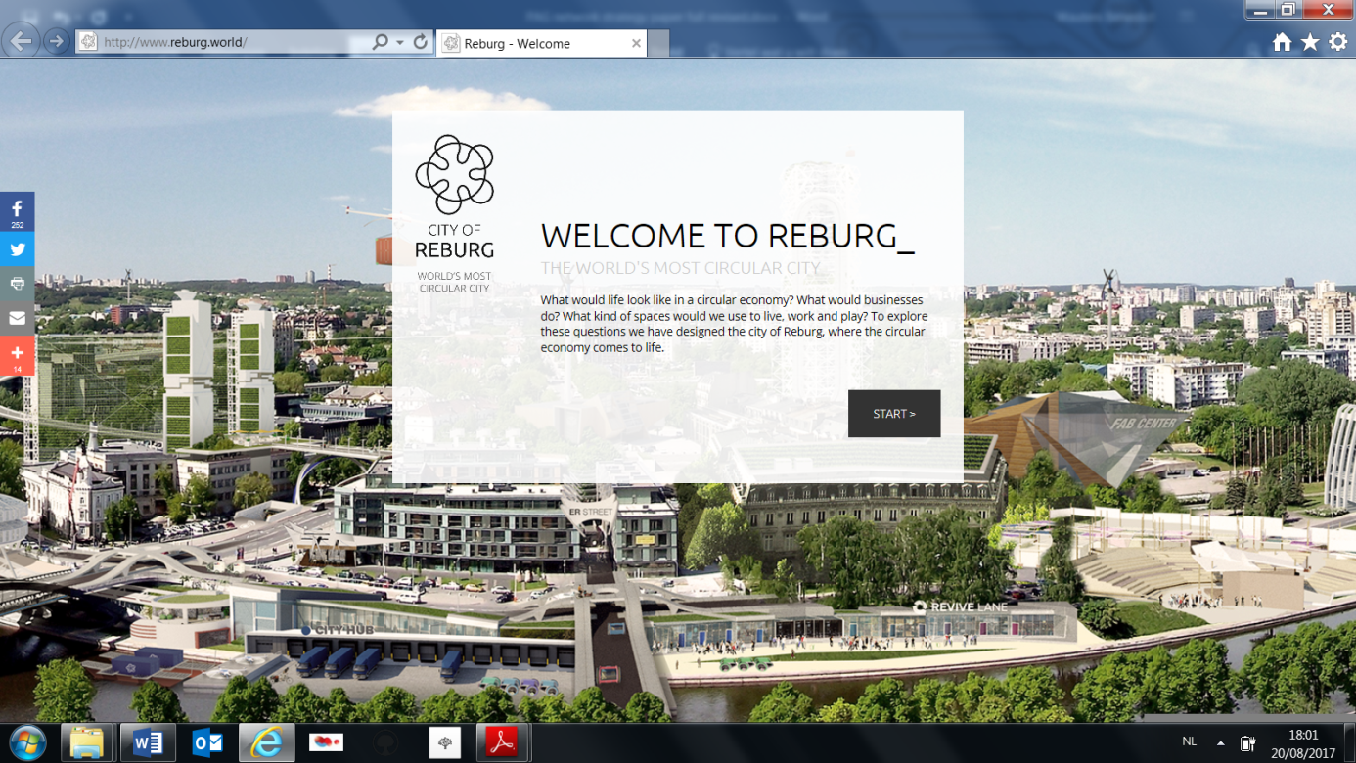

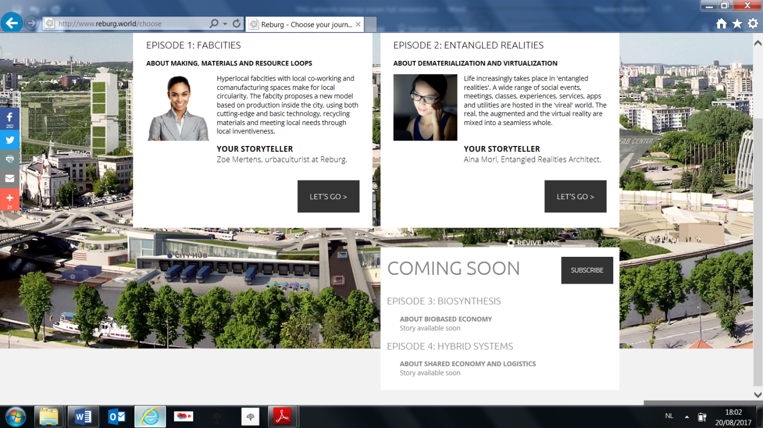

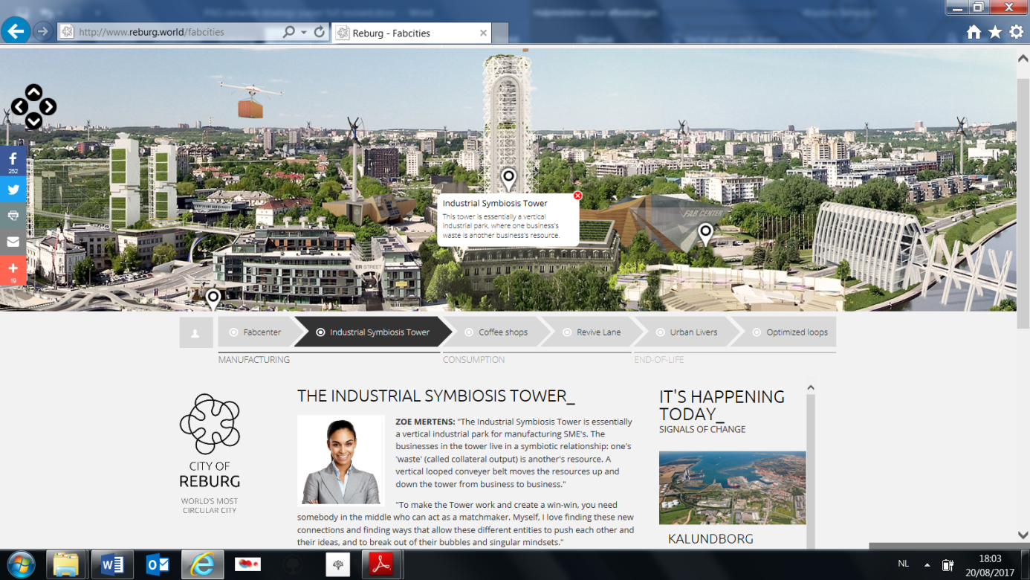

As its 2015 annual report (annex 6) shows, Plan C continued to work on various other projects, with a range of partners.

In 2016, the Flemish government agreed a government wide “vision 2050”, effectively adopting the transition approach to shape its long term strategy processes at government level. It consists of seven transition priorities, one of which is a transition to a circular economy (see annex 7). Plan C again ran several projects (see annual report of 2016, annex 8).

Finally, another major development occurred in 2016. It was decided that as of 2017, Plan C would merge with the other pillars (Agenda 2020 and Summa) of the Flemish Materials Programme and be integrated into OVAM.

# Reflections

1. Toolkit for supporting social innovation with European Social and Investement Funds. ESF Agency Flanders.
2. Accessed 20/8/2017