Strategic management in the public sector

A CHALLENGE PAPER FOR DISCUSSION

Benedict Wauters

Report to the European Commission’s

Public Administration and Governance network

September 2017

Content

Introduction 5

PART I: Exploring the concepts 7

1. Defining strategy, strategic planning and strategic management 7

a. Strategy 7

b. Strategic planning and management 12

c. A model for strategy making in the public sector? 18

i. Bryson’s model 18

ii. Mulgan’s model 27

iii. Strategic agility 36

iv. Merging three models? 40

d. Reflections 43

2. Emerging themes from the literature 46

a. Entrepreneurial thinking aiming to transform core, value generating processes 46

i. Literature review 46

ii. Reflections 59

b. Engagement that cuts across levels and boundaries to produce coherent action 64

i. Literature review 64

ii. Reflections 81

c. A continuous, non-linear process of learning, thinking and acting, guided by a longer term perspective 83

i. Literature review 83

ii. Reflections 94

d. Shaping ecosystems of actors 95

i. Literature review 95

ii. Reflection 102

e. Conclusions 103

Part II: Public versus private sector characteristics 118

1. Public versus private value 118

2. The nature of the policy-making process 125

3. Empirical research on differences 131

4. Reflections 134

PART III: Strategic management in the public sector? 137

PART IV: Cases 138

PART V: Conclusion 139

# Introduction

According to Poister and Streib (1999, p.310), “Strategic planning has gained widespread currency in government. Agency managers now view it as a valuable tool for charting future directions in changing and sometimes turbulent environments”.

Poister (2010) also states that, while still unheard of in the US in 1980, strategic planning is now ubiquitous[1]. However, Poister (2010) states that criticism abounds. For example, he states that the General Accounting Office found in an evaluation covering 2004-5 that federal managers “had difficulty establishing outcome oriented goals, addressing issues that cut across federal agencies, adequately soliciting or incorporating consultation from external stakeholders,…relating annual goals to long-term goals, and identifying…resources needed…” (p. 247).

At the same time, “We still know little empirically about how public sector organisations use strategic thinking in practice” (Johnsen, 2015, p. 244[2]).

In addition, Troupin and Pollit (2012)[3] state that, while there are many books dealing with corporate strategy, only few deal with strategy making in central government. They refer to three key sources, notably Joyce (1999[4]), Bryson(2011[5]), and Mulgan (2009[6]). The two most recent of these three references will be used in this report to provide useful reference points.

Given the relative scarcity of both empirical and conceptual coverage of the topic, the report will **elaborate concepts rather than provide a thorough empirical assessment** of what strategic management processes actually exist in the public sector. It also does not aim to be comprehensive nor to provide a template. Its goal is only to **broaden and stimulate the discussion regarding a fruitful application of strategic management in the public sector.**

In order to accomplish this, the report will in a first part, based on an extensive review (covering both authors who focus on the public as well as other sectors) of literature since the 90’ies, explore what are the key concepts and how they can be related to each other.

In a second part, the specificity of the public sector as compared to private sector will be explored, again on the basis of a literature review.

A third part will the reflect on whether and in what way, the concepts explored in the first part can be applied in the public sector.

A final part will consist of a selection of case studies that serve to check to what extent the suggestions are already being enacted in practice or could be integrated in the future.

It should be clear that the reflections included in this report represent only the author’s views rather than any official position. The hope is that these reflections stimulate the reader to come up with reflections of his/her own and to engage in fruitful discussions with others.

# PART I: Exploring the concepts

# Defining strategy, strategic planning and strategic management

# Strategy

The business dictionary[7] defines “strategy”, the presumed output of strategic planning, as:

“1.A method or plan chosen to bring about a desired future, such as achievement of a goal or solution to a problem.

2.The art and science of planning and marshalling resources for their most efficient and effective use.”

Tactics are defined as “Means by which a strategy is carried out; planned and ad hoc activities meant to deal with the demands of the moment, and to move from one milestone to other in pursuit of the overall goal(s).”

Mulgan (2009, p.19) likewise defines **public** strategy as “the systematic use of public resources and power, by public agencies, to achieve public goals”. It can concern (p. 21) the high strategy of geopolitics (building alliances, military preparedness, …), strategy at the level of the political economy (e.g. establishing institutions that can negotiate income levels and socials wages) to strategies at the level of public service systems (setting legal and regulatory frameworks, ensuring the right flow of trained staff, or the right sequence of reforms).

Desmidt and Heene (2005, p. 131) attempt to provide more detail concerning the “content” of a strategy via their concept of the strategic logic as depicted in Figure 1.

Figure 1: strategic logic

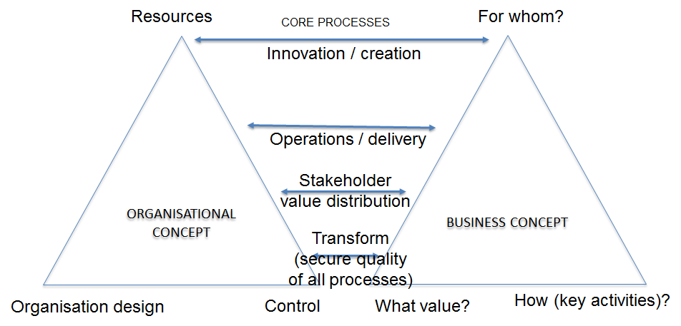

Source: Desmidt and Heene (2005)

The strategic logic starts from a ”business” concept (what value to provide for whom in what way) and then devises an organisational concept that makes explicit what resources will be brought to bear via which organizational design (who will do, know and decide what), with what control mechanisms to realise the business concept. Together, the organizational and business concepts shape the core processes of the organization namely innovation, operations, stakeholder value distribution and transformation. This latter process is a kind of meta-process as it is there to secure occasional deep changes in the other processes. Deep changes imply changes in the strategic logic. The need for deep changes is derived from the “turbulence” in the environment of public sector organisations, as pointed out by Poister and Streib (1999[8]) and Doz and Kosonen (2014[9]).

Desmidt and Heene (2005), drawing on Mintzberg (1987)[10] describe strategy in terms of five “P”’s as depicted below.

Figure : Mintzberg’s five P’s

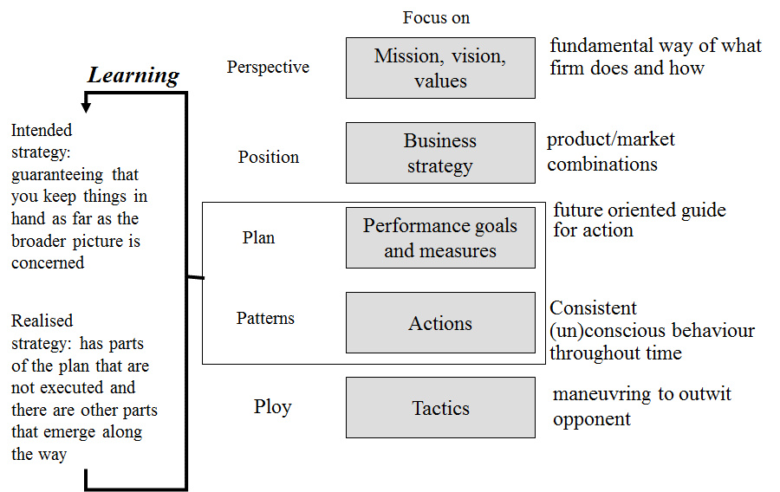

Source: adapted from Mintzberg (1987) and Desmidt and Heene (2005)

“Position” (in terms of product/market combinations) and “perspective” (what the firm fundamentally does and how) correspond clearly with the business concept of Desmidt and Heene (2005). “Plan” (in terms of goals and measures to enable control) are rather part of the organizational concept. “Ploy” (or opportunistic strategy) refers to tactical maneuvering. “Pattern” is what actually happens in terms of consistent behaviour. Deviations from the intended strategy as “plan” as visible in the realised strategy as “pattern” may indicate learning.

However, while the above clarifies the elements a strategy can relate to, it does not really explain any better what a “good” strategy is. To Mulgan (2009, p. 112-3), “good” strategies are those that **align mission and values with architectures and structures**, that deploy **tools and delivery mechanisms** to interact with the public, whose needs and concerns are to be served and taken on board. The more missionary an organization is, the more this will matter. Good leaders try to revitalize the sense of core mission, which can be helped by talking to people at all levels to clarify what they care most about. Structures can then be adjusted (usually involving simplification) as can the tools. In short, to Mulgan (2009) “good” strategy refers to a **business concept and an organizational concept that are aligned to each other as well as to the outside environment**.

However, UCLA management professor Rumelt (2011)[11], who first coined the term “bad” strategy, states states that strategy is neither about ambition, charismatic leadership, vision or planning. **It is about coherent action backed by an argument**. He defines “good” strategy as **concentrating** resources and action on a few **strategic insights and critical issues in a situation and the associated pivot points** that can multiply effectiveness of effort. A good strategy acknowledges the challenges faced and an approach to overcoming them. “Bad” strategy, on the other hand, ignores the power of choice and focus and tries to accommodate a multitude of conflicting interests and demands. It covers up its failure to guide by embracing the language of broad goals, ambition, vision and values. He cites as an example the US education system which is rife with targets and standards but poor at comprehending the sources of underperformance.

His criticism of **bad strategy** boils down to four points:

* **Failure to define the specific challenges**: this is to be distinguished from generic statements concerning poor performance on topline indicators (e.g. decreasing market share). It takes **real insight into causes** of poor performance on these indicators. If obstacles to be removed are not identified, you only have a stretch goal, a budget or a wishlist of things to do;
* **Mistaking goals for strategy**: just setting “aggressive” goals does not make for a strategy. There needs to be an **understanding of the leverage points** that will help address the specific challenges. Good strategists need not just push (like generals did in WW 1) but create the conditions that will make the push effective;
* **Bad strategic objectives:** these are:
  + either a scrambled mess of things to accomplish, usually grown out of planning meetings in which a wide variety of stakeholders make suggestions. Rather than focus everything is sweeped together in the plan and “long term” is added implying that none of it needs to be done today;
  + or “blue sky”, meaning that they are a simple restatement of the challenge or desired state of affairs, without having a clue how to get there. If the strategic objectives are as hard to meet as the original challenge, there is little value to this.
* **Fluff:** restatements of the obvious with buzzwords added (e.g. our strategy is to ensure world class processing of tax declarations).

The reasons for so much “bad” strategy are two-fold:

* Inability to choose;
* Fascination with positive thinking associated with charismatic, transformational leadership that produces a vision, inspires people to sacrifice for the good of the organization (change) and then empowers them to do it. This produced, by the early 2000’s, a **template style system of strategic planning** consisting in the vision (popular is to be the best or leading), mission (high sounding politically correct with words like innovation, human progress as well as sustainability), values (ensuring these are non-controversial like integrity, respect, excellence), strategies (usually just aspirations and goals) sequence.

“Good” strategy on the other hand requires three things:

* A sound diagnosis: **explaining the nature of the challenge**, simplifying the overwhelming complexity of it, by **identifying certain aspects as being the critical** ones
* A guiding policy: an overall approach to **coping with the obstacles** identified in the diagnosis;
* Coherent actions: steps that are **coordinated** to ensure the guiding policy is accomplished.

Desmidt and Heene (2005), stated that realised strategy as “pattern” (see above) may deviate from what was intended/planned, as learning may occur. This give rise to various distinctions depicted below.

Figure 3: intended versus realised strategy

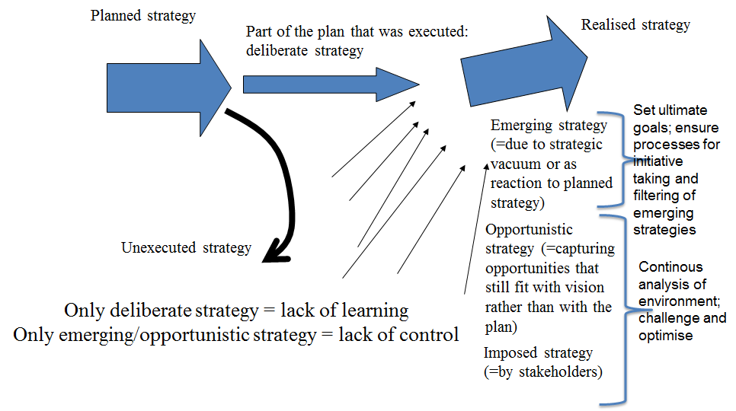

Source: adapted from Mintzberg (1987) and Desmidt and Heene (2005)

Deliberate strategy is the part of the plan that is actually realized. However, realised strategy may also contain opportunistic parts (e.g. derived from strategy as ploy, but still consistent with the planned strategy) as well as emergent and imposed parts (that are not consistent with what was planned). If nothing would end up being deliberate, this could indicate a lack of control. If nothing emerges or is opportunistic, then this could indicate a lack of learning. Enabling learning via emerging strategy, requires to set ultimate goals and ensure processes for initiative taking and filtering. Enabling opportunistic and imposed strategy requires continuous analysis of the environment. Hence to these authors **“good strategy” would be a strategy that balances learning and control.** However, this is an **assessment that can be made only in hindsight**.

There are also authors like Eisenhardt (2002)[12] who claim the nature and dimensions of strategy have fundamentally changed. Increasing globalization, which refers to a much **more densely connected world** (culturally, environmentally, technically, financially) is a key factor. The dense connections have amplified the effect of a second factor, which is **increased instability**. The latter is due, first, to **increased fragmentation** (a loose “structure” evident e.g. in geopolitics where the post WW2 era was shaped predominantly by the US and Soviet Union) where no one is ”in charge” and unlikely coalitions constitute (and decompose) themselves to (re)act to protect their interests. Second, there is an **increased availability of information** (e.g. via the internet). Even small events can trigger big reactions making prediction even harder than it ever was. The play is now high velocity, with strikingly non-linear instability, unpredictability and ambiguity. The abbreviation **VUCA (volatile, uncertain, complex, ambiguous)**, originally denoting the end of the ordering function provided by the Cold War, is becoming a mainstream concept in the public sector discourse (e.g. at the level of the OECD, 2017[13]).

This new context poses some **challenges to the traditional “military” based concept of strategy**. It used to be about locating **defensible positions** (on a map in the strategy room) and then fortifying them. This also implied wars were, at least in part, fought in the storeroom by amassing stockpiles of specific weapons and then deploying them wisely. This is represented by **strategies of positioning** (planning a position and then defending it with intertwined activity systems) **and the resource based view** (leveraging core competencies in many markets) of strategy. However, in the new VUCA world, **strategy resembles more guerilla warfare**: moving quickly, taking advantage of the opportunity and rapidly cutting losses. This is not random but informed by a clear purpose. This idea used to make sense only for small underdogs that lacked resource and position, but now it also starts to make sense for large organisations.

Also Hagel (2015[14]) makes a similar distinction between **“strategies of terrain”** and “strategies of trajectory”. The former concern scanning the terrain and finding a favourable position to occupy. But as the terrain becomes more unstable, strategists shifted from a view of the external terrain to the internal one, focusing “core competencies”. The danger is that we can be the best at something that is rapidly becoming obsolete. In parallel, others focused on strategy as “hustle”: sensing and quickly responding to near term events. The only terrain that mattered there was the immediately surrounding one within a timeframe of today, not tomorrow. However, according to Hagel (2015) this approach also poses risks, specifically, of spreading resources too thinly across too many fronts, racing to respond, with difficulty to ascertain what really matters rather than represent a one-off distraction. This approach also has a hard time reacting to fundamental disruptions that require more than a short term response.

Hence, Hagel (2015) proposes what he calls **“strategies of trajectory”**. Rather than looking from the present to the future, this entails looking from the future to the present. In this view, we create a clear view of a trajectory to this future and how this will reshape the current terrain. It is dangerous to play a wait and see game in the hope that things will become clear over time as by the time they do, it may be too late to act. We do not need a detailed blueprint of the future terrain, only enough detail for a sense of direction and to help make difficult near term choices. In fact, without a detailed blueprint, we have a greater incentive to keep identifying and understanding the forces that shape the terrain, rather than get lost in details. The broad direction of these long term forces is easier to predict than the shape of the terrain.

Stopford (2001)[15] espouses very similar views to Eisenhardt (2002) and Hagel (2015). He cites three aspects of the new business environment that are driving changes in what strategy is all about:

* **Rapid decline in transaction costs** that are making the traditional advantages of scale disappear and allow smaller, more dynamic organisations to be successful. Supporting quick action and reaction is therefore the new challenge for strategists;
* The **internet has broadened the supply of information and encourages activism** (e.g. people overcoming “it can’t work” attitudes by pointing to experiences from all over the globe). This means restricting strategic dialogue to the top of an organization ignores people that carry valuable data, ideas and ambitions and that are then likely to leave (or worse, typically in the public sector, stay and grow cynical);
* Successful strategizing is **no longer predominantly concerned with resources** (who can muster the most) **but with having alternative ideas** (business model innovation). Before, innovative strategies used to involve in depth analysis of the environment and, based on that, forecasting of future conditions and in response, planning of largely one-off efforts that relied on controlling physical assets. That worked well in relatively stable environments but now, there simply is not enough time to sit down and logically derive a strategy from such analysis. Even assets are hard to pin down (as evidence by the difference between book and market value for the most innovative companies). Today, **managers must learn NOT to see the world through the lens of the past**, making all evidence fit that view, reinforcing old models.

# Strategic planning and management

In their seminal article, Gluck, F.W. , Kaufman S.P. and Walleck, A.S. (1980[16]) distinguish four phases in the development of fully mature strategic management:

* Phase 1, basic financial planning, corresponds to:
  + procedures to forecast revenue, costs, and capital needs and to identify limits for expense budgets on an annual basis;
  + information systems reporting on functional performance as compared with (budgetary) targets;
* Phase 2, forecast based planning, requires:
  + a longer time frame to accommodate, amongst other things, making estimates of capital needs that take into account trade-offs between a larger number of services and types of users served;
  + this requires giving thought to the potential business impact of discernible current trends;
  + hence sophisticated forecasting tools combined with portfolio analysis make their entry;
* Phase 3, externally oriented strategic planning, implies:
  + taking on an external, objective outsider’s perspective to look at oneself in order to ascertain which new business capabilities need to be developed or markets need to be redefined to better fit strengths (dynamic resource allocation);
  + a formal grouping of related businesses into strategic business units (SBUs) or organizational entities large and homogeneous enough to exercise effective control over most factors affecting their businesses, which in turn triggers the distinction between corporate and business strategy and issues concerning shared resources, concerted action and the transferral of resources;
  + judging various strategic alternatives;
* Phase 4, fully mature strategic management, corresponds to:
  + a planning framework that **cuts across organizational boundaries and levels** (product/market units, business units, shared resources as well as concern and corporate levels) to facilitate strategic decision making about customer groups and resources;
  + a planning process that **stimulates entrepreneurial thinking:**
    - where **routine business requires no involvement** outside of the SBU level apart from routine monitoring and an occasional intensive strategic review;
    - where manager’s **thinking is challenged and stimulated**:
      * focusing on a theme;
      * negotiating objectives e.g. requiring additional funding in return for newly proposed future achievements;
      * demanding new strategic insights;
  + a corporate value system that **reinforces top managers’ commitment** to the strategy by recognising the importance of:
    - **teamwork,** which leads to task-oriented organizational flexibility;
    - entrepreneurial drive, or the **commitment to making things happen**;
    - **open communication**, rather than the preservation of confidentiality as it is impossible to be strategically managed without the **involvement of wide niches of relatively junior people** in many aspects of the strategic plans;
    - a shared belief that the organisation can largely **create its own future**, rather than be buffeted into a predetermined corner by the winds of environmental change.

According to Gluck et al (1980), phase 2 systems will…

* fail to signal major environmental shifts;
* focus on current capabilities, rather than on the search for options;
* are usually oriented towards short- or medium-term operating performance at the expense of long-term goals, via incentive compensation as well as informal rewards and values;
* all too easily become a mechanical routine, as managers simply copy last year’s plan, make some performance shortfall adjustments, and extend trend lines another 12 months into the future.

Phase 3 however ends up being not much better in practice than phase 2, as Gluck et al (1980) explain how it becomes increasingly difficult to maintain strategic management as a process that is predominantly operated at the corporate level, sticking rigidly to a formal corporate calendar. This tends to make strategic planning degenerate into a mind-numbing bureaucratic exercise, punctuated by ritualistic formal planning meetings that neither inform top management nor help business managers to get their jobs done.

Poister and Streib (1999) state that “Strategic planning is a principal element but not the essence of strategic management, which also involves resource management, implementation and control and evaluation” (p. 310). Also, “Strategic management is **not a linear process of planning, implementation and evaluation.** Rather,…**strategic perspective** on an **ongoing basis** to ensure that strategic plans are kept current and that they are effectively driving other management processes” (p. 311).

Poister and Streib (1999) put forward that strategic management requires a strategic management group (SMG) to provide leadership to the process, consisting of the CEO, top-line managers and key executive staff members. These then execute following tasks:

* **Meeting regularly** to discuss strategies, monitor progress, evaluate effectiveness, maintain focus on the strategic agendas;
* I**dentifying newly emerging issues** (problems/opportunities) as they develop, modifying strategies, providing direction and control over implementation plans, developing new strategic initiatives...**on an ongoing basis**;
* **Coordinating** strategic **planning at various levels, e.g.:**
  + specific operating department’s strategies requiring a SMG at city level to determine common results areas / objectives;
  + cross-departmental task forces then specifying strategies and action plans to achieve those;
  + in parallel, operating departments also specifying their own specific strategies and action plans;
  + SMG reviewing and approving both departmental and organisation wide initiatives;
* Tying **funding** to specific programmes, projects or actions;
* Assigning **responsibility** for initiatives to individuals and units;
* **Tracking progress**.

Poister and Streib (1999) stress that “…an agency’s strategic managers can be truly strategic in their thinking and decisions only if they really understand what is going on in their organisation and its environment” (p. 319). Hence they require **ongoing monitoring of the internal and external environment**. Internal monitoring happens formally via management information systems, employee surveys, etc. as ell as more informal debriefings, conversations, site visits, brown bag lunches, management by walking around, etc. External monitoring happens via published reports, professional associations, customer feedback, advisory committees and interactions with a variety of external stakeholders.

Poister (2010) defines **strategic planning as “a big picture approach that blends futuristic thinking, objective analysis and subjective evaluation of values, goals, and priorities, to chart a future direction and courses of action** to ensure an organisation’s vitality, effectiveness and ability to add value” (p. 247).

For him, **strategic management is then “concerned with ensuring that strategy is implemented effectively and encouraging strategic learning, thinking and acting on an ongoing basis…**.implementation aspect involves working all the “management levers” in concerted effort.... largely matter of utilizing and coordinating all of the resources and venues at top management’s disposal,…in the interest of advancing the strategic agenda.” (p.249). The aforementioned levers include operational and business planning, budgets, analytical and problem-solving capabilities, workforce development and training, internal and external communications, programme delivery mechanisms, legislative agenda’s, leadership skills and the ability to influence other actors in networks.

Similarly, Bryson (2011, p. 26), makes the following distinctions:

* Strategic planning: “A deliberative, disciplined effort to produce fundamental decisions and actions that shape and guide what an organisation (or other entity) is, what it does, and why it does it.”
* Strategic management: “ The integration of strategic planning and implementation... in an ongoing way to enhance the fulfillment of mission, meeting of mandates, and sustained creation of … value”.

Fundamentally, strategic planning and management can be discussed as a **specific process of “regulating”,** to be distinguished from “execution” which entails the primary (value adding) processes (e.g. purchasing, preparation and delivery) as well as supportive processes (required to sustain the value adding processes e.g. HR, finance,…) in an organisation (Wauters, 2017[17]). Regulating can be defined as solving problems and learning to get better at solving problems (Christis, 2011)[18]. It is an activity that is typically **depicted as a cycle** (see figure below)[19].

Figure : regulating cycle

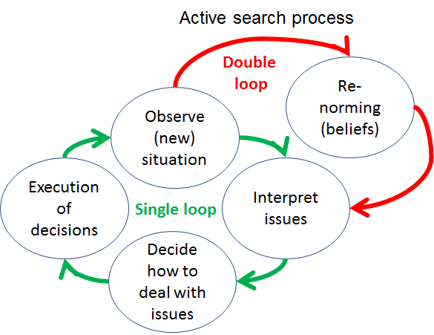

Source: author’s own depiction adapted from Kuipers et al (2012)

When data comes in (“observe”), this must first be made sense of (“interpret”). This is done by comparing the observation with our expectations. This means we use an implicit/explicit norm. If the observation does not deviate from the norm, we do not need to take any new action but can continue to do what we are used to doing (run our routine). However, if there is a deviation, we need to figure out how to deal with this (“decide”). Once we have done this, we need to execute our decisions (“execution”) and then observe again what happens.

However, from time to time, we need to realise that our “norms” may be set wrongly. In other words, we may be misinterpreting the observations because we are looking at them with an inappropriate set of expectations. This can be a matter of substance (qualitatively wrong e.g. we think users value something which is not at all important to them in reality and/or we miss what really matters) or magnitude (quantitatively wrong, e.g. users do value something but at a much higher/lower degree than we think).

Regulating cycles can take place at various levels (as described by Kuipers et al, 2012, p. 78 and Christis, 2011) (which, for simplicity sake, are illustrated by the example of a cookie factory):

* Operational: this concerns task execution (e.g. in a simple cookie factory this can concern making the proper mix of ingredients for cookie dough) where we can solve problems (e.g. poor mix is detected and corrected) and learn (e.g. ensuring that we get better at proper mixing so less corrections are needed);
* Tactical: this concerns the internal structure in terms of rules, procedures, processes, functions, roles, units (who does/decides what, when, where) of the organisations (for example, do we put mixing and baking into separate units or, do we create a unit that takes care of all cookies with fruit fillings versus a unit for chocolate cookies) where we can solve problems (e.g. bakers notify mixers that the cookies are burning and that they need to check their mix) or learn (e.g. how to detect issues with the mix faster);
* Strategic: this concerns the external structure, i.e. the purpose of the organisations for whom (scope), which external partners to work with, at what scale (e.g. how many citizens to serve) where we can, again, solve problems (e.g. when too many users come in, temporarily increase capacity) or learn (e.g. how to better forecast demand).

When going back to Desmidt and Heene (2005), strategic regulation relates more to the “business concept”, while tactical regulation relates to the “organizational concept” that need to be aligned to it.

These three cycles are interlinked as depicted below.

Figure : interlinked cycles

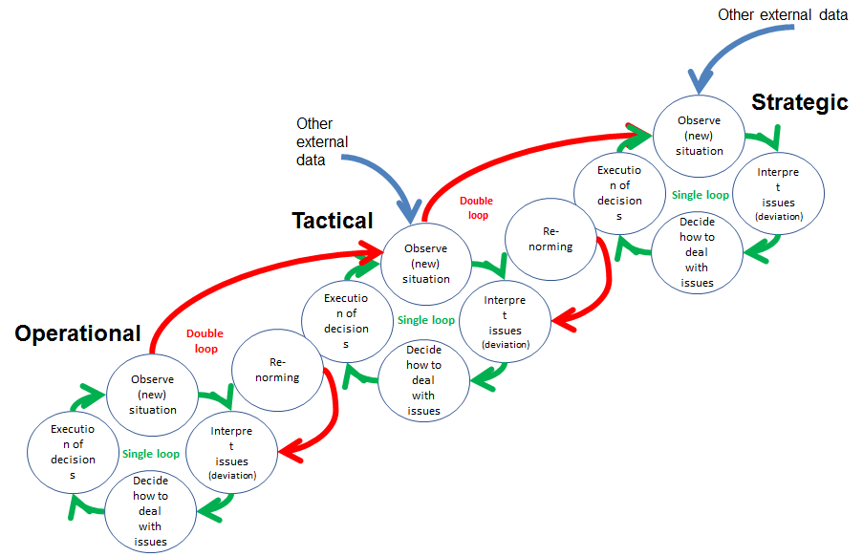

Source: author’s own depiction

As can be seen from the figure, the connection between the cycles occurs via the setting of norms. Defining partners, scope (incl. purpose) and scale (strategic) also triggers decisions concerning the most appropriate internal structure, which then forms the normative framework (who “should do what, when, where) for tactical regulation. Tactical regulation, in turn, sets the norms for operational regulation (how to execute each task).

Typically, this process is seen as starting with strategic regulation, triggered by data concerning the outside world, and then affecting the tactical and operational regulation. However, equally important is the reverse response, i.e. questioning tactically set norms at operational level. Indeed, at operational level, problems may persist, no matter how much operational learning takes place. This is then an indication that perhaps there is a problem with the normative framework of the operational level (as it seems impossible in practice to adequately conform to it). Tackling this requires shifting to the tactical level. Indeed, the current set of “who should do/decide what, when, where” may not be adequate for dealing with the purpose for the targeted citizens at the scale that was decided on at strategic level.

Finally, it is also possible that no matter how well at tactical level we have learnt how to organize for a given set of partners, scope and scale, we are observing issues that point towards the need to rethink these foundational elements. Indeed, as the external world keeps changing, by definition, our existing internal structure will cease to perform well at some point as it was explicitly designed to suit a different world. This is the link to “VUCA” as it was defined above.

When the normative framework of a regulating cycle is re-set, this is referred to as double loop learning (Christis, 2011). Simply learning how to get better at conforming to a given set of norms is referred to as single loop learning. The regulating cycle is then limited to observing, interpreting, deciding and implementing (correcting errors and, every time this happens, learning better how to avoid the error in the first place).

Hence, operational double loop learning happens when at tactical level, the normative framework for the operational level is changed. This “renorming” can be triggered by the operational level itself, as it receives data that shows it struggles to conform to the norms set by the tactical level. But it can also be triggered by an effort at the tactical level, when it has received external info as to how it is conducting its processes or itself was subject to re-norming derived from a regulating cycle at the strategic level.

As the strategic level is the highest level, there are no “organizational” norms there that guide it, except the expectations that exist toward the organisation in the outside world. Hence, strategic double loop learning is all about challenging our views concerning partners, scope and scale by confronting these with expectations from the outside world. Decisions concerning partners, scope and scale then become norms for the tactical level.

When authors such as Desmidt and Heene (2005) state that strategic management is a “transformation” process, then this can now be better understood as strategic regulation that triggers a re-norming of the tactical (and ensuing operational) level. It should however be clear that different levels of regulation do not imply that these need to be allocated to different (hierarchical) units. Wauters (2017) makes clear that frontline teams can themselves, next to the more obvious operational regulation, also take care of the bulk of strategic and tactical regulation.

# A model for strategy making in the public sector?

As stated earlier, Troupin and Pollit (2012), note the dearth of books on strategy making in central government. They referred to three key sources, notably Joyce (1999), Bryson(2011), and Mulgan (2009). The latter, most recent two, will be discussed below. In addition, a third model will be discussed that has emerged even more recently.

# Bryson’s model

The entire process as proposed by Bryson (2011) is depicted below where steps 1 to 8 typically reflect the “planning” part and steps 9 and 10 more with “implementation”. The whole process is then “strategic management”.

Figure 6: Bryson’s framework of strategic management

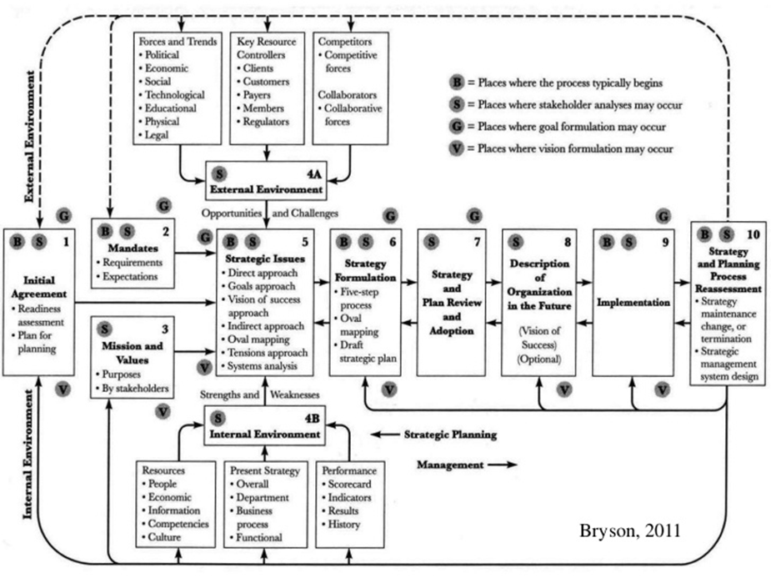Source: Bryson, 2011

Below, the various steps are elaborated in more detail.

**Step 1: initiating and agreeing on a SP process:**

* Identify who key decision-makers are
* Which persons, groups, units, organisations should be involved
* Initial agreement will be negotiated among them
* Requires a preliminary stakeholder analysis:
  + To immerse oneself in the networks and politics surrounding the organisation
  + Identify the “stakes” (criteria for judging the organisation) and how well the organisation performs from the stakeholder point of view, how they influence the organisation, what the organisation wants from them (money, staff, support,…) and how important they are
* Helps clarify if different missions are needed and/or different strategies, whether mandates should be changed and other strategic issues

Bryson (2011) devotes considerable attention to this step (p. 83-116). A good initial agreement (on the purpose of the process, sponsors and champions, who to engage in what way, the steps and resources needed,…) is key to ensuring there is broad sponsorship and legitimacy, no suspicion arises that the effort is a power play by a small group and, finally, results should be seen as objective (not seen as driven by narrow partisan interests). Essentially, stakeholders need to have a sense of “procedural justice” (the way decisions are reached and the decisions is seen as fair), e.g. by consulting or involving stakeholders in decision-making. In addition, there has to be a sense of “procedural rationality” (where decisions are seen as the outcome of appropriate deliberations, via a series of coherent and sensible steps), linked to key decision-making points in arenas such as the budget, elections and the legislative cycle.

Identifying and gaining the political support of key decision-makers and/or opinion leaders at several levels and involving them in the exercise is necessary to gain access to their time (typically 10% on an annual basis) and attention, as well as information, staff, budgets and meeting space. Also, it is needed to ensure their commitment to dealing with the strategic issues that will come up. In the end, a coalition must develop that is large and strong enough to formulate and implement strategies. Such coalitions do not develop quickly but “coalesce around the important strategic ideas that emerge from the sequence of deliberations, consultations, mutual education and reconceptualization that are at the heart of any strategic planning effort” (Bryson, 2011, p. 91). Bryson (2011) recommends involving top policy and decision-makers (who control resources, are boundary spanners, are formally charged with addressing mismatches between the organisation and its environment,…) , middle managers (who translate decisions into operations) and technical core or frontline personnel (who have useful technical and user knowledge, are most likely to be helped or hurt by change and who can support or sabotage it in practice). Also outside resource persons, representatives of key stakeholders groups, process experts and critics may be included. Typically, the top level also would include elected officials.

Bryson (2011) proposes a distinction between a planning coordinating committee and a planning team. The committee requires someone with the standing, credibility and trust needed to ensure the effort has the right visibility and credibility with all key stakeholders rather than be seen as a narrow partisan affair. It is better to start off with a restricted participation of decision-makers and opinion leaders, that can be expanded when the need arises, as it is easier to add participants than drop them. In addition, there is a big difference between giving people a seat and consulting with them. For larger efforts, it may be useful to create a larger representative and legitimising body, next to a smaller executive committee that engages in the most extensive discussions and makes recommendations to the larger body. The planning team is headed by an organizational diplomat and carries out the necessary staff work as well as facilitates the work of the key decision-makers. It includes planners, change advocates and helpful critics, versed in the substance of the topic area as well as boundary spanning, advocacy, self-criticism, analysis, process facilitation and synthesis of diverse views. This team can set up task forces to look in more depth at particular issues and report back with recommendations.

To Bryson (2011), it is also key to clarify at the start what is to be off-limits (e.g. mandates, legal engagements, personnel, organizational designs, resources, job descriptions, …) while ensuring there is enough allowance for tension to prompt change to make it worth engaging in a planning exercise. If major changes are intended, implying changing the conceptual frame (in terms of visions, goals, technologies, coalitions,…) underpinning current strategies, then it is advisable to include people other than the “usual suspects” on the planning committee or planning team and then increasing its power and influence, giving it authorization for a series of background studies, arranging visits to innovative places,… This can lead to undesirable fear and rigidity among stakeholders. Psychological safety is important for the process to succeed and broad sponsorships supports this, especially when decision-makers across functions, levels and organizational boundaries (e.g. in networks and communities) will need to deliberate together, requiring a considerable amount of trusts.

Most of the time, planning efforts concern the entity that the decision-makers control, oversee or heavily influence. But sometimes, a planning effort is externally initiated to show decision-makers how an entity might conduct itself if it took reformers seriously. Proposals during a political campaign to change key policies, think tank reports, etc. …are in essence strategic plans.

**Step 2: Identifying organisational mandates:**

* Various “musts” it confronts
* Requirements, restrictions, expectations, pressures, constraints
* Formal and informal (typically political)

**Step 3: Clarifying mission / identity:**

* Social justification for existing activity
* Social, economic, environmental or political demands or needs the organisation seeks to fulfill for stakeholders
* Careful stakeholder analysis required to determine purpose for “whom”
* Requires lengthy dialogue

**Step 4: assessing external and internal environment**

* Requires monitoring variety of trends and events as well as important external stakeholders (especially those that affect resource flows) to identify opportunities and challenges:
  + External
  + Future oriented where scenarios can show different plausible futures
  + Better identified by outsiders to avoid being captured by existing categories of classification and search since they formalise and routinise the past
  + Threath of stakeholders withdrawing support is one of the reasons organisations reinvent, restructure, reengineer…
  + Critical success factors = criteria one MUST meet (incl. mandates identified in step 2)
* Requires monitoring resources, present strategy and performance (outputs and outcomes) to find strengths and weaknesses:
  + Internal
  + Present

**Step 5: Identifying strategic issues**

* Steps 1-4 attempt to slow down things so there is enough information and interaction for good deliberation
* As issues involve conflict, they raise emotions and hence this step requires emotional intelligence of those involved
* Iterative nature of SP becomes apparent as the mission itself may become an issue
* An issue statement consists of three elements:
  + A question one can do something about with more that one possible answer
  + Factors that make the issue a fundamental challenge: what is it about the mission, mandates, SWOTs that make for an issue?
  + Consequences of failure to address
  + About one page
* Different ways to identify issues:
  + Direct: Straight from mission, mandates, SWOTs
  + Indirect :brainstorm possible actions (towards the mandates, mission, SWOTs,…) first, then cluster them into groups and derive issues from that
  + Start with goals or CFSs or indicators and identify issues in terms of achieving those
  + Sketch a vision first: this is more apt if you want to find really strategic (complex adaptive, developmental) issues versus operational (technical; complicated) ones (Bryson, 2011, p. 58)
  + Action oriented strategy mapping:
    - create cause and effect maps of actions (oval mapping) where important clusters of actions may comprise strategic issues
    - Useful when people are having trouble making sense of complex issue areas, time is short, emphasis must be on action and commitment of those involved
  + Find issues by identifying misalignments between mission, mandates, goals, strategies, actions and systems
  + One can further deepen understanding of complex issue areas with a systems analysis (e.g. breaking up the issue area in elements and how they are linked together in feedback loops)
  + The issues should create some useful tension to prompt organisational change
* Map them into strategic and operational and then also in requiring immediate response, to be monitored and to require attention in the future
* Check if issues should be combined or split
* Attention should be focused on issues as questions, not on answers:
  + If only one answer, then it’s just a choice
  + Question should stimulate thinking out of the box
  + People will come with their preferred solutions (wish list) anyway, so challenge them to explain exactly how that addresses the issue
* Ensure the issue can be addressed:
  + otherwise it is not an issue but just a constraint
  + There should be some useful clues about how to resolve the issue:
    - What exactly is it in the mission, mandates, SWOTs that creates an issue / question?
    - Links to overcoming weakness, building on strength,…
* Issues framed in a multi-organisational/institutional way will have to be addressed by more organisations (the same goes for several departements in one organisations, rather than just one)
  + This is a key tactic to force decision makers to share power and to consider strategies that are about doing the right thing, rather than just efficiency in perhaps the wrong thing to do
* Initial framing of issues is likely to change based on further deliberation and dialogue if people are aware of the consequences of not dealing with an issue (in terms of lost opportunity , etc.)
* Expect misalignment issues to come up as you progress
* Prioritise and/or sequence issues
  + E.g. temporal/logical order by using an issue-precedence diagramme (relating the issues to each other as cause-effect)
  + May be opportune to try to develop strategies for lower priority issues first (learning by doing on issues that are not so tricky)

**Step 6: Strategy development**

* Five step process:
  + 1) Formulate alternatives, visions, dreams in response to the issues in action terms (do, get, achieve, …) = “grand” alternatives
  + 2) Enumerate barriers / constraints to those alternatives, visions, …
  + 3) Develop major proposals to achieve them directly or indirectly (by tackling barriers); display and link the proposals in a cause/effect map to articulate more clearly the relation among options
  + 4) Identify actions to be taken in the next two or three years to implement the proposals
  + 5) Prepare a detailed work programme for the next 6 monts to 1 year
* Alternatively, one can create options in a brainstorming process to address each issue and then organize these into means-to-ends map (with options towards the end of a chain of arrows are more likely to be goals and closely related to the organisation’s mission)

It should be clear that the success of step 6 depends on the ideas that can be created, brought forth and organized by the participants. They should therefore prepare incl. relevant background reading, visiting relevant organisations, attending conferences, being part of online groups,…

A two cycle process can be used e.g. by letting smaller units do the above exercises first, which are then reviewed by the cross-functional planning committee. Then in a second cycle, more detailed operating plans are drawn up.

**Step 7: review and adopt**

* Criteria:
  + Technically workable
  + Administratively feasible
  + Politically acceptable to key (internal and external) stakeholders
  + Results oriented: create public value
  + Fit organisation’s identity even if the purpose is to change the identity
  + Ethical
  + Legal
  + Dealing with the issue
* Careful deliberation and negotiation among key decision-makers who have adequate information and are politically astute is required
* Finding or creating inducements for key stakeholders to secure their support is part of the game

This is therefore the step where “traditional” strategic goals typically are formulated. However, as depicted in the figure below, Bryson (2011) also facilitates that goals are used in the process at other times. Most notably, goals formulation at step 7 is not the same as at step 9. For step 7, they are used to review the logic of the overall strategy, while for step 9, they are used as part of action planning, and hence are far more specific. It should also be clear that until step 7, goals do not need to be agreed. But as of step 7, they are strategy specific.

Figure 7: goals in Bryson’s framework

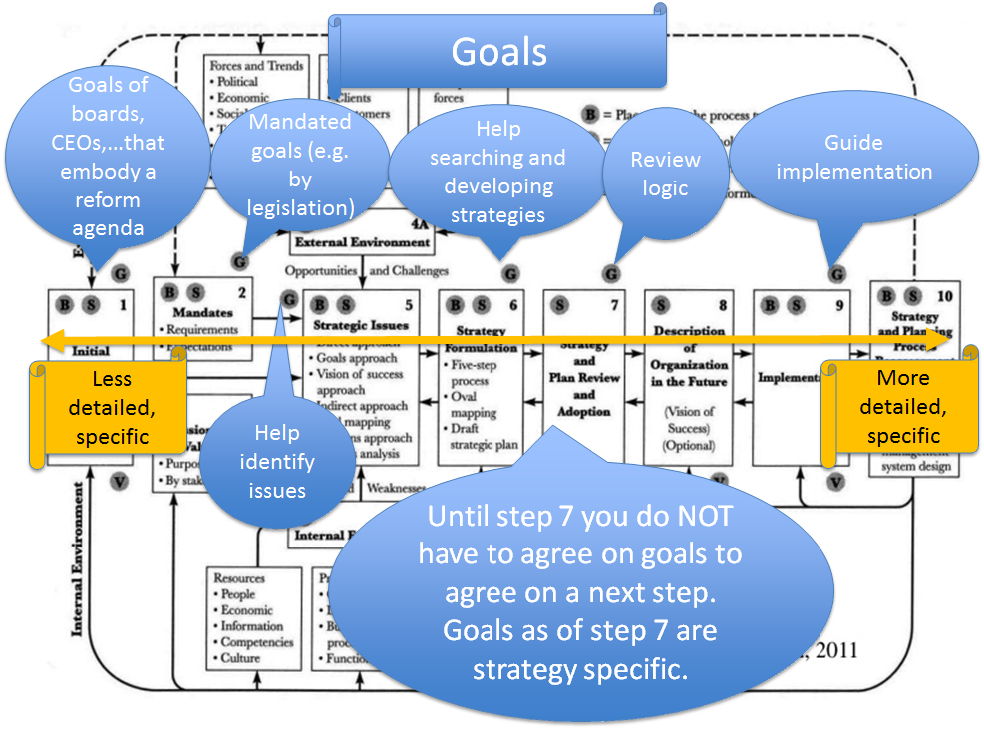

Source: adapted from Bryson 2011

**Step 8: Organisational vision**

* What does it look like when the strategies have been successfully implemented and achieved their full potential?
* Added to a summary of mission/identity, strategies, performance criteria, decision rules, ethical standards expected of employees
* At this point it is a guide for strategy implementation
* But (less elaborate, fragments of) visions can be formulated already earlier in the process (see especially steps 3 “mission” and 4 “SWOT”) as depicted in the figure below
* A vision is not always needed to get performance improvement –this can happen by enhancing current business- but it is a crucial element if you want to challenge current strategy by identifying truly strategic issues

Figure 8: vision in Bryson’s framework

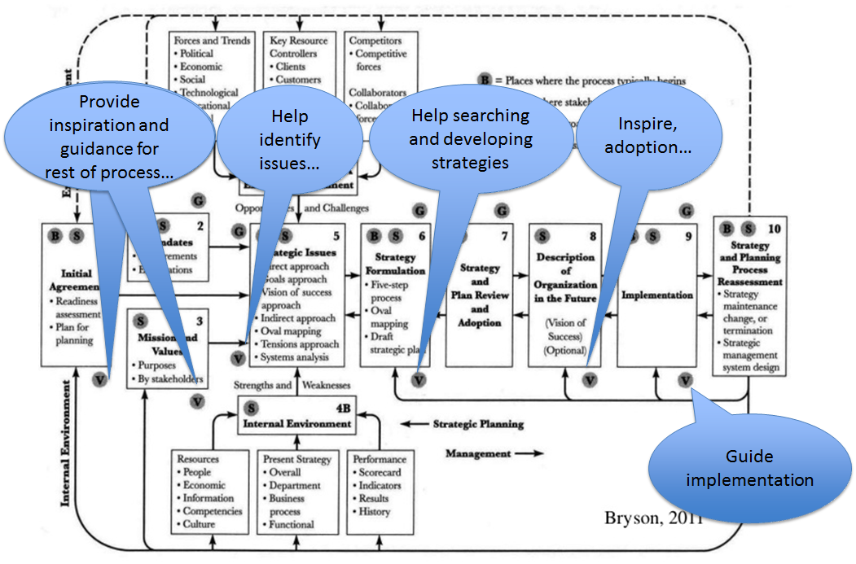

Source: adapted from Bryson 2011

**Step 9: Develop an effective implementation process**

* Action plans contain:
  + Roles and responsibilities of oversight bodies, teams, task forces and individuals
  + Expected results, objectives, requirements, milestones
  + Specific action steps
  + Schedules
  + Resource requirements and sources
  + A communication process
  + Review, monitoring, correction procedures to build in capacity for learning
  + Accountability procedures (based on performance measures and learning)
* Successfully implemented strategies result in the establishment of a new regime of implicit/explicit principles, norms, rules and decision-making procedures around which actor’s expectations converge in a given area (Bryson, 2011 p. 65)

Bryson (2011, p. 311-316) also makes a distinction between direct and staged implementation. Direct implementation means that all the conceived changes are incorporated simultaneously into all relevant sites. This is appropriate when the situation is technically and politically simple (with enough resources to cover costs and provide incentives and resistance is low or can be easily reduced), or when immediate action is required in a crisis (making people more willing to defer to centralized decisions of a technically feasible nature), or when the solutions are “lumpy” (e.g. new buildings).

Otherwise, it is better to consider staged implementation. Here, initial adopters are assumed to be followed by later adopters (shaping the familiar S-curve of adoption of innovation). Typically, various efforts at prototyping are needed. When this reveals technical difficulties, it is best to run a pilot project to discover or prove cause-effect relations in benign and controlled conditions. Once technical difficulties have been resolved, transfer to remaining potential implementers can be pursued. When prototyping reveals political difficulties, it is useful to engage in a demonstration project (with two cycles, the first of which is used to learn and to feed changes into a second one, where the effects of the changes are monitored) to show the process works in typical implementation settings. This is more likely to work if opposition is not well organised and changes can be put in place before effective opposition can materialise. When there is organized opposition, a demonstration effort may at least convince some opponents and thereby divide opposition. When opposition however is implacable, direct and massive implementation effort may be warranted (shock and awe) but chances of success of this type of actions tends not to be great either. Finally, when there is both technical and political difficulty, a pilot followed by demonstration projects may be required. In general, the more difficult the situation, the more important it is to promote education and learning, offer incentives to change and develop among all interested parties a shared sense of commitment to successful implementation and long term protection of the changes. Finally, after pilots/demonstrations have been communicated, early implementers should be carefully selected and well-supported. Indeed, as there are likely to be various practicalities regarding the changes to work out, it is important to attract people with enough experience, skill and desire to make the changes work. Later adopters will be watching so early implementers should be valued and persuasive role models, seen as courageous, wise, able and committed to addressing the issue in a reasonable way (rather than charging mindlessly after every new fad). They also need to be able to describe their experience effectively to educate the next wave of adopters.

**Step 10: reassessing strategies and the strategic planning process**

* Organisational learning:
  + Hard look at what is really happening
  + Open to new info
  + Wisely assessing
  + Inventing new expectations that make sense of unprecedented events
  + In short, acting “mindfully”
  + View strategic management as “action research” or “utilisation focused evaluation”

**General points**

Overall , a key message of Bryson (2011) is that the process can start at many different points. The figure below shows various starting points.

Figure 9: starting points of the process in Bryson’s framework

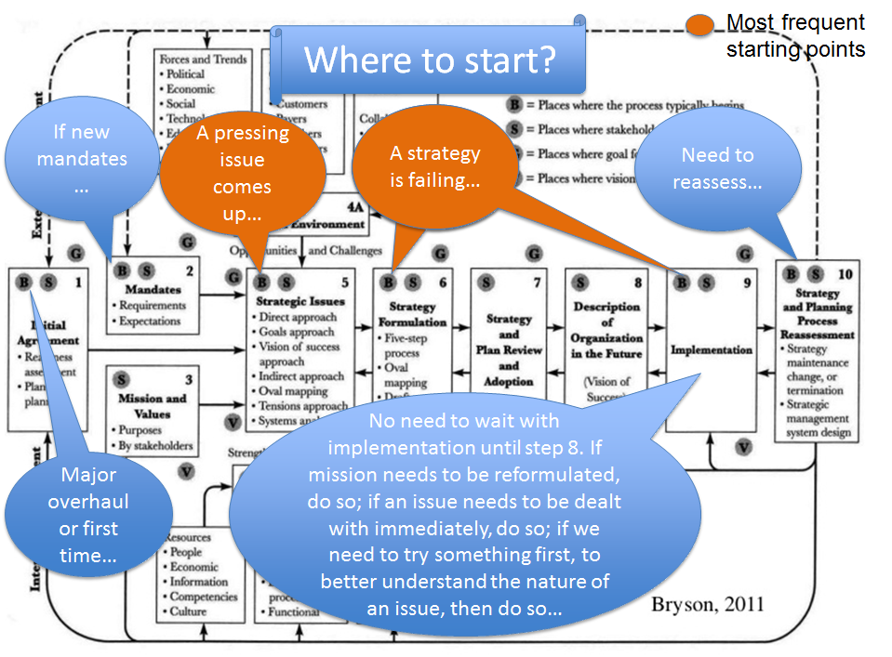

Source: adapted from Bryson 2011

In addition, as depicted above, “action” does not have to wait until step 7 is finished. It is possible that an issue needs to be dealt with immediately or that an action is required to understand the issue better.

# Mulgan’s model

Mulgan (2009), in the other major reference on strategy for the public sector offers a framework for adaptive strategy (p.75-114). Key are two ideas: strategising is about decisions to do some things and not others. Also, as known from the military, “no plans will survive their first contact with the enemy” (p. 76). Hence the need for adaptation. He suggests any serious exercise must cover the following questions:

1. Why actions are taken: purposes, needs, values, aspirations (e.g. for children health, well-being) and fears (of collapse, disorder, attack) that matter to a society, shaped and fought over through politics and via the slow movement of culture. Sometimes values are so clear that they can guide responses directly. But this carries the risk of dogma and myopia. Purposes coming from deep within society manifest in political manifestos and debates (often ideological), longer term pressures of social movements, external pressures from other nations or transnational bodies and the underlying structure of interests;
2. What the context is in which a purpose can be achieved: building an accurate understanding of the present and the state of knowledge on an issue, defining trends that represent opportunities and threats, understanding capacities of institutions;
3. Where to go: a small number of broad strategic directions which can sometimes be translated into more precise goals. This is the hard graft of strategy, involving dialogue between purposes and environments to define the direction a society is to take. It should take shape via vigorous internal debate (sometimes best kept secret) to clarify the (un)doable and help decide what really matters, which goals to focus on and what sequence of priorities to go for. Mulgan (2009, p. 92-3) distinguishes the very broad (path dependent) overall directions (e.g. whether to retain the welfare state or not, whether to emphasize security, …) that do not shift often (but can, e.g. when Germany decided to deregulate labour markets), from the more precise objectives and strategic directions that can be translated into instructions that make sense for large systems and bureaucracies. Typically, governments can deal with only two to three broaderer, high level objectives, as these tend to be all-consuming, e.g. New Zealand’s strategy to achieve a fairer deal with its Maori population or Finlands reshaping of the labour market, involving school children in work as well as members of extended families. More limited and precise objectives can be more numerous e.g. France’s strategies to create high speed-rail networks or the widespread adoption of parenting programmes to cut crime in the US (Mulgan, 2009, p. 28).
4. How to get there: policies and actions that take account of the capabilities of the various agencies involved and can be cascaded down through public agencies. This is where governments need the most creativity. Sometimes the best solution will be found by taking an idea from one sector and trying it another. Some solutions are hybrids (solutions riding on each other’s backs e.g. call centres that also diagnose health problems), some turn weakness into strength (e.g. ageing seen as generating an untapped labour reserve), some are based on simple insights into the nature of things (e.g. that drivers should pay for using roads). Also here, sequencing matters. Some new policies need new capacities and institutions before they can work (e.g. those relying on community engagement need to allow for quite a bit of time). Other policies need to deal with public opinion and high politics, generating a widespread understanding and/or consensus, before specific alternatives can be deployed. In many cases, small first steps can create positive feed-back loops (as some people now have a stake in the game, learning can happen, there is a signal that change is real, it builds confidence of those who initiated it). Financing also comes into play as being strategic often means being though in freeing up resources (hence taking on interest groups and bureaucracies habituated to public money) or allocating new money. Part of the “how” may relate to restructuring who does what. Classical government structures (departments., agencies) were organized around expertise of to prevent concentration of power. However, failures of coordination (apart from field where tasks are easily specified and measures and issues not controversial politically) abound because of this. Ideally, authority should oversee a coherent whole system (in terms of fields, e.g. crime, or people e.g. the elderly). But systems are never self-contained and hence there will always be overlap but the key is to minimize the number of critical boundaries. Hence, restructuring should be reserved for cases where two entities with divergent missions are working against each other. Finally, care should be taken not to draw the lines between strategy and implementation too starkly. People designing policies should draw on people with practical knowledge of street-level realities;
5. Which things worked and which did not: feed-back loops from users, public opinion, data and pilots should provide info that leads to further improvement and adaptation. Indeed, as only in a few areas there will be reliable knowledge about what causes what, getting mistakes in early and rapid adaptation are key. Learning can be helped by various means of formal, institutionalized reflection e.g. via peer networks, “what works” units, etc. This can be strengthened via formal research and a culture of being open to admitting errors. In this legislation can play a part (e.g. in the US the Data Quality Act). Smugness and bias are to be countered e.g. by putting analysts in separate structures to line management (e.g. evaluation in the World Bank), communities of practice, peer reviews, pre-mortems, role plays (bringing out the dynamics of a situation, otherwise buried in analysis) etc.

Relating to the second point in the framework (context), Mulgan (2009, p. 81-82) elaborates on the various fields of action by juxtaposing the power of the state to its knowledge base. First, a continuum in terms of knowledge is made from more to less:

* fields of direct causation (where change in one variable leads to change in another in a predictable way, e.g. vaccination to reduce infection)
* fields with multiple variables where some interactions are understood, other less so, hence defying accurate predictions (e.g. evolution of industries) but still allowing to generate some insight into the future by using scenarios, simulations and foresight methods (drawing on broader networks of experts and practitioners to paint a picture of likely trends, particularly where there is a deficit of political and/or intellectual imagination). To understand interactions better, systems mapping is also recommended (Mulgan, 2009, p.85- 91), where “good analysis shows connections between things and the non-obvious facts that lie beneath the surface”. Good systems maps can directly shape policy and strategy, guiding where useful intervention can be made;
* complex fields: involving less understood phenomena, requiring learning from doing (e.g. crime). The tools put forward above are also useful here as they can help determine where and concerning what pilots and experiments (rather than direct action) should be set up to test and compare different approaches;
* fields of chaos: where old rules and relations break down, requiring speed of action.

While Mulgan (2009) does not provide a reference, the above clearly is inspired by Snowden and Boone (2007)[20].

Figure 10: Cynefin framework



* **simple systems with known causes and effects**: here, cause and effect relationships are generally linear, empirical in nature (almost instant), and not open to dispute. Repeatability allows for predictive models to be created, and the objectivity is such that any reasonable person would accept the constraints of best practice. Knowledge is captured and embedded in structured processes to ensure consistency. The focus is on efficiency. Our decision model here is to sense incoming data, categorize that data, and then respond in accordance with predetermined practice;
* **complicated systems with knowable causes and effects**: while stable cause and effect relationships exist in this domain for a given time period, they may not be fully known, or they may be known only by a limited group of people. In general, causal relationships are separated over time and space in chains that are difficult to fully understand. Everything in this domain is in principle capable of movement to the simple domain via research. The only issue is whether we can afford the time and resources to move from the complicated to the simple; in general, we cannot and instead rely on expert opinion, which in turn creates a key dependency on trust between expert advisor and decision maker. Our decision model here is to sense incoming data, analyze that data, and then respond in accordance with expert advice or interpretation of that analysis. Assumptions therefore must be open to examination and challenge as even tiny errors inassumptions can lead to a false conclusion that is difficult to isolate and may not be seen.

The above systems form the “ordered” side of the framework. **Most traditional managerial approaches assume reality is indeed ordered.** However, the framework also highlights complex and chaotic reality that make up the “un-ordered” side, as described below.

* **complex systems**: there are cause and effect relationships between the agents (where agents can be any element of a system not just people), but both the number of agents and the number of relationships defy categorization or analytic techniques. Emergent patterns can be perceived but not predicted; we call this phenomenon retrospective coherence. In this space, structured methods that seize upon such retrospectively coherent patterns and codify them into procedures will confront only new and different patterns for which they are ill prepared. Once a pattern has stabilized, its path appears logical, but it is only one of many that could have stabilized, each of which also would have appeared logical in retrospect. Patterns may indeed repeat for a time in this space, but we cannot be sure that they will continue to repeat, because the underlying sources of the patterns are not open to inspection (and observation of the system may itself disrupt the patterns). Thus, relying on expert opinions based on historically stable patterns of meaning will insufficiently prepare us to recognize and act upon unexpected patterns. The decision model in this space is to create probes to make the patterns or potential patterns more visible before we take any action. We can then sense those patterns and respond by stabilizing those patterns that we find desirable, by destabilizing those we do not want, and by seeding the space so that patterns we want are more likely to emerge. Understanding this space requires us to gain multiple perspectives on the nature of the system;
* **chaotic systems**: in the first three domains there are visible relationships between cause and effect (when complex, at least retrospectively). In the chaotic domain there are no such perceivable relations, and the system is turbulent. We do not have the response time to investigate change. The decision model in this space is to act, quickly and decisively, to reduce the turbulence and then to sense immediately the reaction to that intervention so that we can respond accordingly. We may use an authoritarian intervention to control the space and make it simple; or we may need to focus on multiple interventions to create new patterns and thereby move the situation into the complex space.

The latter statement reveals another feature of Snowden’s “Cynefin” framework: that the boundary between the four different systems is not absolute. For example, a chaotic system can move into complex space or even into the simple. Finally, an area of “disorder” also exists but this refers to systems where there is no agreement even in which one of the four other spaces it belongs.

Mulgan (2009) also takes into account “power”. A high degree of power reflects a state that has the tools for action in its hands, particularly those of “command” (laws, directives,…). In the case of low power, the state cannot act alone, as power is diffuse.

Together, knowledge and power generate a matrix with four types of strategies (see below).

Table : matrix of strategy types

|  |  |  |
| --- | --- | --- |
|  | **Low knowledge** | **High knowledge** |
| **High power** | Emergent strategy:  Need to learn quickly. What matters most is how those at the periphery / bottom respond to outside pressures. Hence, strategy should focus on creating the conditions for systems to organize themselves (e.g. via laws underpinning markets). For the top it is important to be ad hoc and opportunistic, not becoming trapped in formal plans. Example: teacher behavior matters more than curriculum definitions to improve student outcomes. | Control strategy: key is how those at the top man and respond to the context. E.g. seeing a coming water shortage and taking appropriate action in time. |
| **Low power** | Distributed strategy:  Bottom-up, evolutionary and organic change to be reinforced via strategies of communication, trust building, cooperation, mutually reinforcing action. | Insurgent strategy: involves guile and feinting, operating behind the lines, turning weakness into strength. E.g. Local authorities getting around central state rules. |

As to the third point of the framework, Mulgan (2009, p. 94 and 105) introduces the concept of the “change margin”, which reflects the governments appetite for change. This margin can be understood in financial terms: how much of today’s spending can be redirected to future priorities? In most governments this tend to be small, with only 1-2% of spending within a year. Most of the growth of revenues is taken up by pay increments and inflation. Typically, the criteria for starting anything new are a lot tougher than those for what exists. External shocks and political catharsis can unlock resources. At a deeper level it reflect will power and commitment. This in turn depends on exceptional qualities of leadership and the widely shared sense that status quo is no longer an option.

In terms of the fourth point, Mulgan (2009) describes the standard linear process (p. 136):

* politicians identify a priority and broad outlines of a solution;
* policy makers in central government design a policy to put this into effect;
* implementation is then handed over the a new group (e.g. an agency or local government);
* within the group the task is given to managers who hopefully get their staff to execute.

This linear process is more likely to work when there is:

* a tight process with few intermediaries;
* simple lines of accountability (division between purchasers and providers of output);
* clear prescriptions;
* tough penalties and rewards on each link in the chain to do what is expected.

Mulgan (2009) then discusses the experience with such a way of working. Even when the state has a lot of knowledge and power, implementation is never that linear. He concludes that Britain has learned the lessons learned by many big firms and governments over the years: “whipping the system harder can achieve temporary gains in performance, perhaps for two to three years…but these gains are unlikely to be sustained... Worse,…likely to bit the target setter.” (p. 139) He also adds that a massive shift of people from frontline implementation into inspection and auditing has escalated costs with scant evidence of better performance. Inspectors are too focused on process and rules rather than outcomes and on micro-issues rather than strategy as well as on risk reduction rather than entrepreneurship. He concludes that hierarchies are inherently bad at learning and self criticism but good at blame. He proposes that there should be a combination of top-down (central government), horizontal (peers) and bottom-up (citizens, users, voters) pressure and support to increase chances of change and improvement.

Mulgan (2009, p. 147) also states that there should not be a division between the people and units doing strategy and those responsible for implementation. “It’s wiser to see strategy, policies and implementation as a whole, best done by at least some of the same people working on project teams, and making full use of feed-back loops including data, measurement, piloting and testing, and public responses…strategy has to be more about conversation and negotiation, along with faster learning from the unexpected results which are bound to occur”.

Mulgan (2009) then turns to the combination of positive risk taking (innovation) and negative risk reduction (strategies for resilience) as a way to operationalize step 4 (how to get there) that is different from the linear model described earlier. Regarding innovation, he states that all ideas need to pass through two groups of gatekeepers who control money and power: politicians / political activists and bureaucrats. The former are looking for new ideas to gain an edge over their rivals or keep their party in power: “…political leaders who are willing to experiment help to make government vital and alive -energizing the society around them” (p. 154). The latter can promote innovations a fair distance without much involvement of politicians. However, innovations typically come from the “hinterland” of the public sector, at one remove from the formal structures of accountability and control, where risks and imagination are easier. This hinterland is composed of decentralized systems (local or regional authorities seeking public approval), business (seeking profit), academia (seeking recognition for new knowledge) and civil society (seeking growth or recognition, while fearful of having their ideas picked up by better funded public actors, who then put them out of business). He mentions six elements of an innovative public sector, including leadership and culture, pulls and pushes (e.g. users versus technology), creativity and recombination, prototyping and piloting and scaling and diffusion. Regarding the latter, he points out that it depends mainly on willing adopters, as there is not enough political capital around to just impose (command and penalize when not complying) many new ideas to be implemented, nor is there enough money to bribe people (with incentives) into adopting. However, in the public sector, managers are not accountable for failing to keep up with best practice. Services lack a culture of rigorous learning and benchmarking and it is rarely clear whose job it is to identify what works and to promote it. When diffusion happens it is due to effective champions, strong networks (including inside professions), plenty of hand-holding and some financial inducement. Indeed, some professions may have different ideas of “success” and innovations may threaten demarcation lines and power structures, particularly when they cut across organizational boundaries.

To Mulgan (2009), as innovation is a form of risk taking, it will be easier when there is consensus that things are not working, government is honest that it is experimenting with a range of options, hence not everything can be a success, users will have some choices, and the innovation is conducted at one remove from the state so that if things go wrong, it can take the blame.

What is needed are teams and networks dedicated to organizing innovation. These need people that scan the world for promising ideas, keep an eye on current pilots and pathfinders and assess which ones are worth building up as well as design new innovations, incubate, and launch them. These teams therefore need a mix of skills, experience and contacts, combining civil servants, social entrepreneurs, designers and practitioners as well as brokers (linking ideas and changing needs). They can be organized, at arm’s length, across boundaries, reporting directly to central departments like the Cabinet Office or Treasury or the CEO in local authorities. They can focus on problems or groups or places. Of course, sufficient funds should be set aside for innovation. Less than 1-2% of overall budgets seems futile, with more needed in areas with higher failure rates. These funds can be allocated through departments or cross-cutting budgets. From there, they can go to projects or, better, to teams with good track records and to similar intermediaries (eg local authorities, user groups, networks of collaborators).

Innovation concerns strategies designed to achieve something positive. But Mulgan (2009) also states that being strategic concerns readiness for the unexpected and resilience in the face of an uncertain future, potential crisis and disaster. Governments need to manage risks that range from the predictable to the unknowable. In fact, many risks are combinations of knowns and unknowns. They pose the challenge of “signal detection” or how observers can determine if information is relevant or just noise. Governments should make judgements in five areas:

* What could happen (identification): trends, possibilities, dangers and their likelihood and impact by institutionalized awareness through networks, committees, procedures and safe spaces to speak openly about threats and the capacity to respond, where non-executive directors can play a role, making the most of their detachment from decisions;
* What matters (assessment)
* What can be done (action): how to avoid, mitigate or contain?
* What has happened (review): assessment of whether an action had the intended effect, analysis was correct, …

Action can take three forms:

* Regulating: governments act when risks taken voluntarily by some may affect others adversely (e.g. smoking). Courts provide a backstop. But governments must find a balance and not go too far in protecting citizens from risk (e.g. not let policy be shaped by the experiences of a few very unlucky ones);
* Stewarding: governments pool risks when these cannot be attributed to any pone individual or agency eg via social insurance, flood defence, public health, … Sometimes, governments try to persuade the public to insure themselves (e.g. personal pensions). Where there is a risk that activity will harm others, those engaging in the activity may be required to take out insurance first (e.g. third party motor insurance, requirements for buffers/ stocks/reserve systems for critical services provided by the market e.g. electricity);
* Managing: this relates to the risks government themselves face in their activities (e.g. unbudgeted expenses).

Mulgan (2009) puts handling risks at three levels:

* Strategic: governments political contract with the electorate with risks including demonstrations and calling into question the very legitimacy of the state (e.g. when the army needs to be called in);
* Programme: risks include overspends, lack of attention to the operating environment, resistance by powerful stakeholders, lack of coordination to deal with cross-cutting risks, …
* Project / operational: risks relate to lack of contingency planning, overoptimistic timescales,…

At all three levels, what matter is to have a systematic approach. For systems to be resilient, the capacity to understand risk and respond to them needs to be widely distributed, grounded in real life experiences of failure and adversity. Too much centralization and reliance on formal machinery of risk registers and audits renders systems less able to respond to the unexpected. When seniority and political trump experienced people who know how things work, then unnecessary disasters will happen and cures will be dispensed that are worse than the disease.

Finally, Mulgan (2009, p. 117-124) also discusses where to locate strategy. To him, there is no right place as it depends on the balance of roles between politicians and officials and the balance of power between different politicians. But if strategizing is given no time / resources (implying a need to engage with the Treasury in a timely way, so that recommendations have a change of getting funded), is subordinate to political or media management (with a focus on announcement, the speech, elections) or, the reverse, becomes too detached from politics (taking refuge in analysis, without political or moral compass or sense of the public mood), it risks irrelevance, no matter how brilliant the analyses.

To Mulgan (2009), strategy definitely has a place at the centre of government. There is a need for a number of people who can move between different time horizons (linking the long term to the immediate) as well as synthesise administrative and political aspects of policies. This group needs to be small and committed enough, with sufficient trust, to cope with fierce arguments and air radical possibilities. Around them there can be a wider range of specialists, located in dedicated teams, that can define and assess options[21]. These teams work best when they combine experience from within government with that from outside (business, NGOs, academia,…) and combine a stable core staff with high turnover of secondees, so as to ensure plenty of networking across both the government and outside. What is then key is the presence of brokers, who can tie the longer term work of strategic thinking to decision-making in departments, cabinet committees and agencies. These brokers need to be able to pull in the right knowledge at the right time. They also need to be powerful, canny and bold enough to fight their corner against short term advice and imperatives or critical decision-making without knowledge of the issue at stake.

A key challenge is then to secure sufficient time and attention from political leaders. Mulgan (2009, p. 122) recommends that these spend 20% of their time at a minimum on the longer term, preferably in longer chunks (e.g. two hour sessions during the working week, along with the occasional half or whole days) to remain fresh and strategic.

Finally, Mulgan (2009, p. 123) devotes some attention to the role of parliament. He sees parliament as being able to provide the middle-ground between fully open and closed methods of strategizing. The fully open ones work well where there are unambiguous goals, leaders with authority to intervene in an otherwise open process and few, if any, competing interests. However, most of the time, there are diverging interests, risks of capture by particular groups and constitutional reasons why some will be held to account for decisions and others will not. Parliament can then play a more strategic role than they are doing today. They can investigate possible futures (as happens in Finland with its futures work), scrutinise strategies, host debates with other stakeholders and use technology to allow the public to participate. In this way, parliament would combine its role as legislator with a role as guardian of a more inclusive public conversation about what needs to be done.

# Strategic agility

While not mentioned by Troupin and Pollit (2012), another, recent concept, that has received some attention at the level of the OECD (e.g. OECD, 2015[22] and OECD, 2011[23]), is referred to as “strategic agility” (Määttä , 2011[24] and Doz and Kosonen, 2014, based orginally on Doz and Kosonen, 2007[25]).

Määttä (2011) elaborates the model depicted below.

Figure : strategic agility

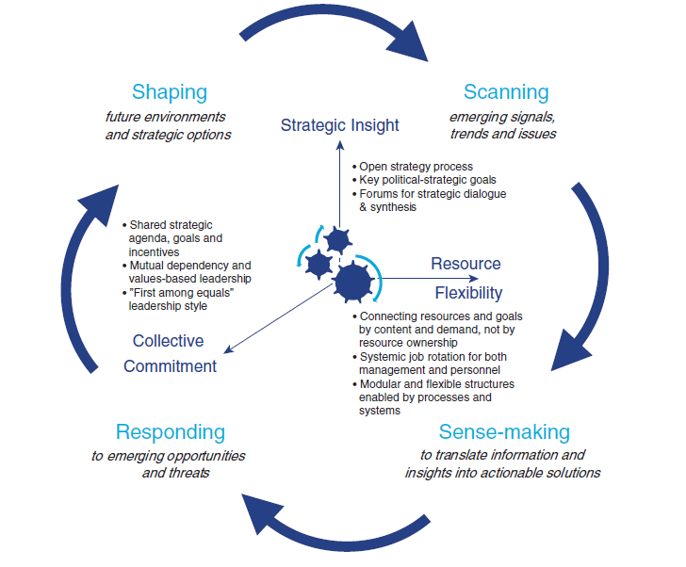

Source: Määttä (2011)

The outer cycle of the model represents the activities involved in strategic management:

* scanning is the process of gathering and analyzing useful, timely, actionable information;
* sense-making is the process of interpreting relevant information as the basis for decision-making:
  + It turns data into a narrative that supports practical understanding of the issue or problem so that solutions can be generated;
  + politicians and senior civil servants determine the issues requiring action by considering multiple and often competing demands on resources;
* responding is about setting priorities and allocating best available resources across the government in order to be able to deliver at two levels:
  + strategic, where politicians and senior civil servants create policy responses and allocate resources to new priorities;
  + operational, where frontline workers respond to the day-to-day changing needs of the customers they serve and the stakeholders they co-operate with;
* shaping moves governments beyond the reactive mode to proactively responding to emerging issues, stakeholders’ signals and citizens’ needs, influencing the future to come.

These activities are underpinned by three key capabilities, elaborated more in detail by Doz and Kosonen (2014):

* **Strategic sensitivity**: seeing and framing opportunities and threats in new, insightful ways, as they emerge:
  + Ambition gap to overcome complacency via interplay of:
    - alertness supported by discomfort from awareness that current policies and actions are failing:
      * supported by stretch goals, burning platforms as well as multiple and contradictory goals to force hard thinking, taking into account different perspectives and transcending apparent trade-offs;
    - innovation and risk-taking spirit in innovative policy solutions with small scale experiments to
      * bring new insights (where no evidence yet exists) in complex and multidimensional problems;
      * show new solutions actually working so decision-makers can change their minds with manageable risk;
    - strategic intelligence based on foresight (painting many possible futures rather than forecasts), evaluation, benchmarking to show shortfalls, incipient problems and opportunities and develop contingency plans;
    - using independent think tanks for fresh perspectives;
  + Input diversity via open, participative strategy process
    - Collision of new/orginal sources of info
    - Gathered via cross-functional and inter-organisational visioning and strategising, foresight, experiments
    - Involving not only top and specialists but also wider stakeholders, experts (from multiple fields) and observers as well as general public (eg via social media) rather than know quantity experts and stakeholder group representatives
  + Gain insight into evolving situations within complex environment using superior information but also based on high quality internal + external interpretative dialogue with the relevant people:
    - around emerging issues, tentative hypotheses and key options that guide further data collection and analysis
    - challenging due to organisational/functional/hierarchical boundaries, locational separation, pre-occupation with daily operational tasks and lack of shared vocabulary between experts (highly conceptual) and operating professionals (highly context specific)
* **Resource fluidity**: funds, talent, expertise, finance to be harnessed and redeployed quickly where needed as issues emerge, rather than parceled out in accordance with prior plans:
  + Requires focus on common optimum rather than parochial sub-unit interests which is challenging as
    - it is hard to identify superior aggregate public value (with cost/benefit calculations of a complete policy mix taking into account contextual interdependencies between policies showing that the the whole has more value than the sum of the parts)
    - freeing up public resources bumps into tendency of hierarchies to jealously guard established budgets, coalitions having painstakingly negotiated detailed lists of policies that reflect disparate party politics catering for specific interest groups
    - management systems are designed for functional optimisation of resources not reallocation or sharing
    - incentive systems geared towards specific activities rather than wider societal goals
  + Requires to relinquish control hence calls for reciprocity/trust and integrative negotiation
  + Can be supported by practices such as:
    - Flexible budgeting: dissociates unit’s past performance from expected resource commitments but ties these to governments strategic objectives
    - Basing financial allocations on performance goals rather than line items
      * Designing portion of resources to a common pool
      * Fostering mobility of civil servants
    - Some flexibility in applying administrative rules and processes (eg allowing “silent” deviations without having laws formally voted)
    - Multidimensional organisation
      * Horizontal cross-ministerial programmes with own budgets
      * Dedicated ministers to run horizontal programmes
    - Reallocation of responsibilities based on mission
    - Etc…
* Impossible without **collective engagement** to make joint decisions that all ministers, their cabinet staff and senior civil servants commit to, based on
  + Mutual understanding between them derived from repeated collaboration supported by
    - overlapping areas of expertise and rotations between ministries to enable appreciation of the perspectives of others
      * Keep experts and specialised analysts in junior positions or bring them in on a case by case basis (eg from universities, consulting, …)
    - time and opportunities to exchange views outside official meetings to get to know each other
    - time for open-ended substantive meetings to address larger strategic questions outside of day to day operations
  + A pan-governmental agenda with shared goals and related incentives:
    - National ambition, incl. an intended position for the country, e.g. in the global economy, rather than electoral tactics, representing shift from output to outcomes to emphasize the importance of positive effects to be accomplished delivered by policies incl. funding, regulations and services (Määttä , 2011)
    - a political plan or roadmap for the decisions and policies to be drafted and implemented (Määttä , 2011);
      * based on discussion and negotiation by top leadership, supported by the chief executive who has an appropriate leadership style
      * provides a common strategic framework that also highlights which policies need collaboration across ministries
    - only a few tightly focused and internally consistent priorities with measurable progress indicators (clear and transparent objectives / guidelines for policies that are set as high priority and for those that are set as low priority as stated in Määttä , 2011)
    - enable decision-makers down the hierarchy to make decentralised decision consistent with the set direction
  + Goals of various government entities that are transparent and fair in the eyes of peer top leaders
  + No political appointees in ministries

Doz and Kosonen (2014) out forward that skills development of senior civil servants may be needed. For example, for strategic sensitivity:

* Systems thinking and stakeholder analysis
* Scenario planning, avalanche modelling,… to develop a rich set of hypothesis on a situation and how it may evolve and to heighten sensitivity to weak signals as well as enhance pattern recognition
* Ability to recognise good from bad strategies (fluff –a lot of words but little substance; mistaking objectives/targets for strategy; lack of focus on a challenge to solve; unrealistic /unfeasible action plans)
* Dialogue skills with good level of abstraction (not too high/academic or low/too concrete and hence difficult to discuss across boundaries)
* “Business model” thinking to ensure possibilities turn into action
* Contextual awareness to enable translation of new insights from orginal context to new one

For resource fluidity:

* Adaptive leadership for common solution discovery and joint committment
* Integrative negotiation, looking for win-wins
* Entrepreneurship to take an idea, shape it into an initiative, garner support from those with power to allocate resources, maximise learning to cost ratio
* Similar system thinking, dialogue skills as with strategic sensitivity

For collective engagement, all the earlier skills are needed. Next to these, in general, leaders will need the ability to take practical, concrete action, to lead people with theory Y (participative, engaging, pluralistic) rather than X (coercive, hierarchical, autocratic) and listening and discerning.

# Merging three models?

Below, we add to Bryson’s (2011) model, elements from Mulgan (2009) and Doz and Kosonen (2014) / Määttä (2011), that enrich it or note similarities.

|  |  |  |
| --- | --- | --- |
| **Bryson (2001)** | **Mulgan (2009)** | **Doz and Kosonen (2014) / Määttä (2011)** |
| 1 Initiating and agreeing on a SP process | Not explicit in Mulgan (2009), although there is only a discussion how the process could be situated anywhere, but most certainly also at **central government level with involvement of parliament**.  Mulgan (2009) also recommends drawing on people with practical knowledge of street level realities when designing policies.  Bryson (2011) likewise recommends a careful consideration of whom to involve (in decision-making or consultation) in the planning process, incl. top level, middle management, technical core specialists and front-line staff as well as a variety of other actors.  Bryson (2011) also emphasizes the need at this stage for a “vision” for change (which can be partial and not very elaborate), to be carried over into steps 3 and 4, when one aims to trigger putting truly strategic issues on the table in step 5. | Not explicit in Doz and Kosonen (2014) / Määttä (2011) as there is an automatic assumption that the process is **situated at central government level**.  Doz and Kosonen (2014) / Määttä (2011) do devote much attention, under the capability of “strategic sensitivity/insight”, to the nature of the process which should be open and participative (beyond the top and a few specialists, to ensure input diversity). As noted, Bryson (2011) recommends a careful consideration of whom to involve. |
| 2 Identifying organizational mandates | Not explicit in Mulgan (2009), which makes sense as he tends to focus on strategy at central government level, which is not really an organization as such and which receives its mandate directly from the electorate. | Not explicit in Doz and Kosonen (2014) / Määttä (2011),for the same reasons as in Mulgan (2009). |
| 3 Clarifying mission/identity | Covered briefly in Mulgan (2009) under the step “why actions are taken”. | Not explicit in Doz and Kosonen (2014) / Määttä (2011). |
| 4 Assessing external and internal environment | Mulgan (2009) covers steps 4 and 5 in his steps “why actions are taken” as well as “What is the context”. There is broad agreement between both sources, all be it with some subtle differences. Whereas Mulgan (2009) discusses simple, complicated, complex and chaotic contexts in terms of knowledge, Bryson (2011) juxtaposes strategic (complex adaptive, developmental) and operational (technical, complicated) issues. Bryson (2011) then situates systems analysis as a tool for complex issues while Mulgan (2009) links this to non-complex (but still challenging in terms of number of variables) ones. Both authors situate the use of “futures” oriented tools (e.g. scenario’s) in these steps, with Mulgan (2009) again explicitly linking it to non-complex ones. Yet, Mulgan (2009) also states that scenarios and systems analysis can be a good basis for setting up experimentation to deal with complex issues.  On the other hand, Mulgan (2009) seems to take (more or less) power (of the state) to address an issue as a given fact, while Bryson (2011) puts this forward as a choice: framing the issue in a way that power must (not) be shared with other actors and is strategic rather than operational. | Doz and Kosonen (2014) / Määttä (2011) cover steps 4 and 5 under the capability of “strategic sensitivity/insight” which concerns seeing and framing opportunities and threats in new ways. This entails an ambition gap derived from the combination of alertness (driven by discomfort that current policies are failing or that stretch goals are beyond reach), small scale experiments (driven by an innovative and risk taking spirit) that bring new insights, as well as strategic intelligence derived from foresight and fresh perspectives from independent think tanks. In Bryson (2011) there is also a mentioning of the use of future oriented scenarios and using outsiders to avoid being captured by existing categories of classification and search. Also “alertness” is covered in some fashion under the guise of understanding “must meet” criteria and/or threats of stakeholders withdrawing support.  A difference to Bryson (2011) is that **Doz and Kosonen (2014) / Määttä (2011) explicitly mention experiments as sources of insights** while Bryson (2011) sees pilots or demonstration projects as tools for implementation (step 9 of his model).  To Doz and Kosonen (2014) / Määttä (2011), gaining insight is not just a question of superior information but also high quality interpretative dialogue with relevant people. They use the term “sense-making” which refers to turning data into a narrative that supports a practical understanding of an issue so that solutions can be generated.  Bryson (2011) likewise notes that issues need to be framed and that there is a need for deliberation and dialogue and the cultivation of useful tension between issues. Also, he states that conflict is to be expected, hence requiring high degrees of emotional intelligence. |
| 5 Identifying strategic issues |
| 6 Strategy development | In Mulgan (2009) steps “where to go” and “how to get there” basically encompasses four distinct steps in Bryson’s (2011) framework.  In “where to go” Mulgan (2009) makes a distinction between overall (typically path dependent, numbering no more than 3-5) strategic directions and goals at societal level and more precise ones (more limited in scope and hence more numerous), where the latter are not necessarily embedded in the former (no hierarchy) but just differ in terms of scope. This is linked to the concept of the change margin of government (e.g. financially, how much money does one want to divert to working on the future and how much power and commitment will one bring to bear…). Bryson (2011) likewise stresses the need, at this stage, for a guiding vision as crucial to guide implementation when dealing with truly strategic issues.  Bryson (2011) elaborates what is entailed by “strategy” in terms of major proposals, actions for the next 2-3 years and detailed work programmes for the next 6-12 months. Mulgan (2009) rather discusses this in terms of creative solutions, financing, restructuring (of who does what) and sequencing. In Bryson (2011), sequencing already happened in at the level of issues (step 5).  Also, for Mulgan (2009), vigorous (internal) debate happens during the “where to go” stage, whereas Bryson (2011) situates this more in step 5 at the level of issues. In step 7 (review and adopt), Bryson (2011) calls more for careful deliberation and negotiation.  In “how to get there” Mulgan (2009) does not cover detailed action plans. However, he does cover the traditional linear implementation model which in his view has limited applicability. He puts innovation forward as a model. Bryson (2011) similarly puts forward a choice between “direct” and “indirect” implementation. The former may work when there is a crisis or few technical or political difficulties. The latter concerns prototyping and piloting / demonstrating, with the aim of getting early adopters on board, followed by others. | Doz and Kosonen (2014) / Määttä (2011) put under “collective engagement” a few tightly focused and internally consistent priorities, linked to a pan-governmental agenda which contains a national ambition and a roadmap for decisions and policies to be drafted and implemented. This roughly reflects Bryson’s (2011) guiding vision as crucial to guide implementation and the elaboration of major proposals, actions for the next 2-3 years and detailed work programmes for the next 6-12 months.  Doz and Kosonen (2014) / Määttä (2011) see **strategic agility as not just responding reactively to a changing environment but also proactively shaping that environment.**  Doz and Kosonen (2014) / Määttä (2011) do not cover detailed action plans. However, they do cover innovation and the small scale experimentation that goes with it, hence showing a preference for the “indirect” approach of Bryson (2011). |
| 7 Review and adopt |
| 8 Organisational vision |
| 9 Develop an effective implementation process |
| 10 Reassessing strategies and the planning process | For Mulgan (2009) this concerns “which things worked and which did not”. He describes this as getting mistakes in early and rapidly adapting while Bryson (2011) similarly described this as action research. | This is a major focus for Doz and Kosonen (2014) / Määttä (2011) as the entire “outer cycle” of their process is essentially a learning cycle: scanning (=observation), sense-making (=interpreting), responding/shaping (=deciding and implementing). All three capabilities depicted in the model matter for this learning cycle, but crucially also resource fluidity (in terms of a focus on a common optimum, reciprocity/trust and integrative negotiation) as well as mutual understanding due to repeated collaboration (under collective engagement).  Also, Doz and Kosonen (2014) / Määttä (2011) make clear that “responding” is not only for politicians and senior civil servants, in terms of creating new policy responses and allocating resources to new priorities, but **also to enable frontline workers to respond to the changing needs of their customers and stakeholders on a day to day basis.** |

Overall, Bryson (2011), Mulgan (2009) and Doz and Kosonen (2014) / Määttä (2011) are broadly similar. The main differences with Mulgan (2009) lie in his focus on strategy that is made at central government level and his position that the context defines if knowledge and power are low or high. Bryson (2011) assumes strategy is made at an organisational level (which could be local government, a central agency, a ministry,…, although some mention is also made of communities and networks) and that issues are to be “framed” as strategic, rather than taken for granted. Also, Bryson (2011) sees framing the issues as provoking the most heated debates, whereas Mulgan (2009) puts this rather in the development of strategies.

Doz and Kosonen (2014) / Määttä (2011), like Mulgan (2009) also focus more on central government. They mention the lessons derived from experiments as an important part of gaining strategic insight, whereas Bryson (2011) positions these more as tools for implementation. Doz and Kosonen (2014) / Määttä (2011) put a learning cycle at the centre of their model, rather than as a separate (final) step. They also situate this learning cycle at the top in central government, as well as on the frontline. Finally, Doz and Kosonen (2014) / Määttä (2011) see strategic agility as not just responding reactively to a changing environment but also proactively shaping that environment.

# Reflections

From Rumelt (2001) we take away the following key points:

* Strategy should concern concentrating resources and action in a coordinated way on a few strategic insights and critical issues:
  + these reflect a deep understanding of what the key aspects of challenges are, e.g. specific causes of underperformance and associated obstacles to be overcome;
  + they also reflect an understanding of leverage/pivot points that will help address the challenge and multiply effectiveness of effort;
* Without the above, strategies are not strategies but just a loose collection of statements concerning (stretch) goals, visions, values, budgets, wish lists and the obvious.

Rumelt’s (2011) position is not incompatible with the idea of strategic logic as described by Desmidt and Heene (2005) (and similarly Mulgan, 2009) in terms of a business concept being matched with an organisational one. Rather, the strategic logic can be seen as one of many analytical support tools for pinpointing challenges as well as leverage points. There can be challenges pertaining to any element or to the logic connecting the elements. Indeed, a major challenge can be a lack of logic leading to incoherent actions and waste.

Rumelt’s (2001) views are also not in contradiction to the concepts of “guerilla strategy” and “strategy of trajectory” espoused on the one hand by Eisenhardt (2002) and Stopford (2001) and on the other by Hagel (2015). Indeed, these concepts relate more to a change in the nature of challenges and leverage points. For Eisenhardt (2002) and Stopford (2001) the key element is that building up resources (incl. core competencies) to address a clear and stable challenge for the longer term can no longer represent the main leverage point in responding to a VUCA reality. Rather, strategy then concerns the continuous generation of new ideas (business model innovation) to tackle rapidly shifting threats and opportunities. Hagel (2015), in turn, warns of the danger of spreading resources too thinly and missing what may really matter, when strategy concerns only short term, opportunistic responses. He adds that there still needs to be a longer term sense of direction, continuously in/reformed by (shifting) ideas of what the future may look like.

Hence, **strategy can be defined as “coherent action, guided by a longer term sense of direction, to transform core, value generating processes, backed by an argument.”**

This definition makes clear that the purpose of a strategy is to generate value via a transformation of core processes (such as innovation, operations, stakeholder relations, …). It also makes clear that the way this purpose is to be achieved is via coherent action guided by a sense of direction, implying coordination of actors (e.g. across levels, unit and other entities) as well as over time. There should also be an argumentation as to why a proposed transformation (of a business and/or organizational concept and the associated processes) is needed (insight into the issues) and how the proposed action actually would realise it (insight into the solution).

Based on Gluck et al (1980), Poister and Streib (1999) and Poister (2010) as well as the perspective of strategic regulation, the type of strategic management that should generate strategies as defined above can be described as a process that entails:

* Entrepreneurial thinking in terms of:
  + demanding new insights in terms of
    - identifying newly emerging issues (rather than running the routine business or focusing on incentivizing better short or medium term operating performance);
    - generating new options (rather than focusing on existing capabilities);
  + drawing on monitoring of the internal and external environment, futuristic thinking and subjective evaluation;
* Cutting across levels and boundaries, engaging widely (incl. junior people), with a focus on making things happen as a team;
* Ongoing strategic learning, thinking and acting (rather than engaging in a mechanical, annual routine of planning, implementation, evaluation and incrementally adjusting last year’s plans).

**As a definition of strategic management, we propose therefore “a continuous, non-linear process of entrepreneurial thinking and learning, cutting across levels and boundaries, guided by a longer term sense of direction, that produces coherent action aiming to transform core, value generating processes.”**

This definition integrates Mintzberg (1987) as follows:

* Entrepreneurial thinking aiming to transform core, value generating processes: this relates to strategy as position (value);
* Engagement that cuts across levels and boundaries to produce coherent action: coherent action concerns strategy as plan and pattern. Indeed, a pattern of coherent action does not imply that only a planned strategy is realized as it also contains emergent strategy;
* A continuous, non-linear process of learning, thinking and acting, guided by a longer term sense of direction: indeed, this is the reason why strategy as plan does not equal the realized strategy as pattern. If realised strategy would be equal to the planned one, this would reflect a lack of learning in a dynamic environment. It also would imply that there is a lack of strategy as ploy (taking on opportunities without questioning the overall strategy or responding to impositions). The longer term sense of direction relates to strategy as perspective.

The definition integrates the traditional notions of strategic planning (focused on analysis and strategy formulation) and strategy implementation and evaluation into one process of strategic management, as also proposed by Bryson (2011). While Bryson’s (2011) model, encompassing Mulgan (2009), Doz and Kosonen (2014) and Määttä (2011), therefore creates a useful starting point, in the sections below, we will use the literature concerning strategy and strategic management (both in the private as non-private sectors) since the 90 ies to further enrich the discussion on how to realise the various elements present in the proposed definition.

# Emerging themes from the literature

We provide a brief recap here of the main elements that emerged from the literature review.

In terms of **entrepreneurial thinking aiming to transform core, value generating processes**, we drew attention to:

* the transformational nature of strategic management as opposed to merely copying/elaborating strategies from the past and supporting “within the box” incremental improvement of the existing business;
* understanding that issues can be framed in different ways, namely as operational issues versus strategic ones. Strategic issues themselves can be further framed as requiring:
  + a regular innovative response: new solutions that may require new resources and capabilities that address newly conceptualized needs of certain actors, but do not conflict fundamentally with the existing configuration of regimes, actors and ST systems;
  + a systemic innovation response that aims to change the existing configuration;
* opening up to different perspectives and challenging fundamental assumptions in three fundamental ways:
  + taking the user perspective, enabling frontline teams, occasionally with the help of higher level management, to identify and respond to challenges in today’s environment;
  + taking a perspective from diverse futures, identifying where a risk lies of the absorptive capacity of frontline teams in being overwhelmed, initiating work on making the organization as ready as possible for an unpredictable future;
  + drawing on a larger variety of perspectives, held by diverse stakeholders, as to understanding the above mentioned user perspective as well as diverse possible futures and how to best address these;
* considering prioritizing the implementation of self-organised frontline teams (as intended by movements such as TQM) before strategic management, to ensure that taking the user perspective leads as much as possible to appropriate action (operational or strategic) without requiring senior management attention, except when a strategic issue exceeds the capacity of the front line to deal with it;
* being clear about the roles for strategists and planning support staff with increased attention to;
  + mobilisers (who focus on asking the right questions and challenging assumptions);
  + visionaries who focus on external trends and the opportunities and risks these represent and who run innovation processes to find ways to address these;
  + surveyors who take the longer term and broader perspective (beyond the organization itself), looking to frame issues as requiring systemic innovation.

As to the theme of **engagement that cuts across levels and boundaries to produce coherent action**, we noted the following:

* to increase the potential for new perspectives and conversations, one should include the young, those at the periphery and newcomers, within and even outside the organization;
* senior management must follow them closely in order to share their insights and understand their emerging convictions, co-creating a coherent story why the changing world needs the decided new ways of working;
* the top needs to retain the big picture and endorse opportunities but not confuse strategy execution with tightening the screws on alignment (cascading objectives and linking this to performance management) as these are tools better suited for business as usual -since they reinforce silos and hierarchy- than for transformation which tends to require collaboration across levels and boundaries;
* the tension between transformation efforts and maintaining business as usual needs to be managed by:
  + looking at what needs to be done today, from the perspective of business as usual, growing new solutions and creating options for future new ones;
  + as to growing a new solution, it needs to be understood that the more the required transformation deviates from what exists, the harder it becomes to absorb this within the same organisational “box” and the more it may be needed to set up parallel boxes, enabling new solutions to grow, while still borrowing from the existing box if possible.

There was also the theme of **strategic management being a continuous, non-linear process of learning, thinking and acting, guided by a longer term sense of direction**:

* as strategy is about transformation, driven by (unpredictable) change in the environment, and, hence, moving into uncharted territory, uncertainty abounds
* information gathering should focused on resolving uncertainty to enable decision-making on next steps. It should happen at the same pace as things happen, implying a shift from “review and approve” to “debate and decide”;
* low cost experimentation can support people in learning from mistakes (which are unavoidable, given the level of uncertainty noted above) and understand the issues better, with several options being executed in parallel;
* “discipline” (rather than acting ad hoc, at a whim) is required in the strategic management process as follows:
  + sticking with something long enough to be able to learn, dealing with a lot of biases in terms of identifying, interpreting and clarifying the nature of “signals” coming from the environment
  + maintaining a regular pace of decision-making
* in order to distinguish “noise” from real opportunity a longer term sense of purpose is needed; nevertheless, even this may, over time, need to shift, to ensure an organization continues to add value over time rather than tries to defend a specific value at a specific moment in time;
* over time, next to the many smaller, incremental changes that relate to the existing business; there will also be a need engage in a number of mid-sized ones as well as occasionally, larger, more radical ones that reinvent the business.

Finally**, shaping an ecosystem of actors** was also a theme that figured as an extension of the theme of engagement across boundaries. It involved:

* shaping a transition relates to a longer term, more radically different future that transcends the fate of any single actor but rather concerns an entire sector or societal function;
* radically different refers to challenging the current collective (societal) way of doing things, which is deemed to be unsustainable in the long run;
* as this concerns many actors, external to any specific organization, there is a need to mobilise these and move them out of the grid-lock of current reality, through positive incentives which amount to reducing risk/cost and helping with envisioning rewards;
* this leads to some particularities in how to run such processes:
  + a temporary network of innovators coming from many different corners, transcending any single organization, as they are supposed to represent only themselves, is supposed to engage in an arena to envision the new future as well as pathways to it;
  + the process is intended at some point to create a self-steering network of actors that connect their (organizational) agenda’s and develop experiments together;
  + there is still an important role for an specific actor, to facilitate and intermediate between the other actors in the ecosystem and to create a space for open discussion and experimentation. This actor then needs to ensure that it has credibility that it is in it for the long haul, that it has the strategic relations to create a critical mass and will not turn against any participants.

1. The Government Performance and Results Act (GPRA) had a large role in this in the US.
2. “Strategic management thinking and practice in the public sector” in Financial accountability and management 31 / 3
3. Short literature review for the governments of the future project: deliverable 1.
4. Strategic Management for the public services, Open University Press
5. Strategic Planning for Public and Nonprofit Organizations: A Guide to Strengthening and Sustaining Organizational Achievement, Jossey-Bass, 4th ed.
6. The art of public strategy, Oxford University Press, 2nd edition.
7. http://www.businessdictionary.com
8. “Strategic Management in the public sector” in Public productivity and management review, vol. 22 nr 3”
9. Governments for the Future: Building the Strategic and Agile State: SITRA
10. Five P’s for strategy in California Management Review, Fall
11. “The perils of bad strategy” in McKinsey Quartely, June
12. “Has strategy changed?” in MIT Sloan Management Review, Winter
13. From Transactional to Strategic: systems approaches to public service challenges. Paris: Oecd.
14. The big shift in strategy- strategies of trajectory. Blogpost at <http://edgeperspectives.typepad.com/edge_perspectives/2014/12/the-big-shift-in-strategy-part-1.html> . Retrieved 7/3/2017
15. “Should strategy makers become dream weavers” in Harvard Business Review, January
16. “Strategic management for competitive advantage” in Harvard Business Review, July 1980
17. “Zelfsturing in publieke dienstverlening: een verhaal van twee paradigma’s” in Vlaams Tijdschrift voor Overheidsmanagement, 2017
18. Christis J.H.P. (2011), De moderne sociotechniek als theoretische onderbouwing van Lean. In M & O nummer 2, pp. 96-115.
19. Based on Kuipers H., van Amelsvoort P. en Kramer EH. (2012), Het nieuwe organiseren. Leuven: Acco.
20. “A leaders framework for decision-making” in Harvard Business Review, October. As described in Wauters, 2015, Sourcebook on results based management.
21. Examples are the UKs strategy unit, SITRA in Finland, BEPA in the EC
22. Achieving Public Sector Agility at Times of Fiscal Consolidation, OECD
23. INTERNATIONAL WORKSHOP: “STRATEGIC AGILITY FOR STRONG SOCIETIES AND ECONOMIES”, OECD
24. Mission Possible: Agility and Effectiveness in State Governance, SITRA
25. Fast strategy, Pearson education.