 | EUROPEAN COMMISSION

European Structural and Investment Funds
Guidance for Member States and Programme Authorities

CPR_37_7_8_9 Combination of support from a financial instrument with other support

1. Regulatory references and text
CPR Article 37(7), (8), (9), Article 65(11)

2. Background
The legislative framework for the 2014-2020 programming period contains detailed and comprehensive provisions on financial instruments, including on the possibilities and conditions for combination of financial instruments with other forms of support.
Article 65(11) sets out the general rule for combining support from one or more ESI Funds or from one or more programmes and from other Union instruments.
As regards financial instruments Article 37(7) to (9) CPR set out more specific rules which clarify the conditions to be met for combining support in the form of financial instrument with another financial instrument or other forms of support. These conditions are applicable to all ESI Funds.

3. Legal Framework and recommendations

3.1. Two types of combination of support from a financial instrument with other support
The CPR provides for two types of combination of support from a financial instrument with other support (for example grants or other financial instruments).
3.1.1 Combination of support within a single operation
Financial instruments and other forms of support (including technical support, interest rate subsidies, and guarantee fee subsidies) may be combined under Article 37(7) CPR in a single operation.
This means that the ESIF programme support allocated to the financial instrument should cover the other form of support envisaged to be combined with the financial instrument, in addition to the funds to be used for investments in final recipients in the form of loan, equity, quasi-equity or guarantee and eligible management costs and fees. The total contribution from the ESIF programme to the financial instrument (including other forms of support combined with financial instrument) and its subsequent disbursement to the final recipients or for the benefit of final recipients and eligible management costs and fees constitute a single financial instrument operation ("FI operation").
The other forms of support (including technical support, interest rate subsidies, and guarantee fee subsidies) and the financial instrument are part of the same operation, financed from an ESI Fund under a priority axis (or measure in EAFRD) of an ESIF programme.
The other forms of support (including technical support, interest rate subsidies, and guarantee fee subsidies) are provided either by the fund manager or, in the case of financial instruments implemented pursuant to Article 38(4)(c), by the managing authority.

The conditions for combining the other forms of support (including technical support, interest rate subsidies, and guarantee fee subsidies) with a financial instrument under Article 37(7) CPR are:
- The other forms of support (including technical support, interest rate subsidies, and guarantee fee subsidies) must be directly related to the financial instrument;
- The financial instrument and the other forms of support (including technical support, interest rate subsidies, and guarantee fee subsidies) must target the same final recipients;
- The applicable state aid rules must be respected;
- Separate records must be maintained for each form of support.
As regards the condition under 1 the Commission considers interest rate subsidies and guarantee fee subsidies to be directly related to the financial instrument if they are associated and combined with ESIF programme loans and guarantees in a single financial package. As regards other grants the Commission considers them directly related to financial instruments if they concern technical support for the purpose of the technical preparation of the prospective investment and for the benefit of the respective final recipient (cf Article 5 of Regulation (EU) 480/2014).
The technical support, interest rate subsidies and guarantee fee subsidies follow the provisions applicable to financial instruments (e.g. on co-financing rate, payments, management costs and fees, reporting). The existence of such grant elements within a financial instrument operation does not exclude the possibility to apply a preferential co-financing rate for the priority axis under Article 120 (5) or measure in EAFRD under Article 59(4)(d) of Regulation (EU) No 1305/2013.
As regards the condition under 3, as the same final recipient may receive a technical support grant for the preparation of the investment and repayable support for this investment (e.g. in the form of a loan) the State aid rules on the cumulation of aid must be respected.
As regards the condition under 4, separate records for each form of support should be maintained (e.g. loans/guarantee fee subsidy/technical support) for the reporting purposes and for the declaration of eligible expenditure by the fund manager to the Managing Authority.

For the combination of a financial instrument and other form of support (including technical support, interest rate subsidies and guarantee fee subsidies) in a single financial instrument operation (under Article 37(7)CPR) other provisions within the CPR impose further conditions:
- The need for other forms of support (including technical support, interest rate subsidies and guarantee fee subsidies) to be combined within the financial instrument operation and the estimate of the ESIF programme contribution for such form of support must be covered by the ex-ante assessment (Article 37(2)(a)(e)CPR);
- Insofar as Article 37(9) CPR allows for the support provided through a grant and a financial instrument to cover the same expenditure item, the sum of all forms of support combined must not exceed the total amount of the expenditure item concerned.
- In accordance with Article 37(9) CPR, grants must not be used to reimburse support received from financial instruments.

- In accordance with Article 37(9) CPR, financial instruments must not be used to pre-finance grants.

3.1.2 Combination of support within two separate operations
Support from a financial instrument may be combined at the level of final recipient under Article 37(8) CPR with support from another ESI Funds priority or programme or another EU financed instrument. In this case the grant or other form of assistance does not constitute part of the financial instrument operation. The combination of the financial instrument support and of the grant (or other form of support) coming from another priority, programme or instrument takes place within two separate operations having distinct eligible expenditure.
Where an ESIF programme is designed in such a way that under one priority axis a grant support and a financial instrument support is delivered and the combination takes place within this priority axis the same approach as enshrined in Article 37(8) can be followed.
The conditions which need to be fulfilled are the following:
- The ESIF financial instrument support to final recipient is part of an operation with eligible expenditure distinct from the other sources of assistance;
- State aid rules are respected, in particular on cumulation of aid;
- Separate records are maintained for each source of assistance. In the case of ESI Funds this means that separate records and supporting documents for the audit trail should be maintained for the financial instrument operation and for the other operation ( e.g. grant operation).

For the combination of the financial instrument support and of the grant (or other form of support) under Article 37(8), again the conditions set out in Article 37(9) must be respected, namely:
- Insofar as Article 37(9) allows for the support provided through a grant and a financial instrument to cover the same expenditure item, the sum of all forms of support combined must not exceed the total amount of the expenditure item concerned;
- Grants must not be used to reimburse support received from the financial instrument;
- The financial instrument must not be used to pre-finance the grants.

For EAFRD, the combined support from the two separate operations shall not go beyond the admissible rate of support defined in Annex II of Regulation (EU) No 1305/2013.

3.2 Combination of assistance under Article 65(11) and Article 37(7) to (9)

Article 65 (11) CPR in relation to the support for an operation from one or more ESI Funds or from one or more programmes and from other Union instruments provides that an expenditure item included in an application for payment for reimbursement by one ESI Fund must not receive support from another Fund or Union instrument, or support from the same Fund under another programme.
In the case set out in point 3.1.1, the combination of support is within one single operation which is the financial instrument itself. This operation is financed from one ESI Fund only and from one priority axis (measure in EAFRD programmes).
In the case set out in point 3.1.2 the situation provided for in Article 65(11) will not occur because the combination of support is within two separate operations (the combination of a financial instrument supported with an ESI Fund with another ESI Fund or another Union Fund implies two separate operations).

Annex I. Examples

1. Illustrative example on combination of FI and grant within FI operation – (point 3.1.1)
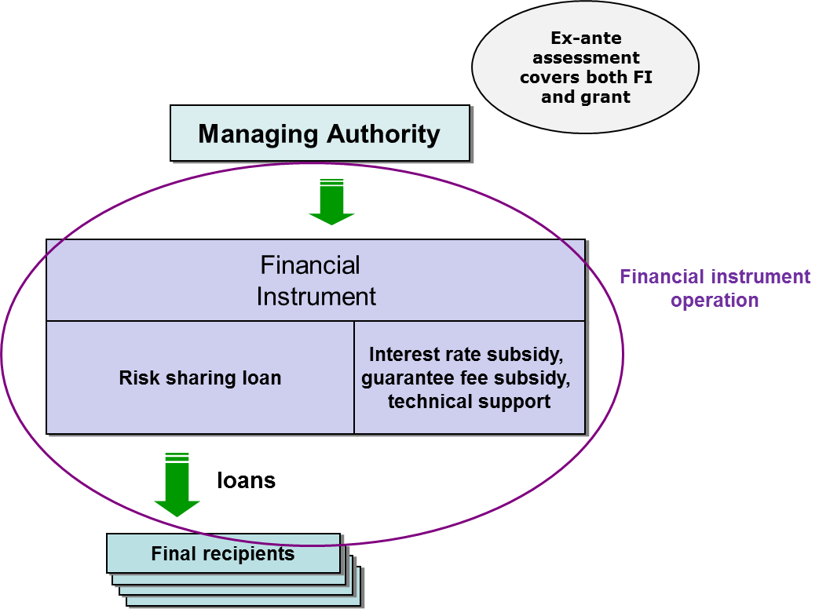

2. Illustrative examples on combination in the context of two operations – (point 3.1.2)

Four basic options are possible:
- Both FI and grant are financed (from the same priority axis or measure or different priority axes or measures) under the same ESIF programme or two different ESIF programmes (FI ESIF + G ESIF): in this case these two distinct forms of support combined at the level of investment in final recipient form parts of two separate operations (financial instrument operation and grant operation) with distinct eligible expenditure.

Example: the investment consists of 1 expenditure item of EUR 100.000 which is financed by ESIF programme grant and ESIF programme loan. The programme loan of 45.000 constitutes part of FI operation which, in the case at stake, is financed by ESIF and national co-financing. The programme grant of 55.000 includes both ESIF and national co-financing.
A similar distinction will have to be applied when financial instrument support is combined with repayable assistance.

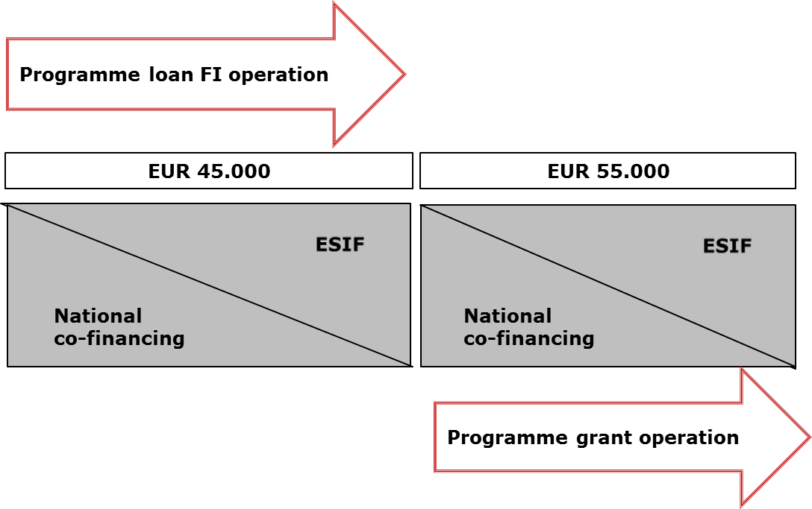
- A FI financed from an ESIF programme is combined with another FI financed from an ESIF programme (the same or other) (FI ESIF +FI ESIF): in this case these two sources of financing combined at the level of investment in the final recipient form parts of two separate FI operations under the CPR with distinct eligible expenditure.
Example: The investment consists of 1 expenditure item of EUR 100.000 which is financed by an ESIF programme loan of EUR 55.000 and an ESIF programme guarantee in respect of a commercial loan of EUR 45.000. The prudent ex-ante risk assessment referred to in Article 42(1) (b) concluded that ESIF programme resources committed for guarantee contracts will be 20% of underlying loan (i.e. EUR 9.000). The ESIF programme loan and the guarantee are financed under two separate FI operations financed by ESIF and national co-financing under two separate thematic objectives.
In case of ESIF programme guarantees, the eligibility rules should be applied to the entire loan (portfolio) supported with the guarantee. Such a requirement is linked to the nature of the guarantee and universality of the loan (portfolio). Indeed, at the moment of committing the guarantee, it is not possible to predict which (and if any at all) part of the loan (portfolio) will default and be written off and eventually covered by the ESIF programme guarantee. As a result it would be necessary that the entire loan (all underlying loans in the portfolio) respect eligibility rules and that for the entire loan (for all underlying loans) the conditions on combination are applied.
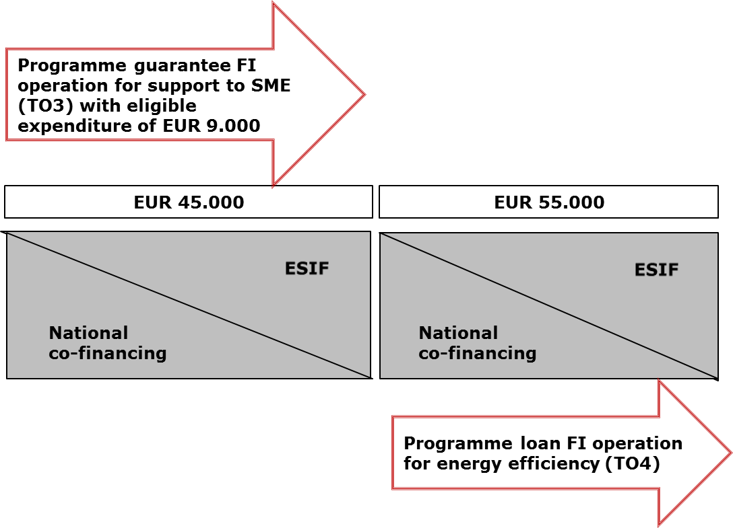

- A FI financed from ESIF programme is combined with a grant financed from another instrument supported by the budget of the Union (FI ESIF + G non-ESIF): in this case the FI support to the investment in the final recipient forms part of a separate operation (financial instrument operation under CPR) with distinct eligible expenditure. The other part of support to the investment at the level of final recipient (e.g. grant from Horizon 2020) represents a separate intervention to which the rules specific to the other instrument supported by the EU budget apply. It cannot be presented as eligible expenditure under ESIF programme even for the part covered by the national co-financing.
Example: The investment consists of 1 expenditure item of EUR 100.000 which is financed by a loan of EUR 45.000 from FI co-financed by ESI funds and by a grant of EUR 55.000 from EU level programme, e.g. Horizon 2020.

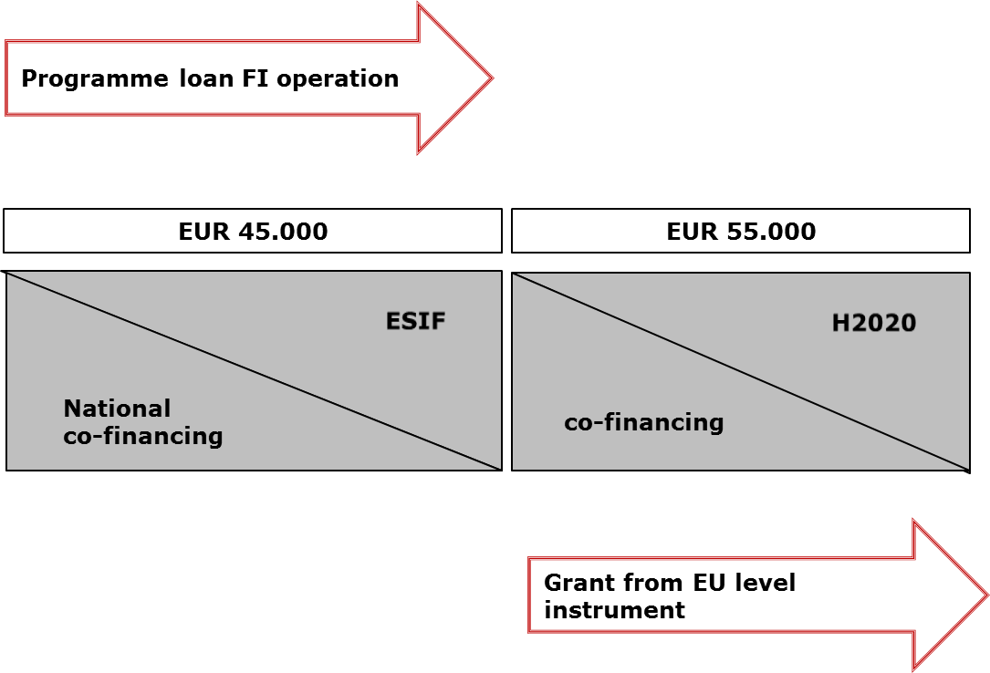

- A FI financed from an ESIF programme is combined with a FI financed from another instrument supported by the budget of the Union (FI ESIF + FI non-ESIF): in this case the FI support to the investment in the final recipient forms part of a financial instrument separate operation with distinct eligible expenditure. The support from the FI financed form another instrument supported by the budget of the Union to the investment at the level of final recipient (e.g. a loan from Horizon 2020) represents a separate intervention to which the rules specific to the other instrument supported by the EU budget apply. It cannot constitute co-financing for the ESIF part.
Example: The investment consists of 1 expenditure item of EUR 100.000, which is financed by a loan of EUR 45.000 from a FI co-financed by ESI Funds and by a loan of EUR 55.000 co-financed by an EU level programme e.g. Horizon 2020.

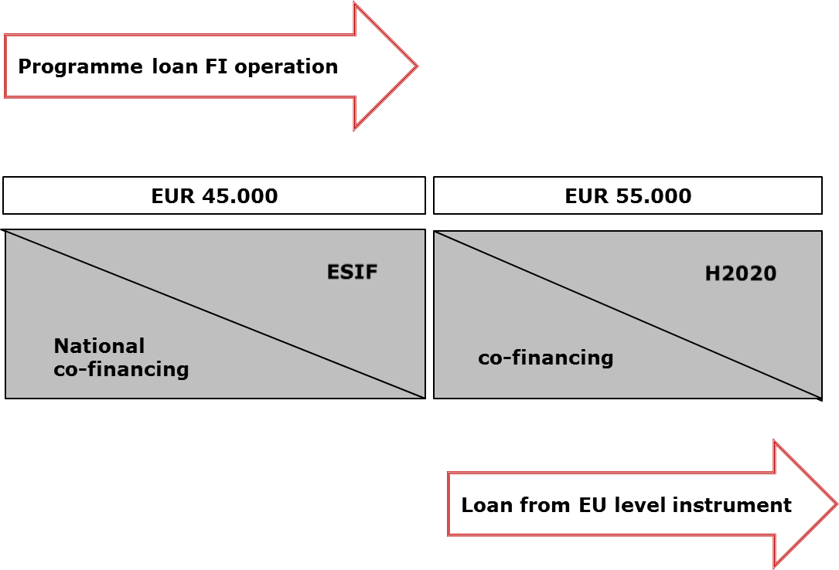
Annex II. Questions and Answers

- Is it enough to comply with State aid rules when combining support from FI and a grant?
No, the MA has to comply with State aid rules, CPR rules as well as any other applicable rules.
- Is it possible to combine within a single FI operation a grant (other than technical support, interest rate subsidy or guarantee fee subsidy ) and a loan for an investment by final recipients?
No, the combination of a grant and support from a financial instrument aiming at investments in a final recipient is covered by provisions under Article 37(8). In this case a grant and a FI constitute two separate operations with distinct eligible expenditure.
- Can capital rebates be combined with FI?
A financial instrument providing support in the form of a loan cannot include a capital rebate in its design. This would be noncompliant with the definition of a loan referred to in Article 2 (k) of the Financial Regulation as an agreement which obliges the lender to make available to the borrower an agreed sum of money for an agreed period of time and under which the borrower is obliged to repay that amount within the agreed time. Since the borrower is obliged to repay the borrowed amount of money, there is no scope to embed capital rebates within a loan.
It should be underlined that a capital rebate cannot be presented as a grant to a final recipient as this would be noncompliant with the provisions of Article 37(9) which forbid using grants to reimburse support received from financial instruments. The purpose of such a grant would be to enable full or partial repayment of the loan. Such a grant would be ineligible as it is used to reimburse support received from a financial instrument.
- Can one enterprise receive from the same priority axis/measure a grant and a loan for a single investment?
Yes, it is possible as described in Article 37(8) CPR. In this case two streams of support constitute parts of two separate operations with distinct eligible expenditure.
- Can an ESIF programme guarantee be used to cover the ESIF programme loan?
The purpose of a guarantee is to share the financial risk linked to the underlying loan between the lender and the guarantor. The situation where the lender and guarantor represent the same financing source (ESIF programme) does not make any economic sense.
Moreover, such construction would be in contradiction with the principle of sound financial management applicable to managing authorities.
- Can the interest rate subsidy combined within the financial instrument operation be used in relation to the ESIF programme loan?
In order to make the best use of the programme contribution transferred to the financial instrument, interest rate subsidies and guarantee fee subsidies should be used only to improve for the final recipient the conditions of access to the private capital co-invested at the level of the relevant financial instrument (i.e. they should not be used to improve conditions of the support already received from ESIF or from national public co-financing through the financial instrument).
- Are the eligibility rules on VAT in financial instrument also applicable to the grant elements combined with financial instrument in a single operation (e.g. technical support)?
The special rules on eligibility of VAT as stipulated in Article 37(11) are applicable only in relation to the investments in final recipients in a form of equity, quasi equity, loans, guarantee or other risk sharing instrument. For the grants which are combined with a financial instrument the VAT rules under Article 69(3)(c) apply.

The co-financing rate at the level of an operation is decided and fixed by the managing authority. Thus ESIF support could provide even 100% financing to an operation. The expenditure of each operation will be included in the application for payment submitted to the Commission to which the co-financing rate of the relevant priority axis will be applied for the sake of determining the amount to be paid by the Commission to the OP.
If the loan and the guarantee are part of the same FI operation (for example ESIF contribution is made to fund of funds which sets up a guarantee fund and a loan fund) the same principle of distinct eligible expenditure should apply.

