 | EUROPEAN COMMISSION

European Structural and Investment Funds
Guidance for Member States and Programme Authorities

CPR_37_7_8_9 Combination of support from a financial instrument with other support

DISCLAIMER:
"This is a working document prepared by the Commission services. On the basis of the applicable EU law, it provides technical guidance to the attention of public authorities, practitioners, beneficiaries or potential beneficiaries, and other bodies involved in the monitoring, control or implementation of the Cohesion policy on how to interpret and apply the EU rules in this area. The aim of this document is to provide Commission services' explanations and interpretations of the said rules in order to facilitate the implementation of operational programmes and to encourage good practice(s). However this guidance note is without prejudice to the interpretation of the Court of Justice and the General Court or decisions of the Commission."
1. Regulatory references and text
CPR Article 37(7), (8), (9), Article 65(11)

The guidance note is applicable to all ESI Funds.

2. Background
The legislative framework for the 2014-2020 programming period contains detailed and comprehensive provisions on financial instruments, including on the possibilities and conditions for combination of financial instruments with other forms of support.
Article 65(11) sets out the general rule for combining support from one or more ESI Funds or from one or more programmes and from other Union instruments.
As regards financial instruments Article 37(7) to (9) CPR sets out more specific rules which clarify the conditions to be met for combining ESIF programme support in the form of a financial instrument with another financial instrument or other forms of support from an ESIF programme or another instrument supported by the budget of the Union.
This note is not applicable to the cases where ESIF programme support, in the form of a financial instrument, is combined with national or regional schemes not supported by an ESIF programme or by the budget of the Union. It is therefore not applicable if ESIF programme support in the form of a financial instrument is combined with support from resources paid back from financial engineering instruments set up in the 2007-2013 period as these resources are not considered to be programme resources any more.

3. Legal Framework and recommendations

3.1. Two types of combination of support from a financial instrument with other support
The CPR provides for two types of combination of support from a financial instrument with other support (for example grants or other financial instruments).

3.1.1 Combination of support within a financial instrument operation (a single operation)
Financial instruments and other forms of support (including technical support, interest rate subsidies, and guarantee fee subsidies) may be combined under Article 37(7) CPR in a single financial instrument operation. The other form of support combined with the financial instrument must be directly linked to the financial instrument. The purpose of such support should be facilitation and enhancement of the implementation of the financial instrument.
This means that the ESIF programme support allocated to the financial instrument should cover the other form of support envisaged to be combined with the financial instrument, in addition to the funds to be used for investments in final recipients in the form of loan, equity, quasi-equity or guarantee and eligible management costs and fees. The total contribution from the ESIF programme to the financial instrument (including other forms of support combined with the financial instrument) and its subsequent disbursement to the final recipients or for the benefit of final recipients and eligible management costs and fees constitute a single financial instrument operation ("FI operation").
The other forms of support (including technical support, interest rate subsidies, and guarantee fee subsidies) and the financial instrument are part of the same operation, co-financed by an ESI Fund under a priority axis (or measure in EAFRD) of an ESIF programme.
The other forms of support (including technical support, interest rate subsidies, and guarantee fee subsidies) are provided either by the fund manager or, in the case of financial instruments implemented pursuant to Article 38(4)(c), by the managing authority. The support is for the benefit of final recipients but it is not directly paid to the final recipient.

The conditions for combining the other forms of support (including technical support, interest rate subsidies, and guarantee fee subsidies) with a financial instrument under Article 37(7) CPR are:
- The other forms of support (including technical support, interest rate subsidies, and guarantee fee subsidies) must be directly related to the financial instrument;
- The financial instrument and the other forms of support (including technical support, interest rate subsidies, and guarantee fee subsidies) must target the same final recipients;
- The applicable state aid rules must be respected;
- Separate records must be maintained for each form of support.
As regards condition n° 1 the Commission considers interest rate subsidies and guarantee fee subsidies to be directly related to the financial instrument if they are associated and combined with ESIF programme loans and guarantees in a single financial package for the financial instrument investment. A single financial package implies that financial products (loans/guarantee/guarantee fee subsidy/interest rate subsidy) are operationally linked and reflected in the legal agreements. As regards other grants the Commission considers them directly related to financial instruments if they concern technical support for the purpose of the technical preparation of the prospective investment and for the benefit of the respective final recipient (cf. Article 5 of Regulation (EU) 480/2014). The technical support, interest rate subsidies and guarantee fee subsidies follow the provisions applicable to financial instruments (e.g. on governance structure, substantiation of expenditure, co-financing rate, payments, management costs and fees, reporting). The existence of such grant elements within a financial instrument operation does not exclude the possibility to apply a preferential co-financing rate for the priority axis under Article 120 (5) or measure in EAFRD under Article 59(4)(d) of Regulation (EU) No 1305/2013.
As regards condition n° 3, as the same final recipient may receive a technical support grant for the preparation of the investment and repayable support for this investment (e.g. in the form of a loan) the State aid rules on the cumulation of aid must be respected. For EAFRD, the combined support must not go beyond the maximum amount/rate defined in the rural development programme, in line with Regulation (EU) No 1305/2013.
As regards condition n° 4, separate records for each form of support should be maintained (e.g. guarantees/interest rate subsidy/technical support) for reporting purposes and for the declaration of eligible expenditure by the fund manager to the Managing Authority.

For the combination of a financial instrument and other form of support (including technical support, interest rate subsidies and guarantee fee subsidies) in a single financial instrument operation (under Article 37(7)CPR) other provisions within the CPR impose further conditions:
- The need for other forms of support (including technical support, interest rate subsidies and guarantee fee subsidies) to be combined within the financial instrument operation and the estimate of the ESIF programme contribution for such form of support must be covered by the ex-ante assessment (Article 37(2)(a)(e)CPR);
- Insofar as Article 37(9) CPR allows for the support provided through a grant and a financial instrument to cover the same expenditure item, the sum of all forms of support combined must not exceed the total amount of the expenditure item concerned;
- In accordance with Article 37(9) CPR, grants must not be used to reimburse support received from financial instruments;

- In accordance with Article 37(9) CPR, financial instruments must not be used to pre-finance grants

3.1.2 Combination of support at the level of the final recipient (combination of two separate operations)
Support from a financial instrument may be combined at the level of final recipient under Article 37(8) CPR with support from another ESI Funds priority or programme or another EU financed instrument. In this case the grant or other form of assistance does not constitute part of the financial instrument operation. The combination of the financial instrument support and of the grant (or other forms of support) coming from another priority, programme or instrument takes place within two separate operations, each having distinct eligible expenditure.
Where an ESIF programme is designed in such a way that under one priority axis or measure (in EAFRD) a grant support and a financial instrument support is delivered and the combination takes place within this priority axis or measure (in EAFRD) the same approach as enshrined in Article 37(8) can be followed.
The conditions which need to be fulfilled are the following:
- The ESIF financial instrument support to final recipient is part of an operation with eligible expenditure distinct from the other sources of assistance;
- State aid rules are respected, in particular on cumulation of aid;
- Separate records are maintained for each source of assistance. In the case of ESI Funds this means that separate records and supporting documents for the audit trail should be maintained for the financial instrument operation (down to the level of final recipient) and for the other operation (down to the level of grant beneficiary).
For the combination of the financial instrument support and of the grant (or other form of support) under Article 37(8), again the conditions set out in Article 37(9) must be respected, namely:
- Insofar as Article 37(9) allows for the support provided through a grant and a financial instrument to cover the same expenditure item, the sum of all forms of support combined must not exceed the total amount of the expenditure item concerned;
- Grants must not be used to reimburse support received from the financial instrument;
- The financial instrument must not be used to pre-finance the grants.

For EAFRD, the combined support from the two separate operations shall not go beyond the maximum amount/rate defined in the rural development programme, in line with Regulation (EU) No 1305/2013.

3.2 Combination of assistance under Article 65(11) and Article 37(7) to (9)

Article 65 (11) CPR in relation to the support for an operation from one or more ESI Funds or from one or more programmes and from other Union instruments provides that an expenditure item included in an application for payment for reimbursement by one ESI Fund must not receive support from another Fund or Union instrument, or support from the same Fund under another programme.
In the case set out in point 3.1.1, the combination of support is within one single operation which is the financial instrument itself. This operation is financed from one ESI Fund only and from one priority axis (measure in EAFRD programmes).
In the case set out in point 3.1.2 the situation provided for in Article 65(11) will not occur because the combination of support is within two separate operations (the combination of a financial instrument supported with an ESI Fund with another ESI Fund or another Union Fund implies two separate operations).

Annex I. Examples

1. Illustrative example on combination of FI and grant within a FI operation – (point 3.1.1)
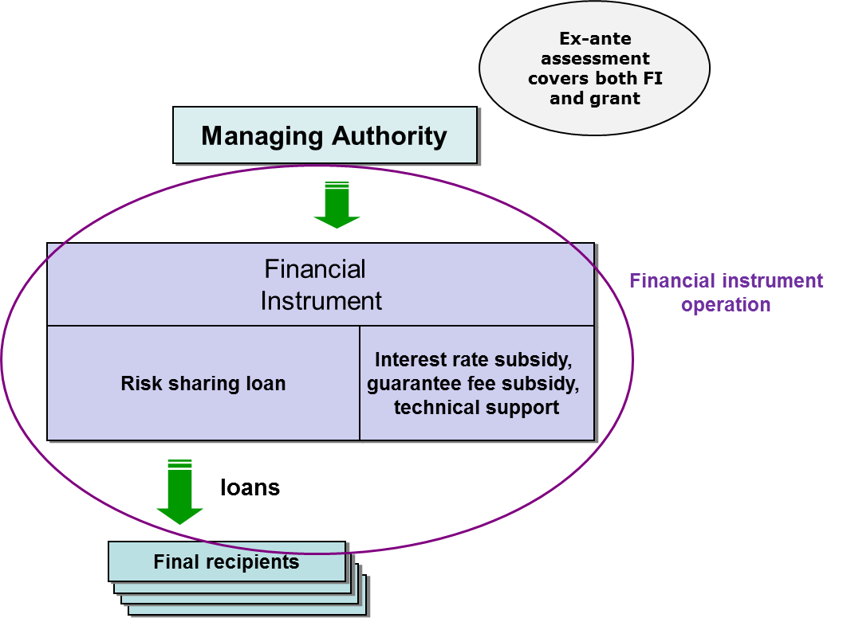

2. Illustrative examples on combination at the level of final recipient - context of two operations – (point 3.1.2)

2.1. Four basic options are possible:
- Both FI and grant are financed (from the same priority axis or measure or different priority axes or measures) under the same ESIF programme or two different ESIF programmes (FI ESIF + G ESIF): in this case these two distinct forms of support combined at the level of investment in final recipient form parts of two separate operations (financial instrument operation and grant operation) with distinct eligible expenditure.

Example: the investment consists of 1 expenditure item of EUR 100.000 which is financed by an ESIF programme grant and an ESIF programme loan. The programme loan of EUR 45.000 constitutes part of a FI operation which, is financed by ESIF and national co-financing. The programme grant operation of EUR 55.000 includes both ESIF and national co-financing. The expenditure declared to the Commission in relation to the loan will be EUR 45.000. The expenditure declared to the Commission in relation to grant operation will be EUR 55.000. When executing the payments the Commission will apply the co-financing rate of the priority axis to the expenditure declared.
A similar distinction will have to be applied when financial instrument support is combined with repayable assistance. It is possible that instead of a grant operation of EUR 55.000 a repayable assistance of EUR 55.000 is granted. The fact that repayable assistance may need to be repaid by the beneficiary to the managing authority subject to the fulfilment of certain conditions has no impact on the expenditure declared to the Commission. In this case the expenditure declared to the Commission in relation to the loan will be EUR 45.000. The expenditure declared to the Commission in relation to repayable assistance will be EUR 55.000. When executing the payments the Commission will apply the co-financing rate of the priority axis tothe expenditure declared.
For the EAFRD, the programme public support must not be higher than the maximum support rate under the measure.

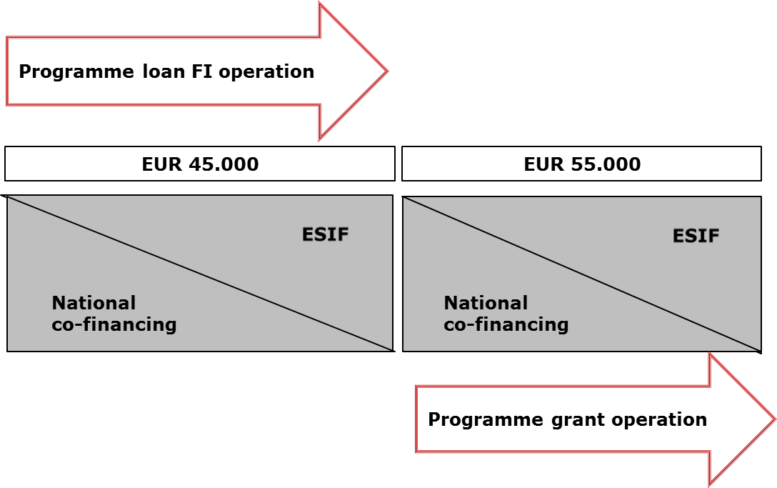
Own contribution by the final recipient
If the final recipient is obliged to provide a financial contribution from its own resources or by external financing in a form which is free of any public support (c.f. Article 14 on Regional investment aid under Regulation (EU) N° 651/2014) then the financing of the project would need to include also an own contribution (or external financing free of any public support).
In this situation, in the example the investment consisting of one expenditure item of EUR 100.000 would be financed by the ESIF programme grant , by the ESIF programme loan and by own resources of the final recipient. The programme loan of EUR 50.000 constitutes part of a FI operation which, in the case at stake, is financed by ESIF and national co-financing. The programme grant operation of EUR 50.000 includes both public expenditure (EUR 25.000 of ESIF and national co-financing) and EUR 25.000 of own private contribution.
If the grant operation is financed under a priority axis with a Fund's contribution calculated on the basis of total eligible expenditure, i.e. both public and private (c.f. Article 120(2)(a) of CPR) the Commission, when executing the payments, will apply the co-financing rate of priority axis to the "total amount of eligible expenditure incurred by beneficiaries and paid in implementing operations" (i.e. to EUR 50.000).
If the grant operation is financed under a priority axis with a Fund's contribution calculated on the basis of public expenditure (c.f. Article 120(2)(b) of CPR) the Commission, when executing the payments, will apply the co-financing rate of priority axis to the total amount of public expenditure incurred in implementing operations (i.e. to EUR 25.000).

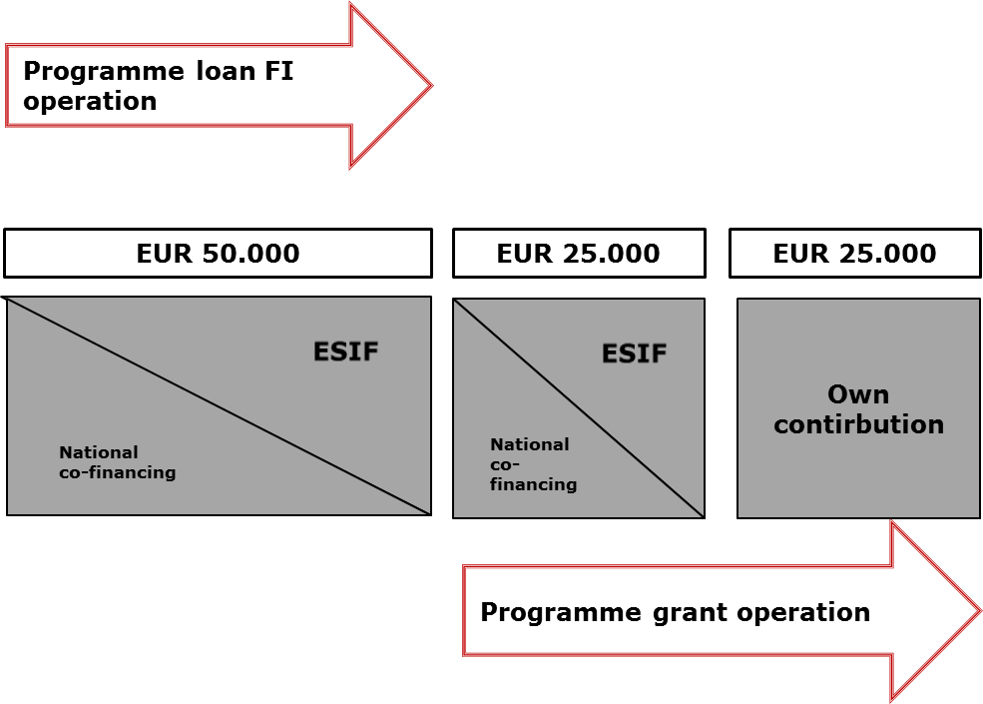

It should be underlined that the own contribution by the final recipient cannot be declared as eligible expenditure under the financial instrument operation, because in accordance with Article 42(1)(a) eligible expenditure is the payment to the final recipient.

- A FI financed from an ESIF programme is combined with another FI financed from an ESIF programme (the same or other) (FI ESIF +FI ESIF): in this case these two sources of financing combined at the level of investment in the final recipient form parts of two separate FI operations under the CPR with distinct eligible expenditure.
Example: The investment consists of 1 expenditure item of EUR 100.000 which is financed by an ESIF programme loan of EUR 55.000 and an ESIF programme guarantee for a commercial loan of EUR 45.000. The prudent ex-ante risk assessment referred to in Article 42(1) (b) concluded that ESIF programme resources committed for the guarantee contract will be 20% of the underlying loan (i.e. EUR 9.000). The ESIF programme loan and the guarantee are financed under two separate FI operations financed by ESIF and national co-financing. .
In case of ESIF programme guarantees, the eligibility rules should be applied to the entire loan (portfolio) supported with the guarantee. Such a requirement is linked to the nature of the guarantee and universality of the loan (portfolio). Indeed, at the moment of committing the guarantee, it is not possible to predict which (and if any at all) part of the loan (portfolio) will default and be written off and eventually covered by the ESIF programme guarantee. As a result it would be necessary that the entire loan (all underlying loans in the portfolio) respect eligibility rules and that for the entire loan (for all underlying loans) the conditions on combination are applied.
The expenditure declared to the Commission in relation to the guaranteed loan will be EUR 9.000. The expenditure declared to the Commission in relation to ESIF programme loan will be EUR 55.000. When executing the payments the Commission will apply the co-financing rate of priority axis to the expenditure declared.

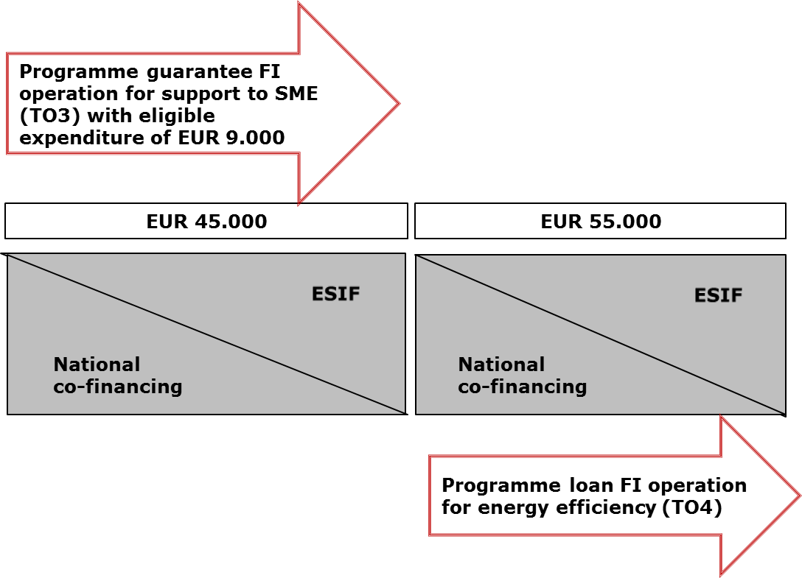

- A FI financed from an ESIF programme is combined with a grant financed from another instrument supported by the budget of the Union (FI ESIF + G non-ESIF): in this case the FI support to the investment in the final recipient forms part of a separate operation (a financial instrument operation under CPR) with distinct eligible expenditure. The other part of support to the investment at the level of final recipient (e.g. grant from Horizon 2020) represents a separate intervention to which the rules specific to the other instrument supported by the EU budget apply. It is not presented as eligible expenditure under ESIF programme including for the part covered by the national co-financing.
Example: The investment consists of an expenditure item of EUR 100.000 which is financed by a loan of EUR 45.000 from FI co-financed by ESI funds and by Horizon 2020 supporting the remaining EUR 55.000 of investment.
The expenditure declared to the Commission in relation to the ESIF programme loan will be EUR 45.000. When executing the payments the Commission will apply the co-financing rate of priority axis to the expenditure declared.

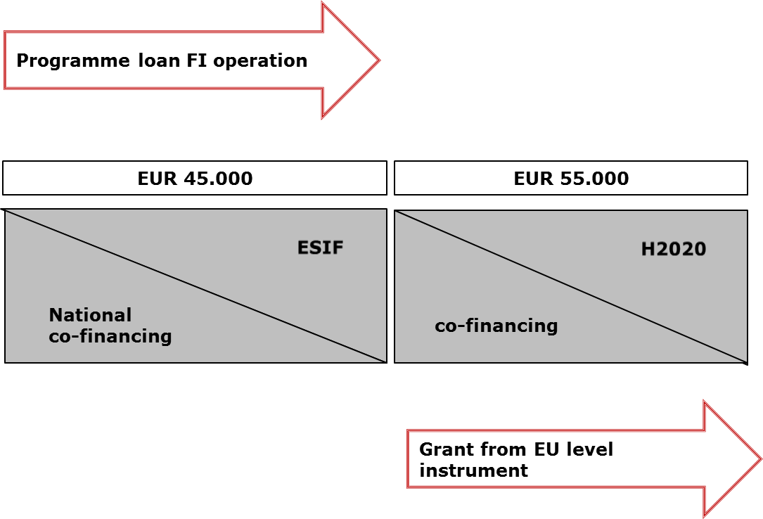

- A FI financed from an ESIF programme is combined with a FI financed from another instrument supported by the budget of the Union (FI ESIF + FI non-ESIF): in this case the FI support to the investment in the final recipient forms part of a financial instrument separate operation with distinct eligible expenditure. The support from the FI financed form another instrument supported by the budget of the Union to the investment at the level of final recipient (e.g. a loan from Horizon 2020) represents a separate intervention to which the rules specific to the other instrument supported by the EU budget apply. It does not constitute co-financing for the ESIF part.
Example: The investment consists of 1 expenditure item of EUR 100.000, which is financed by a loan of EUR 45.000 from a FI co-financed by ESI Funds and by a loan of EUR 55.000 co-financed by Horizon 2020.
The expenditure declared to the Commission in relation to the ESIF programme loan will be EUR 45.000. When executing the payments the Commission will apply the co-financing rate of priority axis to the expenditure declared.

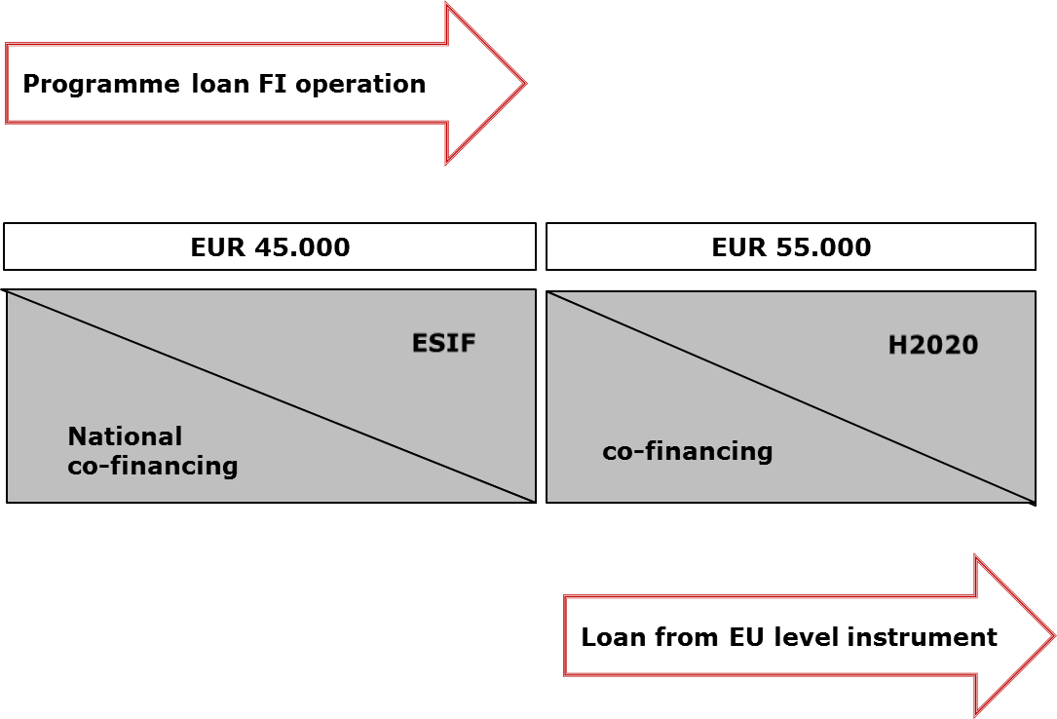

2.2. Combined support delivered through a single body
The requirement for separate operations and distinct eligible expenditure does not imply that both types of support cannot be delivered through the same body.
It is up to the managing authority to design and implement the grant scheme and the financial instrument in a way which ensures that final recipients' needs are properly addressed.
For example, the two types of support: a grant and a loan (formally constituting parts of distinguished operations) can be granted by the same body, i.e. regional financial Institution. The regional financial institution which will act as a "body implementing a financial instrument" for the financial instrument operation will issue loans to the final recipients, e.g. SMEs. On the basis of Article 123(6) CPR the same body can be designated as an "intermediate body" which provides grants to the same SMEs considered "beneficiaries" in case of grants. The grant support and the loan support can be even granted for the same expenditure item. An SME can in practice sign on the same day and with the same body agreement(s) with separate provisions relating to the grant and provisions relating to the loan.
Grant support follow grant rules (e.g. substantiation of expenditure incurred) and the loan support will follow FI rules. The two flows of funding have to be separately recorded as formally they belong to two different operations. At the level of the final recipient/grant beneficiary this separation will be also kept (normally both sources of funding are differently recorded in the balance sheet and have a different accounting nature).

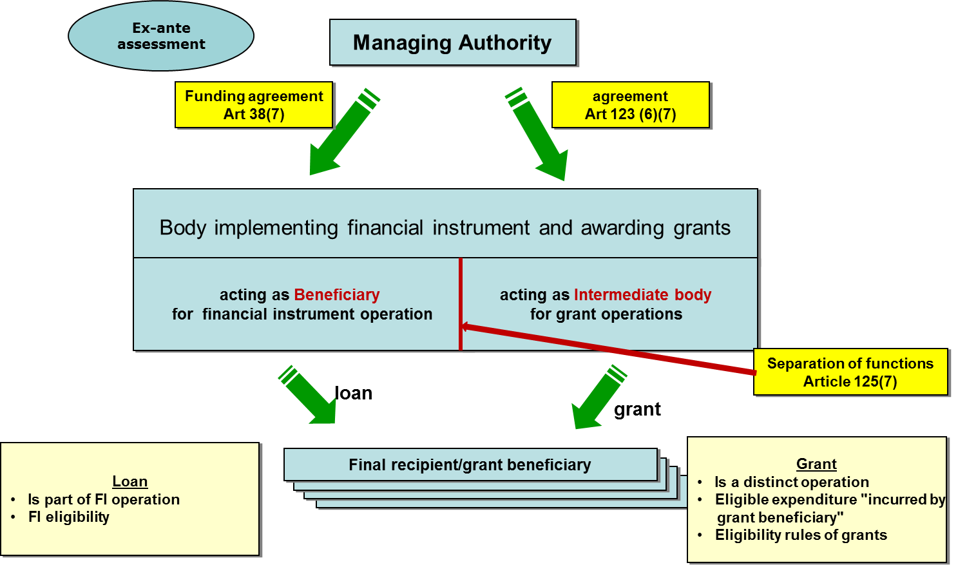
Annex II. Questions and Answers
- Is it enough to comply with State aid rules when combining support from FI and a grant?
No, the MA has to comply with State aid rules, CPR rules as well as any other applicable rules.
- Is it possible to combine within a single FI operation a grant support to be paid to the final recipient for an investment and a loan support to be paid to the same final recipient for the same investment?
No, it is not possible to combine these two forms of support within one operation. The combination of a grant and support from a financial instrument aiming at investments in a final recipient is covered by provisions under Article 37(8). In this case a grant and a FI constitute two separate operations with distinct eligible expenditure.
- Can capital rebates be combined with FI?
A financial instrument providing support in the form of a loan cannot include a capital rebate in its design. This would be non-compliant with the definition of a loan referred to in Article 2 (k) of the Financial Regulation as an agreement which obliges the lender to make available to the borrower an agreed sum of money for an agreed period of time and under which the borrower is obliged to repay that amount within the agreed time. Since the borrower is obliged to repay the borrowed amount of money, there is no scope to embed capital rebates within a loan.
It should be underlined that a capital rebate cannot be presented as a grant to a final recipient receiving support from financial instrument as this would be non-compliant with the provisions of Article 37(9) which forbid using grants to reimburse support received from financial instruments. The purpose of such a grant would be to enable full or partial repayment of the loan. Such a grant would be ineligible as it is used to reimburse support received from a financial instrument. Moreover, such construction would also imply an inefficient use of ESIF programme resources, as the expenditure declared to the Commission would exceed the amount of the underlying investment, e.g. a loan of 100 and a grant of 20 (serving the purpose of capital rebate) are declared to the Commission in respect of the underlying investment of 100.
In order to make it possible that part of the support to the project can become non-repayable as a reward for good performance the managing authorities are invited to consider the possibility of using repayable assistance for the entire support to the project or of combining repayable assistance with financial instrument support. In case of such combination a loan would cover the part of the project which has to be unconditionally repaid and repayable assistance could cover the part of the project whose repayment would be conditional. For example a loan of 80 and a repayable assistance of 20 support the underlying investment of 100. The expenditure declared to the Commission (100) equals to the amount of underlying investment. The two forms of support and streams of funding (loan and repayable assistance) will formally constitute separate operations (see example 2.1 (a))
- In view of the provisions under Article 37(9) which require that "sum of all forms of support combined does not exceed the total amount of expenditure item concerned", is it possible to combine an ESIF programme guarantee committed in relation to a commercial loan with an ESIF programme interest rate subsidy in relation to the same commercial loan in the situation where the loan is financing 100% of investment?
Yes, it is possible. Article 37(9) refers to the situations where two forms of support cover the same expenditure item. In case of a guaranteed loan an expenditure item is the cost of the investment supported by the guaranteed loan. In case of an interest rate subsidy the expenditure item is the financial cost of the loan. Thus this type of combination does not involve the same expenditure item and as a result the condition under Article 37(9) is not applicable. However, the need for interest rate subsidy in relation to the commercial loan guaranteed by ESIF programme should be thoroughly examined as ESIF programme guarantee should itself have impact on lowering the interest rate of the commercial loan.
- Can one enterprise receive from the same priority axis/measure a grant and a loan for a single investment?
Yes, it is possible as set out in Article 37(8) CPR. In this case two streams of support constitute parts of two separate operations with distinct eligible expenditure.
- Can an ESIF programme guarantee be used to cover the ESIF programme loan?
The purpose of a guarantee is to share the financial risk linked to the underlying loan between the lender and the guarantor. The situation where the lender and guarantor represent the same financing source (ESIF programme) does not make any economic sense.
Moreover, such construction would be in contradiction with the principle of sound financial management applicable to managing authorities. It would imply inefficient use of ESIF programme resources, as the expenditure declared to the Commission would exceed the amount of underlying investment, e.g. ESIF programme loan of 100 and ESIF programme guarantee of 25 (committed in relation to ESIF programme loan) are declared to the Commission in respect of the underlying investment of 100.
It should be reminded that the purpose of ex-ante assessment and related investment strategy and business plan is to design an ESIF programme financial product, which addresses the needs of the targeted market (including lower collateralisation). The designed ESIF programme financial product should be feasible and affordable to the target final recipients.

- Can the interest rate subsidy combined within the financial instrument operation be used in relation to the ESIF programme loan?
In order to make the best use of the programme contribution transferred to the financial instrument, interest rate subsidies and guarantee fee subsidies should be used only to improve for the final recipient the conditions of access to the private capital (i.e. they should not be used to improve conditions of the support already received from ESIF or from national public co-financing through the financial instrument).
- Are the eligibility rules on VAT in financial instrument also applicable to the grant elements combined with financial instrument in a single operation (e.g. technical support)?
The special rules on eligibility of VAT as stipulated in Article 37(11) are applicable only in relation to the investments in final recipients in a form of equity, quasi equity, loans, guarantee or other risk sharing instrument. For the grants which are combined with a financial instrument the VAT rules under Article 69(3)(c) apply.
- What type of grant could be combined with financial instrument within the same financial instrument operation in addition to the interest rate subsidy, the guarantee fee subsidy and the technical support? Article 37(7) includes an opening by using the term "including".
It should be recalled that a grant combined with a financial instrument within one operation must be directly linked to the financial instrument. The purpose of such a grant should be facilitating and enhancing the implementation of the financial instrument. The financial support through such a grant is not paid directly to the final recipient. It must however be for the benefit of the final recipient.
The CPR did not include more examples and enumerated only the three types of grants which are commonly used. As financial instruments operate in changing market conditions the legislator did not want to exclude any other possible support especially in the context of a regulation which will be binding for the next 10 years. This is why Article 37(7) does not make the list exhaustive and includes an opening allowing for possible new categories, within the given conditions.
- What does the expression "eligible expenditure distinct from other sources of assistance" mean in the case of combination of support in the same expenditure item?
Usually, where combination of a grant and a loan covers the same expenditure item there will still be a possibility to distinguish separate sub-items and assign each of them either to the grant operation or to the financial instrument operation. Where support from ESIF programme financial instrument and a grant covers the same expenditure item not dividable in sub-items the support from a financial instrument and from a grant should be established proportionally (in percentage).

ESIF programme support means support from a programme which covers both ESI Funds and national co-financing.
As provided in the Guidance note on glossary, in the context of financial instruments an operation is constituted by the financial contribution from a programme to the financial instrument and the subsequent financial support provided by this financial instrument to final recipients.
see also Article 8 of Regulation 651/2014
see also Article 8 of Regulation 651/2014
C.f. Article 9(1)€(xii) of Delegated Regulation 480/2014
The co-financing rate at the level of an operation is decided and fixed by the managing authority. Thus ESIF support could provide even 100% financing to an operation. The expenditure of each operation will be included in the application for payment submitted to the Commission to which the co-financing rate of the relevant priority axis will be applied for the sake of determining the amount to be paid by the Commission to the OP.
In programmes co-financed by ERDF, ESF or Cohesion Fund
If the loan and the guarantee are part of the same FI operation (for example ESIF contribution is made to fund of funds which sets up a guarantee fund and a loan fund) the same principle of distinct eligible expenditure should apply.

